

**FINAL REPORT**

**Assessment of the value chain for the selected product in Maliq and the construction of the training module according to the farmers’ needs**

**Prepared by: Albanian Centre for Economic Research (ACER)**

March, 2021

Table of Content

Tables and Figures List 2

ACKNOWLEDGEMENT 4

ABBREVIATIONS 5

EXECUTIVE OVERVIEW 6

CHAPTER 1: EVALUATION METHODOLOGY 8

1.1 Selection of value chains for analysis 8

1.1.2 Defining criteria and building understanding on these criteria 8

1.1.3 Weight/Importance of the criteria 9

1.1.4 Identification of a potential list and the product ranking 9

1.2 Evaluation of the selected value chains 10

1.2.1 Collection of existing information and preparation of evaluation 10

Table 1. Qualitative research sample 10

1.3 Assessment of the capacities of farming families 12

1.3.1 Development of a focus group discussion instrument 12

1.3.2 Field data collection 12

1.3.3 Data analysis 13

1.4 Study Limits 13

CHAPTER 2: POTENTIAL PRODUCT IDENTIFICATION 14

2.1 Organizing the workshop in Maliq 14

2.2 Defining / approving criteria and sub-criteria with participants 14

2.3 Ranking of the identified products 15

2.4 Identification of the potential product for the area of Maliq 15

Table 2. Criteria averages for each product in the Maliq area 15

CHAPTER 3: CHAIN VALUE ANALYSIS - BEAN 16

3.1 The selected product for ZV Analysis 16

Table 3. Average area of the cultivated land with bean groves, and the farmers who produce this product by administrative units and in total - Maliq 16

Table 4. Prodhimi i ullinjve- Maliq 16

Table 5: Profile of the actors involved in the survey through the deepened interviews 17

3.2 Growth potential 17

3.3 Poverty alleviation potential 18

3.4 Market Assessment 19

Table 6: Product price data in the Maliq Area 20

3.4.1 Cost and benefit data 20

Table 7: Income and Expenses of an Bean Grower in the Maliq Area 21

Table 8: Financial data for the production of beans / in unit costs 22

3.5 Distribution channels and supply chain 23

Figure 1: Value chain for Bean in Maliq 23

3.6 Capacity Utilization and Technology 24

3.7 Promotion 24

3.8 Financial support and service providers 25

CHAPTER 4: TRAINING CAPACITY ASSESSMENT OF THE FARMER FAMILIES 27

4.1 Organizing focus group discussions 27

4.2 Market access and financial opportunities 27

4.3 Management and collaborative relations 27

4.4 Technology and infrastructure 28

4.5 Knowledge and training 29

4.6 Evaluation of expertise, service providers (NGOs / Local public institutions) 29

CHAPTER 5: CONCLUSIONS AND RECOMMENDATIONS 31

5.1 Study conclusions 31

Table 9. SWOT analysis for the bean product in the area of Maliq 32

5.2 Intervention matrix 33

Table 9: Intervention matrix 34

5.3 Recommendations and next steps 40

Appendix 1: Product Identification (Maliq) 41

Appendix 2: The guide for discussions in Focus Groups 42

Appendix 3: Deepened Interviews 45

Appendix 4: Participating lists and photos of the performed activities in the region of Maliq 51

# 

# ACKNOWLEDGEMENT

**“Evaluation of the value chain for the selected product in Maliq and the construction of the training module according to the farmers’ needs”** was made possible thanks to the support and cooperation of World Vision Albania and several experts in the field of agriculture and livestock in the municipalities of Maliq, Kurbin, Librazhd and Dibra. We therefore cordially thank them who contributed in one way or another to make this evaluation report a *possible task*. This final report wouldn’t have been possible without the reflective help, support and contribution of Ms. Flovia Selmani, Monitoring and Evaluation Specialist part of the staff of World Vision Albania, and Ms. Majlinda Hoxha, Responsible for the Management of this project, in charge of monitoring the implementation of the program "Building a Safe Living", for the assistance provided during the implementation of this assessment..

Special thanks go also to the project management teams in the field-work, of World Vision Albania (WVA), Mr. Altin Vathaj (Municipality of Maliq), Mr. Afrim Haxhi (Municipality of Maliq), Mr. Shpëtim Cura (Municipality of Librazhd) dhe Mr. Erblin Burnazi (Municipality of Dibër). The fieldwork for this assessment lasted for almost a month and the commitments to complete it successfuly were complex. We are grateful for the work done by the responsible staff of the WVA project, providing the necessary data, documents and the contacts well clarified and documented by them. Also, the organizing of the contacts with field beneficiaries, by the service providing teams was quite helpful for us.

During the data collection in the 4 municipalities where the project beneficiaries live, we were surprised by the seriousness and commitment to provide information on the project actiyearies in function of this evaluation. We thank the experts and the farming families for their crucial contribution to this assessment, especially to the stated results in this report.

# ABBREVIATIONS

ACER Albanian Centre for Economic Research

ISETNJ Institute of Economic Studies and Knowledge Transfer

OJF NGO

ToR Terms of Reference

ZV Value chain

WVA World Vision Albania

# EXECUTIVE OVERVIEW

This research was conducted by the Albanian Center for Economic Research (ACER). The study team used a qualitative methodology, starting with a review of documentation in the field of study, followed by a collection of data through field interviews with key informants, business association leaders and farmers, and ending up with an analysis of value chain for the selected product (bean). The methodology chosen by ACER in collaboration with WVA, aims to strengthen the linkage **between value chain analysis and development interventions to improve the opportunities available to the poor.**

In the organized workshop in the municipality of Maliq, on 2nd of March, 2021, the potential product was selected with the participation of ten experts in the field of agriculture and livestock. The selected product is bean, an evaluation based on criteria such as: a) The potential of the value chain to improve the livelihood of the local (poor) families; b) Market potential and c) Other criteria related to social inclusion and gender, existing strategies and infrastructure.

After the product selection, were conducted ten deepened interviews with key stakeholders, in the municipality of Maliq (2 interviews with NGOs and participants from public institutions; 8 other interviews with producers, collectors, sellers), and a focus group discussion with farming families.

From the data of semi-structured interviews it results that **beans** are a product with potential in poverty alleviation, improving the livelihood of farming families by providing additional employment and increasing the inclusion of women in this value chain. The supply chain for the Bean product in the Maliq area includes the following actors: producers or farmers, collectors (even though very rare), as well as traders or sellers, who sell to the final customer. Beans do not have its developed by-products and as a result there are no processing points as substitute actors as the opposite can happen with other agricultural products.

One of the main obstacles for the farmers who are engaged in bean production in Maliq area, is **irrigati**on of the land due to **lack of water and sewerage in the area**. Other barriers mentioned by Bean producers, as well as other actors involved in the value chain, include: the price of petrol, high costs for irrigation, the entry of foreign products and the sale of low-priced products because of the pressure from traders to not tend to buy the product at the price set by the producer.

Producers say that it is difficult to find a market for their product and that traders want to buy the products from them at a very low price that does not even justify their production costs. Due to the fact that bean producers have the opportunity to produce even more of this product, so they have a higher production capacity, but on the other hand have no sales, you have stock and as a result the land is not being used at the right level, which leads to ***reduced production efficiency***.

Farmers have expressed themselves in their interviews that they want to increase their production technology mainly at harvest time by using suitable agricultural tools and investing in tractors, mills, etc. Bean producers in Maliq area are family-owned enterprises (family farming), and therefore do not specialize in product marketing, moreover the cost of promoting the product does not justify the current selling price. Financial opportunities have been assessed as very limited, mainly to transport and sell the product with the right quality and packaging.

Financial assistance was provided by the WVA, and not by associations or other public bodies. The families of the farmers, participants in the focus group, report that the most fruitful collaborations have been and are the **cooperative relations with other farmers / families** on the product in question, and WVA as a non-profit organization. **Participants report very poor cooperative relations with regional public institutions**.

The most important policies for the future that would help farmers in the production and marketing of the product, are the financial support from the government or non-profit organizations for the initial investment of production as well as the strengthening of associations to have a greater influence and access to local jurisdiction (insitutions in power), market, product promotion, etc. Interventions funded by local / central government or various donors with a higher impact on the promotion and marketing of beans are recommended. So, creating a promotional network in the bean product produced in Maliq / Korça would be useful to address some of the challenges.

# CHAPTER 1: EVALUATION METHODOLOGY

There is an extensive literature that presents different ways and tools of value chain analysis. In addition to the universal use and techniques that accompany chain analysis of value, the composed methodology, which is applied to identify and select the product, in order to properly analyze their respective value chains, depends very much on the ultimate goal of the analysis. To serve these different purposes, different authors and organizations have developed manuals. In addition to the fact of existing a large number of books with tools for value chain analysis (see Kaplinsky and Morris, 2000; Gereffi and Fernandez-Stark, 2011; UNCTAD, 2009; DFID, 2008; FAO, 2006),[1] ACER selected the manual developed by UNCTAD (2009) which aims **to strengthen the link between value chain analysis and development interventions to improve the opportunities available to the poor.** Consequently, the developed methodology further elaborated in the next sections, is based on this manual and its focus fits perfectly with the goal of the World Vision Albania economic development program, which is to achieve its goal of sustainable economic empowerment of families and communities in the WVA program area in Dibër, Korçë, Maliq and Librazhd, to increase their capacity to build sustainability and improve child well-being and welfare.

ACER has followed the following steps in preparing the value chain analysis in the Maliq area.

## 1.1 Selection of value chains for analysis

Before developing the complete value chain Report in the Maliq area (deliverable 2 according to ToRs), it was necessary to select the most suitable products in the region.  
Note that, WVA has already developed four, contextual reports[2], which served as the basis of defining a clear contextual picture. So, the process of setting priorities followed the stages defined as follows:

### **1.1.2** Defining criteria and building understanding on these criteria

Value chain analysis begins with the selection of a product. The entry point of the value chain analysis proposed in the manual we are referring to is poverty alleviation and achieving pro-poor outcomes. As a result, the set of criteria used by ACER reflected this entry point. In addition to guidelines for setting criteria, as suggested by various studies (DFID, 2008; UNCTAD, 2009), the local context is taken into account in enriching, approving and revising these theoretical criteria.

ACER sets out these criteria to prioritize local products, as suggested by the manual:

**(i) The potential of value chains to improve the livelihoods of local (poor) households**

* Current integration of the poor into the market (what they are producing, selling, employing);
* Product / activity potential for poverty reduction and economic empowerment;
* Low entry barriers for the poor (capital, knowledge).

**(ii) Market Potential**

* Strong domestic and / or regional / national product demand;
* Growth potential of certain products / activities;
* Possibility for scaling;
* Involvement of a large number of people.

**(iii) Other criteria**

* Social inclusion and gender;
* Within the framework of national and regional strategies e;
* Existing infrastructure, including equipment and tools.

As an important note and as suggested by the manual, the decision on which specific criteria were used to select the value chain was reached in collaboration with WVA and several experts in the field.

### **1.1.3 Weight/Importance of the criteria**

After defining the set of criteria, the weighing process took place. As a remark, the manual suggests different weighing systems. In our case, the weighing system is based on the general rule that *"the more pro-poor we want the value chain choice to be, the higher the weight that should be given to the criteria that emphasize the pro-poor characteristics."*

This is why ACER gives more weight to the first category of criteria and less to the others. As a summary, this weighing system is shown in Appendix 1.

### **1.1.4 Identification of a potential list and the product ranking**

Once the criteria for selecting the value chains, for analysis and after defining the weighing system was done, the next step was to develop a list of all possible local products in Maliq. A participatory approach was used to complete the list identification. ACER conducted a workshop in Maliq to successfully finalize the product identification process. As a rule, the value chains identified during this phase were based on current products currently produced in the Maliq area and having a pro-poor focus, or that the products are considered to have a good market potential (local, regional and national).Each of the products were evaluated against sub-criteria from 1 to 5, and the product with the highest average was the product selected for value chain analysis.

## 1.2 Evaluation of the selected value chains

Following the finalization of the value chain selection, ACER conducted the value chain evaluation for each selected product. This went through the following two stages.

### **1.2.1 Collection of existing information and preparation of evaluation**

During this phase, ACER carried out the following activities:

* **Mapping value chain actors.**

The mapping process aimed to identify all the actors involved along the chain and their respective roles they play in the production cycle, from production to product marketing and marketing in the target market. The following points were elaborated in this value chain mapping process: (i) the actors involved and the interrelationships between them; (ii) Identification of problems along the chain (Barriers in the chain, from the point of production to the final consumer, are described based on the flow of processes identified); (iii) Description of time and variable costs.

* **GAP Analysis**

With GAP analysis, actors in the chain assess their capacity to enter the market, identify weaknesses, and identify the causes of gaps between their current capacity and that required for the target market. This GAP analysis is based on the information available on demand in existing markets (regional and national), given the target market.

**ACER used qualitative data to collect information on each of the selected value chains**. Interviews with key informants (IIK), value chain analysis questionnaires were designed and finalized after the agreement with WVA. A total of ten deepened interviews were conducted (out of 12 initial targets), as defined in Table 1.

The qualitative study helped the evaluators to obtain more deepened information on the current situation, challenges and possible solutions for each of the value chain processes.

# Table 1. Qualitative research sample

|  |  |
| --- | --- |
| **Sample type** | **Sample number** |
| 1. Extensive services (government officials) | 1 |
| 1. Local NGO communities | 1 |
| 1. Producers / Farmers 2. Collectors 3. Processors / Distributors 4. Wholesalers / retailers, etc. | 8 |
| **Total number of participants** | **10** |

*Source: ACER, Value chain evaluation and construction of training module according to farmers' needs, 2021*

The instruments for each of the participants aim to analyze the gaps in a value chain product, based on several issues: a) Product growth potential; b) Potential for poverty alleviation; c) Market; d) The channels and the distribution processes; e) Technology, Promotion and financial support.[3] The deepened interview questions, can be found in Appendix 3.

## 1.3 Assessment of the capacities of farming families

As defined in the Terms of Reference of the study, the economic development program of World Vision Albania aims to achieve its goal of sustainable economic empowerment of families and communities in the WVA program area, so one of the goals of this service is to evaluate Farming House capacities in the four project areas and preparation of a training module / guide to facilitate capacity building for Farming Families. Based on the work of World Vision Albania in this program "Building a Safe Living", ACER developed the following steps to assess the capacity needs of Farming Families in Maliq. During this phase, ACER will aim to do the following activities.

## 1.3.1 Development of a focus group discussion instrument

ACER in collaboration with WVA conducted a qualitative survey to assess the capacity of Farming Families in Maliq, based on the program's goal of increasing their capacity to build sustainability and economic empowerment of WVA[4] program area families and communities. The capacity assessment of Farming Families focused on the following areas:

* Market access
* Financial Possibilities
* Organizational Capacities / Networks
* Knowledge
* Technology / Infrastructure
* Training needs

ACER and the expert group will conduct Focus Group Discussions to assess the Farming Families' capacity for training, to identify current gaps / needs and to conduct the training module (see Appendix 2).

## 1.3.2 Field data collection

The activities under this task were implemented on 2nd and 3rd of March, 2021. The participants in the focus group discussions were Farmer Families (10 farmers in the Maliq area, respecting the anti-COVID19 measures). The selected families were separated from the list of project beneficiaries (500 families per area have benefited from the project). Simple random sampling was used to design the sampling frame. ACER full-time in-house staff provided organization and logistics for the data collection process.

## 1.3.3 Data analysis

All qualitative data collected throughout this project were recorded and a transcript of each semi-structured interview with key actors in the first phase and group discussions focused on Maliq was developed. The transcript of each focus group interview and discussion was read and reread by the ACER expert group for detailed analysis. The results of this analysis were later used for reporting formats / reports.

Interpretation of results, drawing key conclusions and relevant recommendations were used by experts to develop training materials for the specific product selected in the region where the project is being implemented.

## 1.4 Study Limits

ACER experts, during the development of the study encountered several limits. First, the development of fieldwork was delayed due to atmospheric conditions in the country and the pandemic situation COVID- 19. The pandemic situation in the country, also created the possibility of a limited participation of experts and farmers' families in the workshop or discussion in focus group. However, these limits did not affect the validity of the study.

# CHAPTER 2: POTENTIAL PRODUCT IDENTIFICATION

## 2.1 Organizing the workshop in Maliq

ACER in cooperation with WVA, on 2nd of March, 2021, held a workshop in the municipality of Maliq, in order to identify a potential product for this region. The workshop lasted about 60 minutes (start time 10:00 and finishing time 11:02). This workshop involved 10 experts in the field of agriculture and livestock (Representatives from NGOs; Extensionists; Farmers; Producers; Collectors; Processors; Vendors / in the municipality of Maliq (See Appendix 4).

At the beginning of the workshop, the introduction of the participants took place, and the purpose of the meeting. Participants were previously familiar with the WVA project and its purpose for the sustainable economic empowerment of families and communities in the WVA program area in Dibër, Korçë, Maliq and Librazhd, to increase their capacity to build sustainability and improve the well-being of children.

## 2.2 Defining / approving criteria and sub-criteria with participants

Participants were introduced to the potential product identification methodology by the ACER expert. Potential product identification began with the enrichment, approval and revision of theoretical criteria. The entry point of the potential product identification was fully in line with the purpose of the WVA program and value chain assessment, i.e. poverty alleviation and achieving pro-poor outcomes.

As presented in the methodology chapter on potential product identification, based on various studies (DFID, 2008; UNCTAD, 2009) [5] the basic criteria are: a) The potential of the value chain to improve the livelihoods of local (poor) families ); b) Market potential and c) Other criteria related to social inclusion and gender, existing strategies and infrastructure.

The weighting system was based on "***the more pro-poor we want the value chain choice to be, the higher the weight that should be given to the criteria that emphasize the pro-poor characteristics***". As a result, participants gave a higher weight of 60% to the first criterion "The potential of the value chain to improve the livelihoods of local (poor) families". The second criterion “Market potential” was evaluated with 30% of the weight and with a specific weight of 10% the other criteria were evaluated.

## 2.3 Ranking of the identified products

A review of the literature developed by WVA[6] for each project implementation area helped identify the top five products.

Participants were introduced to the top five products derived from WVA reports and that have the potential to develop in their area by adapting to the core purpose of the program (pro-poor and with a good market potential). The five products listed were: **Apple; Cattle; Cherry; Bean and BMA.**

Participants agreed with the listed products and decided to rate the products from 1 to 5 (where 1 indicates the minimum product compliance with the criteria, and 5 the maximum product compliance with the criteria) for the municipality they represented.

## 2.4 Identification of the potential product for the area of Maliq

In the evaluation of products based on specific criteria, 9 participants of the workshop organized by ACER and WVA were included. In the Maliq area, the bean has been rated with the highest potential to improve the livelihoods of poor families, followed by cattle and apple. Meanwhile, even for the market and other criteria, bean accompanied by cattle and apple, are seen as the products with the highest potential in the market, allowing a greater inclusion of women and youth in the value chain. **With an average of 3.85, participants identified as a potential product for the Maliq area, the beant product**. Table 2 presents the averages of the products evaluated by the participants based on the specific criteria.

# Table 2. Criteria averages for each product in Maliq area

|  |  |  |  |  |  |
| --- | --- | --- | --- | --- | --- |
| Criterion | Apple  Points | Cattle  Points | Cherry  Points | Bean  Points | BMA  Points |
| The potential of value chains to improve the livelihoods of the local households (poor)  Weight: 60 % | 3.09 | 3.62 | 1.95 | 3.8 | 2.87 |
| Market potential  Weight: 30% | 3 | 3.72 | 2.12 | 4 | 2.7 |
| Others  Weight: 10 % | 3.37 | 3.62 | 1.83 | 3.7 | 2.79 |
| The Average in total = 0.6*M1 + 0.3*M2 + 0.1*M3 | 3.09 | 3.64 | 1.98 | **3.85** | 2.81 |

*Source: ACER, Value chain evaluation and construction of the training module according to farmers' needs, 2021*

# CHAPTER 3: CHAIN VALUE ANALYSIS – BEAN

Today’s customers which are settled in urban areas, respectively with a high population, are demanding and willing to pay for services and convenience or commodity in the market. Dedicating extra time, place or convenience in consuming a product in order to meet the preferences or tastes of the consumer is known as the added value of the goods. Value-added agricultural products provide farmers with a way to increase the value of products by cultivating, selling and providing products and services that meet customer needs. True value added proof is achieved when the return on tax on invested capital used to generate time, place or form of services exceeds the total investment cost. Raw agricultural food products can be processed by the food industry, generating money only by adding value. Value-added food products are raw goods, the value of which is increased through the addition of ingredients or processes that make them more attractive to the buyer or more usable by the customer. So, it is a production/marketing strategy driven by the needs and perceptions of customers/buyers

## 3.1 The selected product for ZV Analysis

As presented in the above-mentioned issues, the selected product by the actors involved in the workshop, for Maliq area in Korça is *the bean*. The average land area used, which is considered a similar indicator for the size of the farm, for the municipality of Maliq is 15.3 dynym[7]. According to the data resulting from the WVA reports, but also from the interviews conducted for this report, most of the farming families in the Maliq Area rent land to cultivate their products. Farmers rent about 3-5 dynym of land for agricultural products such as beans, medicinal plants, etc., but also for the production of corn used in livestock[8]. The following data refer to the findings from in-depth interviews conducted with the VV actors of the selected product in the Maliq area in Korça.

The following data refer to the findings from the deepened interviews conducted with the ZV actors of the selected product in the Maliq area.

# Table 3: Profile of the actors involved in the survey through the deepened interviews

|  |  |  |  |  |  |  |  |  |
| --- | --- | --- | --- | --- | --- | --- | --- | --- |
| **Category of the Actor** | **A** | **B** | **C** | **D** | **E** | **F** | **G** | **H** |
| **Producer** | **Producer** | **Producer** | **Producer** | **Collector** | **Collector, Vendor** | **Vendor (seller)** | **Vendor (seller)** |
| **Years in Business** | 30 | 15 | 10 | 12 | 8 | 1 | 1 | - |
| **Number of the Employees** | 2 | 2 - 5 | 2 | 4 | 2 | 2 | 2 | - |
| **Land area** | 0.5 hectares | - | 0.5 hectares | 1.7 hectares | - | - | - | - |
| **Bean production (annual)** | 1 ton | 2 – 3 ton | 1-1.8 ton | 2.2 – 2.5 ton | - | - | - | - |
| Quantity collected / **bought** by **the local** farmers | - | - | - | - | 1 ton | 0.5 – 1 ton | 0.5 – 0.7 ton | 1.5 – 2 ton |

*Source: ACER, Value chain assessment and construction of training module according to the farmers' needs, 2021*

## 3.2 Growth potential

One of the main obstacles for farmers engaged in bean production in the Maliq area is irrigation of the land due to lack of water and sewerage in the area, which is reflected in a higher cost and affects the potential for increased production in the future. The other difficulty that farmers face is finding the market, stating that they do not have a specific orientation, market information or collection point where to deliver the product at a reasonable price for them because on the other hand traders speculate on the price.

According to the data collected by the actors of the Deputy of Beans in the Maliq area, it results that the product is being bought partly from the internal market and partly from the external market (this mainly includes traders from Kosovo who come to Korça to collect the product and to sell it in their place). However, in most cases, the purchase of the product from producers is done by occasional traders or sold directly by the farmers themselves using personal acquaintances, friends, relatives, etc. As for the question, if traders are willing to buy more of this product in the future, all the actors of the Office (manufacturer, collector and seller) have said that "yes, they are ready", so this shows for a high potential in the future to increase Bean sales from the Maliq area.

Finding the raw material for production and its availability is another factor that affects the growth potential of the product. According to the interviews with the actors of ZV, it turns out that the raw material for the production of beans can be obtained from other producers (initial seed) and from their own production for use in future seasons. For other substances such as fertilizers or pesticides, they are ordered from other cities or in agricultural pharmacies and in some cases they prepare them themselves (organic fertilizer case). The amount of raw material depends on the demand and financial ability they have. Also, the way of packaging is a form that serves to increase the value of the product, but which in the case of our analysis is not practiced by the actors of the Deputy of Beans. Manufacturers load their production with packaging bags and in the same way follow the collectors or sellers, ending up further in sales in plastic bags for the final consumer.

## 3.3 Poverty alleviation potential

One of the main questions of the deepened interviews with the Beans producers in Maliq area, was related with the entry barriers to the market that the farmers are facing for this product. The biggest problem for these families was the changing price from year to year, which greatly affects their planning for the future. Among the other barriers mentioned by the Bean producers, but also of other actors involved in the value chain, are listed as follows:

• Family economy

• High costs for irrigation

• The price of petrol

• The entry of foreign products, when the Albanian product is still in stock

• High production cost

From the two interviews conducted with NGOs and local government in the area of ​​Maliq, it resulted that some of the main obstacles or gaps for empowering farmers in relation to this product are:

• Fragmentation of agricultural land

• Selling the product at a lower price. In some cases by about 10% less due to pressure from traders not to buy the product at the producers price

The actors in this ZV were asked about the generation of additional employment if this product will be further developed in the future. Respondents said that this depends a lot on the amount of bean production and that they are not very optimistic about additional employment due to the high costs they currently pay.

An important aspect of the poverty alleviation potential is the increased involvement of women in this value chain. As a result the interviewed actors responded that women are more involved throughout the process of spraying, threshing, blowing and bean selection.

To increase the involvement of women in this ZV, it is estimated to set up a point for bean packaging and / or a bean processing point for the extraction of its by-products such as. canned for different types of beans (white, black, red). etc.

## 3.4 Market Assessment

Producers say that it is difficult to find a market for their product and that traders want to buy from them at a very low price that does not even justify their production costs. According to reports from the deepened interviews, it turns out that currently about 200 tons of beans are sold in Maliq area. There is no information about the most important markets. The existing supply of beans meets the current demand according to the data resulting from interviews with value chain actors. The actors of the Bean ZV in the area of Maliq, appreciate the high and increasing competition in this agricultural sector. This result is supported by other data obtained from producers, who have stated that they have stock of the first 1 year bean product still unsold. Demand for beans is estimated to be seasonal and the months with the highest demand are September, October and November.

The interviewed actors in the Bean ZV, also answered about the way of setting the price of their product. The setting of the product price by the producers / farmers is done depending on the market (referring to the market in the capital of Albania). The interviewed farming families stated that they do not have a quality certificate on the product, but that they consider as very important the equipment with these tools to compete the product both inside the Albanian territory, but also outside it.

### Table 4: Product price data in Area of Maliq, Korçë

|  |  |  |  |  |
| --- | --- | --- | --- | --- |
|  |  | Selling price to the final customer  (Variants) | | |
| Nr. | **Product** | A | B | C |
| 1 | White Bean | 150 lekë/kg | 180 lekë/kg | 200 lekë/kg |
| 2 | Red bean, Dark Bean | 230 lekë/kg | 250 lekë/kg | 300 lekë/kg |

*Source: ACER, Value chain assessment and construction of training module according to the farmers' needs, 2021*

**Table 4** shows the selling price variants of the product from the farmer / producer to the other link in the value chain where they belong. Option A, the selling price equals to 150 ALL / kg, belongs to the situation when the farmer sells his product to a collector / retailer or wholesaler. Option B and C, refers to the situation when the farmer sells the product to a trader / intermediary (middle-man), or sells it directly to the final costumer.

## 3.4.1 Cost and benefit data

During the conducted interviews with the ZV actors of the Bean in the Area of Maliq, some financial data were obtained about their annual income as well as the items of expenses they incur for planting, production of beans and until the final sale of product. The main actors identified in this Office were: producers, collectors, traders / sellers.

Economic data for the following producer are for the possession of 5 dynym of land (5000 m2), of which produces about 1 ton of beans per year

### Table 5: Income and Expenses of a Bean Grower in Maliq Area (1­)

|  |  |  |  |  |
| --- | --- | --- | --- | --- |
|  | | Year | | |
|
| **2017** | **2018** | **2019** |
| Annual Bean Production (ton) | | 1 | 1 | 1 |
| from which are extracted (kg) | | 950 | 950 | 950 |
| Selling Price (lekë/kg) | | 180 | 190 | 200 |
| Annual Income (lekë) | | **171,000** | **180,500** | **190,000** |
| Production Cost | |  |  |  |
|  | Purchase of initial seeds for sowing | 8,000 | 8,000 | 8,000 |
|  | Mechanical works (planting, milling, etc.) | 12,500 | 12,500 | 12,500 |
|  | PESTICIDES | 1,000 | 1,000 | 1,000 |
|  | Road transport (petrol) | 7,000 | 7,000 | 7,000 |
| Staff Costs  (2 workers) | Hoeing | 10,000 | 10,000 | 10,000 |
|  | Pruning | 10,000 | 10,000 | 10,000 |
|  | Hulling | 10,000 | 10,000 | 10,000 |
|  | Spraying | 10,000 | 10,000 | 10,000 |
| Total Production Cost (I) | | **176,000** | **68,500** | **68,500** |
| Farmer's gross profit | | 144,000 | 102,500 | 112,000 |
| OTHER COSTS | |  |  |  |
|  | Land rent | 25,000 | 25,000 | 25,000 |
|  | Land taxes (municipality) | 1,500 | 1,500 | 1,500 |
|  | Packing (with bags) | - | - | - |
| Other Costs in Total (II) | | **26,500** | **26,500** | **26,500** |
| Total Cost (I+II) | | 95,000 | 95,000 | 95,000 |
| Total Cost/Unit (leke/kg) |  | **100.00** | **100.00** | **100.00** |
| NET PROFIT | | **76,000** | **85,500** | **95,000** |

*Source: ACER, Value chain assessment and construction of training module according to the farmers' needs, 2021*

# 

The data show that a farmer owning 5 dynym of land for planting beans has an annual production of 1 ton per year, of which he sells about 9.5 kv of beans during the year. The selling price of beans in the market of Maliqi is 200 ALL per kg to the final consumer, but the price that the producer receives may be less than that. For this reason, the table above reflects the calculation of the farmer's profit for the sale price of 180-190 ALL / kg in cases where the producer sells the product to intermediaries (collectors or traders) of the value chain.

The main costs for planting and producing beans are: seeds, organic fertilizers, pesticide spraying, oil costs, land rent, land taxes and labor costs. In total the production and operation costs for a farmer, who owns 5 dynym of land amount to 95,000 ALL per year. The cost per unit calculated for 950 kv of beans sold is equal to 100 ALL / kg. For a sale price of 180 lek / kg, the farmer has a profit margin of 80 lek for every 1 (one) kg of beans sold

To further support the result regarding the profit margin of one bean producer in the Maliq area, economic data were analyzed for another producer interviewed. The case of the following producer or farmer has the following features:

* The farmer owns 17 dynym of land for the production of beans (of which 7 dynym has his own with a certificate of ownership and 10 dynym for rent).
* The farmer produces about 2.2 to 2.5 tons of beans per year.
* The farmer sells the product to the other link in the value chain, ie to a collector or seller.
* The sale price that the farmer receives starts from 110 lek / kg in 2017 and up to 180 lek / kg in 2019.
* Agricultural tools / equipments in his possession and does not pay extra for their use.  
    
  Table 6: Income and Expenses of a Bean Grower in Maliq Area (2)

|  |  |  |  |  |
| --- | --- | --- | --- | --- |
|  | | Year | | |
|
| **2017** | **2018** | **2019** |
| Annual Bean Production (ton) | | 2.2 | 2.3 | 2.5 |
| Selling Price (lekë/kg) | | 110 | 130 | 180 |
| Annual Income (lekë) | | **200,000** | **230,000** | **260,000** |
| Production Cost | |  |  |  |
|  | Purchase of initial seeds for sowing | - | - | - |
|  | fertilizers | 26,400 | 27,600 | 30,000 |
|  | Pesticides (spraying) | 11,000 | 11,500 | 12,500 |
|  | Road transport (diesel) | 5,500 | 5,750 | 6,250 |
|  | Expenses for workers | 35,000 | 35,000 | 35,000 |
| Total Production Cost (I) | | **77,900** | **79,850** | **83,750** |
| Farmer's gross profit | | 122,100 | 150,150 | 176,250 |
| OTHER COSTS | |  |  |  |
|  | Land rent | 40,000 | 40,000 | 40,000 |
|  | Land taxes (municipality) | 24,000 | 24,000 | 24,000 |
|  | Packing (with bags/sacks) | - | - | - |
| Other Costs in Total (II) | | **64,000** | **64,000** | **64,000** |
| Total Cost (I+II) | | 141,900 | 143,850 | 147,750 |
| Total Cost/Unit (leke/kg) |  | **64.50** | **62.54** | **59** |
| NET PROFIT | | **58,100** | **86,150** | **112,250** |
| Profit margin per 1 kg ** | | **45.5 lekë/kg** | **67.5 lekë/kg** | **121 lekë/kg** |

*Source: ACER, Value chain assessment and construction of training module according to the farmers' needs, 2021*

*Total annual revenue (income), is recorded according to data from the deepened interviews with the producer and corresponds to multiplication by the sold quantity of production and not by the produced quantity. The difference is the remaining stock of the bean product.

** Profit Margin = Sale price - Cost per unit

If we calculate an average profit margin for the three years, it is equal to 78 ALL per unit. This average is almost equal to the data extracted from Table 3, and as a result we can generalize it for the entire producer link in the Maliq area.

The following is a reflection of the change in the selling price of beans and the calculation of the profit margin from the first link of the chain to the final customer, assuming a complete line of VC in the area of Maliq

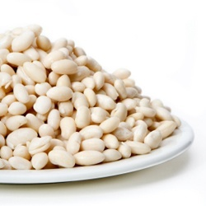

**Producer 🡪** **Collector/Seller (Vendor) 🡪** **Customer**

**Selling Price = 150 lekë/kg 200 lekë/kg**

Total Cost = 70 lekë/kg 170 lekë/kg

Profit Margin **= 80 lekë/kg 30 lekë/kg**

Profit Margin(%) **= 53.3% 15%**

The collector and the seller in the Maliq area perform almost the same function as the ZV actors of the Bean. The price at which these two actors buy from the producer varies from 150 lek per kg to 180 lek per kg. The figure above shows the prices that have the highest frequency of occurring along the bean value chain. The total cost of the collector / seller includes the cost of purchasing beans from the farmer and the cost of operating the warehouse or shop in one year, given that 1 ton of beans is bought and sold. Referring to these data, if we compare the profit margin of the actors between each other, it turns out that the producer receives 53.3% of the profit, while the collector, the seller receive 15% profit margin. Figure 1 shows the profit of farmers in graphical form and the share of their income in the market from the sale of 1 kg of product.  
  
  
  
  
  
  
  
  
Figure 1: Profit of farmers in Maliqi Area for 1kg of beans

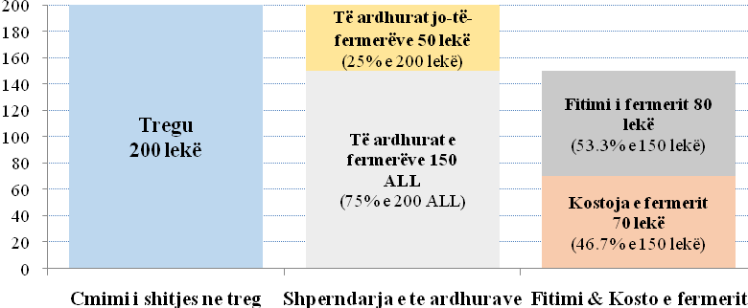  
*Source: ACER, Value chain assessment and construction of training module according to the farmers' needs, 2021*

## 3.5 Distribution channels and supply chain

The supply chain for the Bean product in Maliq area, as expressed in the above issue, includes the following actors: producers or farmers, collectors (even though very rare), as well as traders or sellers who sell to the final costumer. Beans do not have its developed by-products and as a result there are no processing points as ZV actors, as may be the case with other agricultural products. Data collected through the deepened interviews show that part of the farmers sell their product to the final costumer and the other part sells it to the chain intermediaries such as. to the collecting point, or traders / sellers, who then send it to the final costumer

Figure 2: Chain Value for the Bean in Maliq

**Producer**

**Producer**

**Producer**

**Collector**

**Local Seller (Vendor)**

**Customer**

**Customer**

**Customer**

*Source: ACER, Value chain assessment and construction of training module according to the farmers' needs, 2021*

According to the interviews with the ZV actors, it is reported that it is very difficult to find buyers. Sales are made to the same and random buyers (there is no specific separation for the buyers typology). As for the suppliers of raw materials, the producers report that they spend mainly on the purchase of pesticides, while the organic fertilizers are mainly processed by the collection and aging of plant or animal waste (i.e., they perform a kind of waste recycling). In connection with the seed of the plant as a raw material, farmers spend the first time on launching new seedlings and further preserve the seeds of their produce to sow in the next bean seasons

## 3.6 Capacity Utilization and Technology

The capacity utilization of farmers in the area as presented in the issues above, is estimated to not being used in the proper efficiency. Because bean producers have the opportunity to produce even more of this product, so they have a higher production capacity, but on the other hand have no sales, you have stock and as a result the land is not being used at the right level, which which leads to reduced production efficiency.

Another important factor of production is the technology used or the tools. Farmers have expressed in their interviews that they want to increase their production technology mainly at the time of harvest by using suitable agricultural tools and invest in tractors, milling machines, etc. Also, for the improvement of their business in the future, farmers see it as necessary: ​​purchase of seeds of higher quality, irrigation aggregates, opening wells close to the ground as well as improving the road infrastructure that connects the main road with plots of land..

## 3.7 Promotion

The Bean producers in Maliq area are family-owned enterprises (family farming), and therefore they are not specialized in product marketing, moreover the cost of promoting the product does not justify the current selling price. If we single out one of the promoting ways, the product that follows this area we can mention "mouth-to-mouth" marketing through acquaintances with each other. The Bean Value Chain has not had a promotion strategy before, but it would be a good development opportunity for the future to promote the different types of beans that the area produces, and their values ​​so that the people have a detailed and helpful information, for different varieties of beans and consequently to be more price-accepting in the future.

So far in the realization of this report, none of the Bean producers in the Maliq area owns a brand name for their product, but according to data collected from the deepened interviews, everyone claims to see it as possible to have their own brand, if they could afford the initial costs.

## 3.8 Financial support and service providers

In the deepened interviews with actors of the value chain for the Bean product, they were asked if they are members of any farmers' association or trade group, but none of them was aware of the presence of such associations in Maliq area. Meanwhile, in the interview conducted with NGOs in the area and state representatives, it turns out that there is an association of bean production in the village of Libonik and an association of bean production and trade based in the administrative unit of Pojan. The role of farmers' associations is very important for 3 main reasons:

* For the purchase of agricultural inputs;
* For product marketing
* To link customer demand with product sales (supply-demand)

Regarding the assistance received from government agencies, NGOs or local trade groups, the actors of the Office have stated that they have not received financial assistance. The only exception is the case of World Vision Albania (WVA), which has helped them through the donation of agricultural tools necessary for product development such as. for pumps, irrigation, spraying, as well as various trainings for farmers. A single case of benefiting from support schemes was with one of the interviews with the producer, who had benefited from the IPARD 2 scheme, a zetor - agricultural tool, for 2021. The actors of the Deputy, were asked about the application for grants or state support schemes for agriculture. According to the interviews, it turned out that most of them did not apply due to inability to meet the numerous criteria that were set.

In the interview conducted with local government representatives it resulted that the Municipality of Maliq provides services to farmers such as. advisory services, production certificate cooperation and irrigation tax relief. Services provided to farmers by the local government are still on the rise reported by in-depth interviews. In addition to providing services, there are also challenges to serve farming families, and these challenges include: difficulties in clarifying subsidy schemes for agricultural and livestock subsidies because farmers do not understand all the rules and requirements set.

The most important policies for the future that would help farmers in the production and marketing of the product are financial support from the government or non-profit organizations for the initial investment of production as well as the strengthening of associations to have a greater influence and access to power. local, market, product promotion, etc. Regarding the technology used, it turns out that it is not at the right level. Farmers need training and support to equip themselves with new machinery. A positive aspect reported from the interview conducted with the representative of the Municipality of Maliq is the finalization of an important contract, of a group of bean producers, for the possibility of exporting a large amount of product collected by several producers at once.

# CHAPTER 4: TRAINING CAPACITY ASSESSMENT OF THE FARMER FAMILIES

## 4.1 Organizing focus group discussions

ACER in cooperation with WVA, on March 2, 2021 held a focus group discussion with Farming Families in Maliq. The focus group discussion lasted about 1 h and 30 min (start time 12:00 and finishing time 13:30). World Vision Albania economic development program aims to achieve its goal of sustainable economic empowerment of families and communities in the WVA program area, so one of the goals of this service is to assess the capacity of Farming Families and prepare the module of training / capacity building facilitation guidelines for Farming Families.

The discussion in Maliq involved a total of 10 participants from farmers' families. The capacity assessment of Farming Families focused on the following areas: Market access and financial opportunities; Management and collaborative relationships; Technology and infrastructure; Knowledge and training needs.

## 4.2 Market access and financial opportunities

Farming families in Maliq assess the access to market the bean product in the national market as very difficult. The sale of the bean product takes place mainly through personal acquaintances. One problem is that a large amount of the bean plant has remained unsold since a year ago.

Focus group participants reported that there is no specific promotion on the product. The only promotion of the bean plant is at the moment when the seller himself gives a small quantity to the buyer to try it at home and further decide if he wants to buy a larger quantity. Opportunities and knowledge of farming families on product promotion are estimated to be very limited and this affects the marketing of the product. Participants report as a weak point of their buyers the fact that they buy the beans at a lower price, while in the markets of other districts they sell it at a very high price. The main problem with this product is market regulation.

*"We sell beans mainly to the same and reliable buyers year after year. "Meanwhile, a large part of our buyers are drivers who sell beans further in Greece." - Farmer family, Maliq*

Focus group participants assessed their financial capabilities to produce, collect, transport, and sell the bean product. Financial opportunities have been assessed as very limited, mainly to transport and sell the product with the right quality and packaging. Financial assistance was provided by the WVA but not by associations or other public bodies.

## 4.3 Management and collaborative relations

Focus group participants reported seeing a very positive view of being trained in the managerial and organizational skills for growing, developing, marketing, and marketing the bean product. The Directorate of Agriculture, Project Consultancy and the Product Buyer are the main providers of advisory services to farmers in the municipality of Maliq. Meanwhile, the most important development partners in Maliq are the Municipal Unit and the Product Buyers.

The families of the farmers, participants in the focus group, report that the most fruitful collaborations have been and are the cooperative relations with other farmers / families on the product in question and WVA as a non-profit organization. Participants report very poor cooperative relations with regional public institutions.

*"The government should intervene in market regulation and cooperate more for the benefit of farmers." - Farmer family, Maliq*

From these data, there is a need to strengthen in the future the cooperative relations between farmers and public institutions on the produced product and to improve the capacity of the partners in the bean value chain.

## 4.4 Technology and infrastructure

Technological opportunities in the production and provision of services on the bean product are considered very scarce by farming families. Participants in the focus group discussion confirm that in the development of the bean product it is necessary to improve the condition of the current infrastructure in Maliq, such as road conditions, 24 h electricity and water supply, and storage.

The pandemic has hampered face-to-face communication and in addition to telephone communication, internet service has been seen as a necessity by farmers more than ever before. Farmers report that internet service is seen as a disadvantage, the more so not everyone is financially able to have internet service. Meanwhile, the lack of a warehouse or a storage point, for the bean product (lack of a collecting point), has been reported as a problem by all focus group participants.

*"In Maliq there is no collecting point, nor a processing one, for the bean product" - Farmer family, Maliq.*

## 4.5 Knowledge and training

Farmers report possessing sufficient information on the bean product market. They get this information from the cooperative relationship they have with each other and with the consumer. Knowledge about the initiatives or policies pursued by the Albanian government in the agricultural sector is very limited for farmers in the municipality of Maliq. At the same time, they report that they are almost unaware of international / national standards and regulations in the field of bean products.

"Information can be heard in the news but it never comes and is not conveyed properly" - Farmer family, Maliq

Farmers reported receiving training from WVA, but not from public institutions or other non-public associations. Trainings are preferred to be taken in practice / field or in specific classes. Focus group participants confirm that they have a primary need for capacity building and advice on product production, processing and promotion.

*"We want a lot of training, knowledge has no end. We want training on bean production and its preparation. "The most important thing is that we have very little knowledge about the promotion of beans and bean oil produced in Maliq." - Farmer family, Maliq.*

## 4.6 Evaluation of expertise, service providers (NGOs / Local public institutions)

The Municipality of Maliq in its structure on the field of agriculture and livestock has the Directorate of Planning, Control and Territorial Development and the Directorate of Agriculture and Rural Development. The Directorate of Territorial Planning, Control and Development has three important sectors: Project Sector and Environmental Protection; Sector of Territorial Planning and Permit Administration; and Cartography and Geoinformation Sector[9]. On the other hand, the Directorate of Agriculture and Rural Development is composed of certified employees to provide specific services to farming families (eg extension service) although the quality of services remains to be improved (WVA & ISETNJ (2019); WVA & ACER (2021)).

As mentioned above, the main providers of advice and information for farming households are the Directorate of Agriculture, the Project Consultant and the Product Buyer. In WVA and ISETNJ (2019) reports, almost 2/3 of farming families in Maliq report that they have a “very difficult / difficult” approach to obtaining information and counseling. Also, the quality of counseling service was rated as “very good / good” by 25% of farming families and the highest percentage of respondents answered negatively for the quality of counseling service (38% of respondents rated the quality of counseling service). counseling as “very bad / bad”).

In the municipality of Maliq, the main partners for providing advice and information are the Municipal Unit and Product Buyers, but more than 6 in 10 farmers interviewed (61.9% of them) estimate that the capacities of the partners are “low and very low. ”. Farming families in Maliq have a more positive assessment of the service and information provided by Product Buyers.

The above mentioned data on partners and service providers are supported by the study conducted by ACER (2021) the actors involved in the value chain for the bean product in the municipality of Maliq. Regarding the assistance received from government agencies, NGOs or local trade groups, the VO actors have stated that they have not received financial assistance (except for the WVA which has assisted them through the donation of agricultural tools necessary for product development such as for pumps, irrigation, spraying, as well as various trainings for farmers). Farmers report that greater support is needed from the local government, mainly in obtaining subsidies in agriculture / livestock and in regulating the market for bean products.

# CHAPTER 5: CONCLUSIONS AND RECOMMENDATIONS

## 5.1 Study conclusions

# In the municipality of Maliq, the bean is a potential product for improving the economic situation of poor families and this product increases the possibility of involving women, who offer their contribution throughout the production cycle of the product from planting to final sale. According to the data resulting from the WVA reports, but also from the interviews conducted for this report, most of the farming families in the Maliq Area rent land to cultivate their products.

# One of the main obstacles for farmers engaged in bean production in the Maliq area is irrigation of the land due to lack of water and sanitation in the area, which is reflected in a higher cost and affects the potential for increased production. in the future.

# Among the other barriers mentioned by Bean producers, but also of other actors involved in the value chain, are listed as follows:

# Family economy

# High costs for irrigation

# The price of oil

# The entry of foreign products, when the Albanian product is still in stock

# High production cost

# The way of packaging is a form that serves to increase the value of the product, but which in the case of our analysis is not practiced by the actors of the Deputy of Beans. Manufacturers load their production with packaging bags and in the same way follow collectors or retailers, ending up further in sales in plastic bags for the final consumer.

# Producers say that it is difficult to find a market to sell their product and that traders want to buy you at a price so low that it can not even justify their production costs.

# Farmers have stated that they want to increase their production technology, mainly at the time of harvest by using suitable agricultural tools and invest in tractors, mills, etc.

# Bean producers in the Maliq area are family-owned enterprises and therefore do not specialize in product marketing, moreover the cost of promoting the product does not justify the current selling price.

# Regarding the assistance received from government agencies, NGOs or local trade groups, the ZV actors have stated that they have not received financial assistance.

# Table 9. SWOT analysis for the bean product in the area of Maliq

|  |  |
| --- | --- |
| Strengths | Weaknesses |
| * High production potential in the Maliq area. * Increasing investments in the bean sector * Increased willingness to improve the processes of bean substitution (production, collection, processing, sale). * Increasing consumer demand for bio / natural products, with high quality. * Different varieties of the bean production (untapped potential of red and dark beans). | * Lack of a proper collection point for the the bean product in the Maliq area. * Low technological capacities in bean production. * Poor knowledge of national / international standards of bean product. * Low financial opportunities for capacity building. * Insufficient promotion of the bean product and and faced hardships to access the market. |
| Opportunities | **Threats** |
| * Positive trend in raising nationwide the standards of the bean product. * Demand at the regional level is also growing. * Export of the bean product if international requirements / standards are met. | * Import of foreign products * Buyers are driven by price, not quality (lack of knowledge). * Exposure to harmful climatic conditions for the bean product. |

## 5.2 Intervention matrix

The approach to future interventions aims to build on the use and benefit of current local resources and services as well as focus on bringing together key stakeholders to work together to improve product quality and open up new markets. , and at the same time to improve the overall framework of the sector. This includes addressing the key challenges facing the bean sector in Maliq, particularly with regard to costs at all stages of production and the lack of cooperation between farmers and government institutions.

Based on the findings, areas of intervention were identified. Together with sector stakeholders, the study team has formulated intervention proposals and activities which it believes will improve conditions in the bean value chain, generate more income and pro-growth for the poor, and hopefully make the sector more competitive. These proposals are presented in the intervention matrix in the table below.

## Table 8: Intervention matrix

|  |  |  |  |
| --- | --- | --- | --- |
| **LIMITATIONS AND OPPORTUNITIES** | **INTERVENTIONS** | **ACTIVITIES** | **EXPECTED RESULT** |
| Intervention of area 1: Improving quality and increasing production by updating technology | | | |
| **Production can be increased**  **Low quality** | Through the use of good agricultural practices as well as planting/sowing of new productive fields.  Productivity increase and quality improvement through the transfer of knowledge and technology, including:   1. Use the right growers that are suitable for the area and are marketable within the country and also abroad. 2. Methods of using internationally permitted pesticides and fertilizers. 3. Use of modern agricultural technologies required by Global GAP and accepted by importing countries. 4. Training of the workforce for the application of modern agricultural techniques ranging from planting, proper pruning, to day-to-day operations, harvesting and / or processing, in order to ensure a high quality product that meets the level of national and international specifications. | Conducting awareness campaigns  Conducting trainings for farmers and producers  Training of trainers - both agricultural extension workers and private sector trainers | Production increased and quality improved |
| Transfer of the most advanced knowledge and technology in the fields of collection, grading, printing, refrigeration, storage, packaging, processing and transportation.  This can be done through the following measures:  1. Ongoing consultation and coordination with buyers, importers and stakeholders in order to stay informed about pre-defined conditions, specifications and standards that precede local market and export preparation processes.  2. Encourage investment in the collection, grading, printing, packaging, cold storage and equipment necessary to ensure proper handling of the product and maintain its quality during its stay in the warehouse/storage point.  3. Training of technical staff that is able to prepare the product within the required specifications, efficiency and minimal cost.  4. Providing collecting and manufacory processing Centers, with high quality raw materials, in order to be able to keep high quality products at all stages until reaching the customer.  5 Maintaining complete sanitary conditions inside and outside the Centers through the installation of appropriate systems and training of specialized personnel.  6. Installing appropriate systems and follow appropriate measures and practices to ensure that all production and value added requirements are met.  7. Equipping with certificates and licenses that prove and certify the conformity of products and production practices to meet the requirements. | Conducting awareness campaigns  Conducting training of Farmers and Producers  Training of trainers – both, as agricultural extensionists as well as private sector trainers |  |
| **Quality of different types of beans [distinction must be made between high and low quality beans (white / dark / red)]** | Adoption of best standards in agricultural practices leading to engagement in new markets  Introduction of standards, such as Risk Analysis system and Critical Control Points (HACCP system) | Training in better pruning and irrigation methods for the bean product  Training in post-harvest treatment  Training for value chain stakeholders to understand international standards for bean oil production  Training in quality management systems  Capacity building of the government function for quality control and possibly training of private sector service providers in the field of quality management systems |  |
| No services to assist farmers and manufacturing processing centers (an emphasized lack of collecting points) | Establishment of a service center, providing assistance in storage, packaging, marketing, etc.  Establishment of a specific collection and processing centers for bean products in the municipality of Maliq. | Preparation of proposal (or concept note) for the service center, based on a sustainable business model  Funding request |  |
| **Poor access to finances, for the production, harvest, collection and transportation of the product with advanced technological tools** | Facilitate farmers and producers to have better access to finances | Assess current lending financial institutions and assess, even though they are not being used  Capacity building of financial insurers to provide loans to farmers and producers  Capacity building of farmers and producers to access loans, such as preparing business plans |  |
| **Intervention Area 2: Market Development** | | | |
| **Few opportunities to improve the livelihoods of small producers** | Increase the number of people, especially women in the bean sector through technical training and entrepreneurship | Training in the artisanal production of bean-based products (conserved products) | More product differentiation.  A more competitive sector in terms of international parameters  More revenues from more sales |
| **Lack of joint marketing efforts (creating a structure for joint marketing)** | Create a structure for joint marketing, perhaps in the form of a marketing cooperative | Appreciate the interest and create incentives among the Bean Producers  If there is sufficient interest, continue with assistance in training and practice in setting up a common structure for cooperation in the field of product marketing |  |
| **Limited knowledge about new market opportunities** | Prepare a market study to explore local, national and international markets and prepare a marketing plan to address these opportunities and overcome challenges related to entering new and / or existing markets. | Develop ToR and recruit experts to conduct the study  Prepare a marketing plan |  |
| **Very little services and technical assistance to support the sector** | Support from qualified business service providers, to assist the sector in improving its access toward the export markets and more sophisticated customers | The training of the service providers of business development, in technical competences also in the managerial ones for the sector |  |
| **There are no available services in packaging** | Find and enable the service provider to provide services or to set up a common equipment center that can provide packaging services | Training and capacity building |  |
| **NO quality and certification control** | Find and enable service providers to provide quality control and certification services  Establish laboratories and testing equipment in the area of Maliq | Investment in laboratory facilities and technical training |  |
| **Intervention Area 3: Improvement of the supporting functions and coordination** | | | |
| **Bad situation of road infrastructure** | Improvement of the agricultural connecting road | Raise issues with the department of Transport    Seek resources for road repairs | The interested actors are empowered to address the challenges |
| **Poor external cooperation and coordination and no mechanism for promoting the interests of the sector** | Establish a bean sector forum or a Board for stakeholders in the sector, both the private sector and the government.  Develop a long-term strategy for the forum / board | Arrange regular meetings  Support chambers of commerce and industry to include agriculture and strengthen their capacity to assist small agribusinesses  Recruit strategy design experts | Better support which leads to better methods and knowledge, imporving the products and the business |
| **Lack of human resources and budget for research work** | Strengthening the capacity of local institutions to conduct research and disseminate knowledge to farmers and producers | Technical assistance from central level institutions |  |
| **Low availability of extensive services** | Development of relevant and more targeted field-based training and extensive services | Assess the current availability of field training and expansion service as needed  Develop reliable capacity and resources for training and services |  |
| **Poor access to advisory and financial services** | Better access to advisory services to assist businesses in using financial and non-financial services | Build the capacity of local service providers to provide training and business development advice |  |
| **Intervention Area 4: Improving the enabling environment** | | | |
| **Government policies are considered weak as they fail to support the sector** | Creating a platform to address the sector's challenges  Increase the capacity of dialogue and advocacy of stakeholders in the value chain to address issues facing the government and other relevant actors | Holding a dialogue forum, perhaps at the initiative of the bean oil board, forum or business association  Prepare evidence-based arguments for ways to address challenges and create opportunities   Involve agricultural unions (if any) in government-related decision-making processes | Dialogue which leads toward the addressing of the problems, better business and better welfare |
| **Competition from the imported bean product** | Identify ways to protect the bean sector from imported bean product (legal and illegal) | Assess whether the bean sector can be protected from competition by imported oil, at least temporarily  Strengthen measures to stem the flow of counterfeit bean product, smuggled from neighboring countries |  |

*Source: ACER, Value chain assessment and construction of training module according to the farmers' needs, 2021*

## 5.3 Recommendations

Some of the recommendations derived from the workshop data, in-depth interviews with key stakeholders on the bean product in the municipality of Maliq and the focus group with farmers' families are listed below.

To develop a modern value chain from the sales sector some concrete investments need to be made, including encouragement from local / central government and various donors. To create such chains, some of the efforts required are:

• Providing a suitable environment for private investment in production until the sale of the bean product;

• Setting standards for bean products, in order to maintain quality;

• Post-harvest management, skilled manpower and necessary infrastructure;

• Development of cooperative relations between farmers and local / central government or various donors.

Providing training to farmers on best agricultural practices related to bean product. Teaching farmers about optimal land space to maximize bean productivity.

Making available to farmers from various donors irrigation, production and processing tools on the bean product.

Establishment of gathering and processing industries on bean product in the municipality of Maliq.

Interventions funded by local / central government or various donors with the highest impact on the promotion and marketing of beans are recommended. So, creating a promotional network on bean products produced in Maliq / Korça would be useful to address some of the challenges.

Providing training to farmers on processing and packaging methods. Helping farmers get a higher price for their produce by presenting it in a more attractive way to customers (promotional methods).

Capacity building of farmers for the adoption of new technological tools and advocacy with local authorities in strengthening the position of farmers in the value chain or protecting them from unforeseen price fluctuations.

# Appendix 1: Product Identification (Maliq)

|  |  |  |  |  |  |  |
| --- | --- | --- | --- | --- | --- | --- |
| **Criterion** | **Sub-criterion** | **Molla**  **Points** | **Cattle Points** | **Cherry**  **Points** | **Bean**  **Points** | **BMA**  **Points** |
| **The potential of value chains to improve the livelihoods of local (poor) households**  **Weight: 60 %** | a. Current integration of the poor in the market (what they are producing, selling, employing). |  |  |  |  |  |
| b. Product / activity potential for poverty reduction/alleviation, and economic empowerment. |  |  |  |  |  |
| c. Low entry barriers for the poor (capital, knowledge). |  |  |  |  |  |
| **Market potential**  **Weight: 30%** | d. Strong domestic and / or regional / national demand for the product |  |  |  |  |  |
| e. Growth potential of certain products / activities; |  |  |  |  |  |
| f. Possibility for scaling |  |  |  |  |  |
| g. Involvement a large number of people. |  |  |  |  |  |
| **Others**  **Weight: 10 %** | h. Social inclusion and gender; |  |  |  |  |  |
| i. Within the framework of national and regional strategies; |  |  |  |  |  |
| j. Existing infrastructure, including equipment and tools. |  |  |  |  |  |

# Appendix 2: The guide for discussions in Focus Groups

**Region:**

a) Dibër b) Korçë c) Maliq d) Librazhd

**ACCSESS IN THE MARKET**

1. How do you assess the access to market the product in the local / national market? Do you have difficulty selling your product to buyers? (comment)

_____________________________________________________________________________________

_____________________________________________________________________________________

1. What do you think are the strengths and weaknesses in selling your products? What about the strengths and weaknesses of your buyers?

_____________________________________________________________________________________

_____________________________________________________________________________________

1. What do you think are the strengths and weaknesses in selling your products? What about the strengths and weaknesses of your buyers?

__________________________________________________________________________________________________________________________________________________________________________

1. What are your opportunities to promote / market the product?

_____________________________________________________________________________________

_____________________________________________________________________________________

**FINANCIAL POSSIBILITIES**

1. How do you assess your financial capabilities to:
   1. Produce a product __________________________________________
   2. Process a product __________________________________________
   3. Transport the product __________________________________________
   4. Sell the product (to the final customer ______________________________

*(Get feedback from participants about their ability to afford the above activities if they would offer it themselves)*

1. Have you received financial aid / grants to help produce a product other than WVA? If yes, specify from whom you received these grants?

Were they enough?

_____________________________________________________________________________________

_____________________________________________________________________________________

1. What are your primary needs that would help you directly in the production of the product?

_____________________________________________________________________________________

_____________________________________________________________________________________

**MANAGMENT/ COOPERATING RELATIONS**

1. Do you find it positive to be trained in managerial and organizational knowledge and skills for setting up, developing, marketing and marketing a product? Do you think such training is needed for farming families in general?

_____________________________________________________________________________________

_____________________________________________________________________________________

1. What have been or are the most fruitful collaborations, from the following alternatives if you have had any?
2. Collaborative relations with farmers / other families on a product produced _______
3. Relations with local government officials _________________________
4. Relations with business associations _________________________
5. Relations with non-profit organizations _________________________

*9.1 Where did these cooperative relations consist / in what aspects? (Comment extensively)*

_____________________________________________________________________________________

**KNOWLEDGE**

1. Do you have enough information on the market of your product? If yes, where do you get this information (eg from the buyer, collection / processing companies, extensive services, etc.)?

____________________________________________________________________________________

____________________________________________________________________________________

1. Do you have knowledge about the initiatives or policies pursued by the Albanian government in the agricultural sector (eg strategies, action plans undertaken by the Ministry of Agriculture and Rural Development) ?

____________________________________________________________________________________

____________________________________________________________________________________

1. Are you aware of international / national standards and regulations for your business / product area (eg ISO, GAP, GMP standards, quality standards and laws, etc.)
2. Yes. What are these standards? Describe below.
3. No.

_____________________________________________________________________________________

_____________________________________________________________________________________

**TECHNOLOGY AND INFRASTRUCTURE**

1. How do you assess your technological capabilities in producing or providing a service on the product?

_____________________________________________________________________________________

_____________________________________________________________________________________

1. Do you think it is necessary to increase your technological knowledge in producing or providing a service on the product?

_____________________________________________________________________________________

_____________________________________________________________________________________

1. Give your opinions on the state of the current infrastructure in product development:
   1. Road conditions/Transport _______________________________________
   2. Telephone Service _______________________________________
   3. Internet Service _______________________________________
   4. Electricity supply _______________________________________
   5. Storage _______________________________________

_____________________________________________________________________________________

_____________________________________________________________________________________

**TRAINING**

1. Have you previously received training on the production or provision of a service on agricultural / livestock product? If yes, please specify by whom you were trained and what were the topics?

_____________________________________________________________________________________

_____________________________________________________________________________________

1. Do you need training on production and service delivery on agricultural / livestock product? Specify which areas you want to train the most.

_____________________________________________________________________________________

_____________________________________________________________________________________

# Appendix 3: Deepened Interviews

**The guide of the questions for the chain value actors**

*(Producer/farmers, collector, transporter, processer, wholesaler/reatailer)*

**I. BASIC DATA**

Region: ___________________________________________

Product: ____________________________________________

Name: ____________________________________________

Actor (or the name of the company): _______________________________

Geographical coverage: _______________________________

For how long you’ve been working for this business (for a specific product)? ___________ years

Number of the employees (officials, seasonal, genitive): ___________________

The volume of the Annual production: ___________________

Annual turnover: ___________________

**II. SELECTED VALUE CHAIN/ product**

**II.1 Growth Potential**

1. What are the main obstacles to the production / collection / processing / marketing / sale .. of this product?

2. Who is buying this product? Are traders willing to buy more of the product in the future?

3. At what price is the product supplied to the consumer? Is he competitive?

4. Do you use packaging for the product? What packaging do you use? What packaging do buyers and consumers want? Can you do them?

5. What are the prospects for future demand growth?

6. What do you think is the main demand trend (higher quality products, cheaper products, typical products)?

7. Where do you get the raw materials? Can you get enough raw material to fulfill all the orders from the buyers?

8. What are the competitive advantages of manufacturers (cost, product features)?

9. Is there potential for product improvement and innovation?

**II.2 Poverty Alleviation Potential**

10. What are the barriers to market entry for producers / farmers (from poor households)?

11. Will the increase in this specific VC generate additional employment?

12. Is there increasing competition in this sector? Does the VO offer the opportunity to improve (or at least maintain) the actual distribution of benefits across the value chain?

13. Is there a risk of replacement / change of unskilled workers or women?

14. Does the value chain offer any potential to increase income-generating activities for women?

15. Is the inclusion of women in this value chain potential to increase local governance on priority issues (for example, less discrimination, listening to women's voices)?

16. Does the value chain offer the possibility of diversification from agriculture / ordinary agricultural production?

17. Are there any productive / entrepreneurial women groups that have been successful in this particular V / product?

18. What types of interventions can be successful in improving the economic activities performed by women? What would be the impact of such interventions? Can you give some estimates for the costs?

19. Are local groups willing to cooperate in implementing these interventions?

20. Are the workers qualified? Do they lack skills? Get feedback on the circulation, presence and role of women, youth, urban versus rural, circulation, informality, etc. (Approximate if no specific data is provided)

*Get feedback on the circulation, presence and role of women, youth, urban versus rural, circulation, informality, etc. (Approximate if no specific data is provided)III. THE MARKET*

1. How much product is currently sold in the area? Please specify the most important markets (geographically).
2. Is the existing supply suitable to meet the demand, or is there a shortage?
3. Is it seasonal demand? Please explain. Are there any implications for your activity / company? Please specify.
4. How do you set your prices (market based prices, competitive prices, entry prices, prices for different sizes, geographic price, price plus cost)? Why? (Show prices along the value chain.)
5. Do you have a clear idea of ​​your exact production / collection / processing / marketing costs? (utilities, labor, high raw material costs, transportation)?
6. Do you have a good profit margin idea for this product?
7. Do you have any certificates, quality standards, etc.? Please elaborate. Do you consider these standards as important "tools" to compete?

**IV. DISTRIBUTING CHANNELS AND SUPPLYING CHAIN**

1. How is your product distributed (directly to consumers, distributors, wholesalers, supermarkets, grocery, etc.)? How do you deliver the products, when and in what quantity? How many buyers do you have? Do you use your own transportation?
2. Do you sell to the same reliable buyers? Is it hard for you to find buyers? Do you collaborate with others to sell your products (especially to farmers)?
3. How many suppliers do you have? Do you buy from the same reliable suppliers? Is it difficult for you to find suppliers? Why?

**V. CAPACITY AND ITS USE**

1. Please specify projected capacity and current output. If capacity utilization is low, explain WHY (poor planning, low demand due to internal or market factors, technology deficiencies, etc.).

**VI. PROCCESSES AND TECHNOLOGIES**

1. What are the most important processes? What technology do you use? Is the technology expensive? Please elaborate.
2. How much have you invested in the development of this product? Do you intend to increase your production / diversification / capacity improvement technology?
3. To improve your business, which infrastructure improvements (markets, roads) would be most important?

**VII. PROMOTION**

1. What types of promotion do you use (advertising, point of sale shows, free samples, word of mouth, coupons, special prices, free advertising)? Please comment (cost effectiveness if data is available). Do you have a promotion strategy?
2. Do you have a "brand name"? if not, will you give your product a "brand name"?

**VIII. FINANCIAL SUPPORT AND SERVICE PROVIDERS**

1. Are you a member of an association or trade group?
2. Do you have, or do you currently receive, any assistance from government agencies, CSOs, NGOs, social enterprises or local trade groups (formal or informal - for your business and family)?
3. Are you supported by donors or other government agencies? What kind of support is provided by donors, consulting companies or other marketing service providers?
4. Is it difficult to apply for grants? What are the main obstacles? What can be done to facilitate the process? Has the availability of state / IPARD support schemes changed business in recent years? In what way?
5. Are there any additional barriers for women?

**Interview for Public Institutions/ NGO/ Associations**

GENERALINFORMATION

|  |  |
| --- | --- |
| Date: |  |
| Name and Surname of the interviewee |  |
| Institution: |  |
| Function/Institution type: |  |
| Contact Phone Number: |  |
| Geographical Inclusion: |  |

***Inform the interviewee about the profile of the beneficiaries of the project that WVA is implementing.***

**What services do you offer: ____________________________________________**

1. For GOV: The commitment of the central or local government towards the improvement of agriculture / livestock and the quality of the product in question? And in the face of poor farmers?
2. For NGOs: What is your organization's experience in providing services to farmers or consumers on the product? Have you faced any challenges in providing the service?

Ask first if they have served any such beneficiaries (farmers / collectors / sellers). If they say YES, then ask:

1. Do you offer any kind of support to poor farmers?

2. Which services did the farmers benefit from and what were the characteristics of these services.

3. Are the services provided to farmers increasing or decreasing and what are the reasons for the increase / decrease?

4. Ask the provider what was the experience of the institute in providing the required services, i.e. if they have faced any challenges in serving the farming families, if the farmers understood all the rules and requirements of the provider and the procedure they had to follow to benefit from these services

5. How do you think the access of farming families can be improved to benefit from the services you provide?

If not, then ask the institution:

1. **Why did not they serve such a beneficiary (farmers in our case)?**
2. **What prevented you from serving farmers in the respective regions?**

Ask the interviewees:

1. Do you have plans in the future to provide new or existing services to farmers in these regions? What are they?
2. What capacity support will be needed to provide such services?
3. What is your assessment as an additional service provider for farming families regarding the inclusion of women, children and youth in the relevant value chain?
4. Do you have any specific programs or services for women, children and young people? (Yes No)
5. If "Yes", please specify about the program or services and service feature. (Program / service duration, recipient selection criteria, training / service fee, etc.)
6. Are Farmers Associations registered or accredited?
7. How important do you see the role of Farmers Associations in supporting agriculture / livestock?
8. Have you developed any support strategies to facilitate the market chain of the product in question (production / collection / processing / sales)? At what stage of the chain does it intervene concretely?
9. What policies do you think would help poor farmers produce more, with better quality / hygiene / packaging and labeling and lower costs?
10. In your opinion, what are some of the main obstacles / gaps for empowering farmers / community regarding this product?
11. How do you assess the interventions of local and central government on the improvement and empowerment of farmers or the value chain?
12. What is your opinion as an NGO on the promotion of the relevant product?
13. What is your opinion on the technology used for the production / collection / processing and sale of the product in question?

Evaluation of previous experiences:

1. What has been the most successful approach among those applied by various donors / programs / projects? Why (discussion)?
2. What were the most successful support schemes applied in the past (subsidies for inputs / fiscal reductions, investment portion, matching grants, soft loans, etc.) Why (discussion)?
3. Were there or are there examples of successful collaboration activities (eg cooperatives or producer groups)? Who are they and why did they succeed? What are the reasons for failure?
4. What kind of approach would you recommend to develop more cost-effective interventions (eg capacity building and investment)?

# Appendix 4: Participating lists and photos of the performed activities in the region of Maliq

* **Workshop, on 02.03.2021**

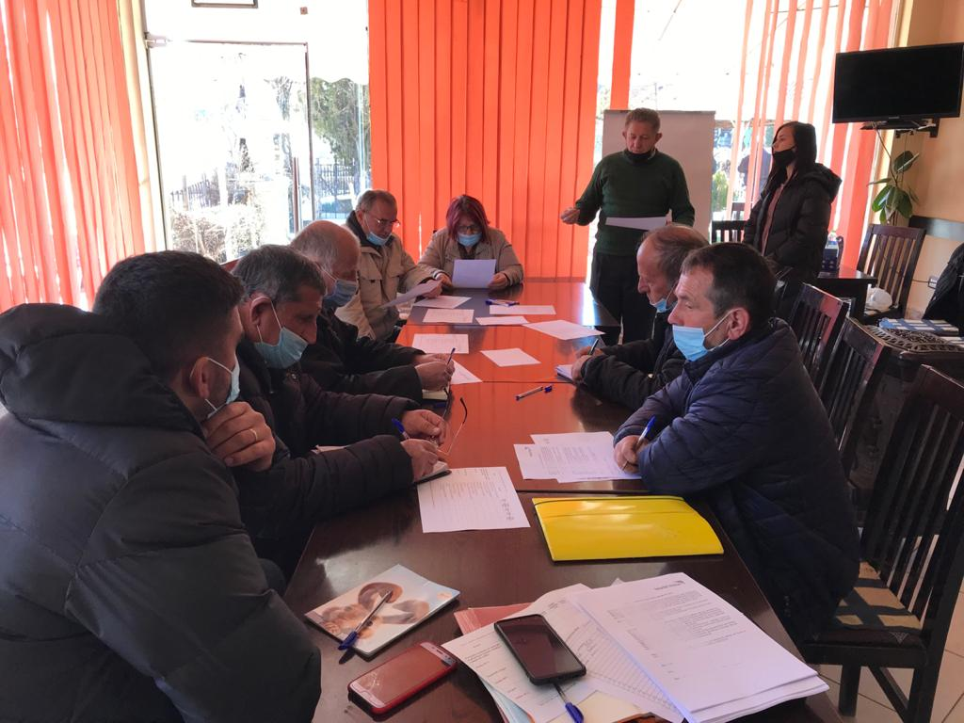 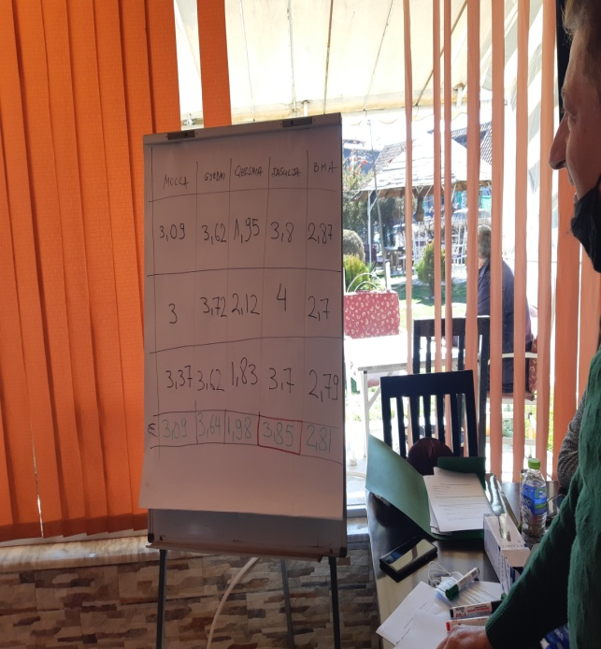

**Photo of the present list**

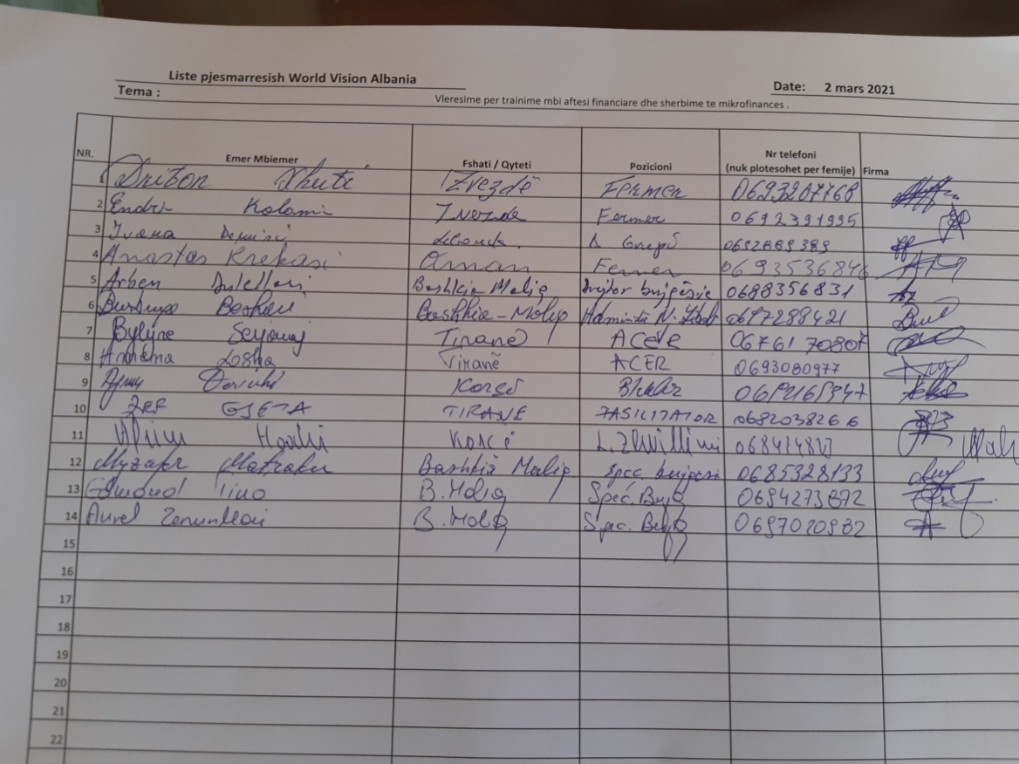

* **Focus Group Discussions, on 03.03.2021**

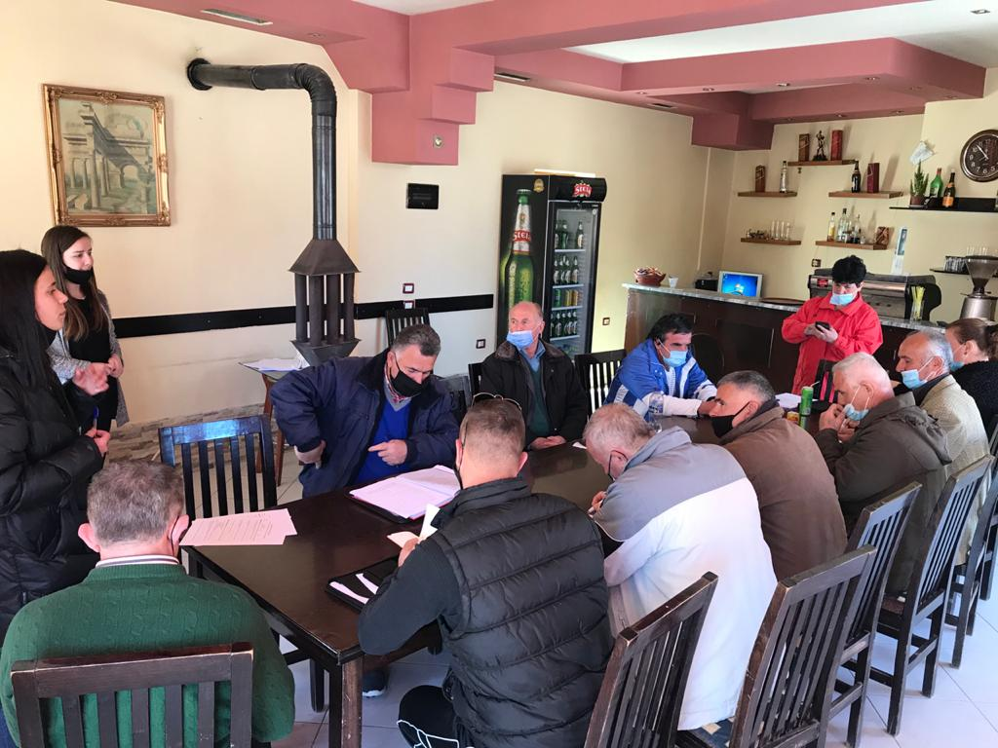

**Photo of the present list**

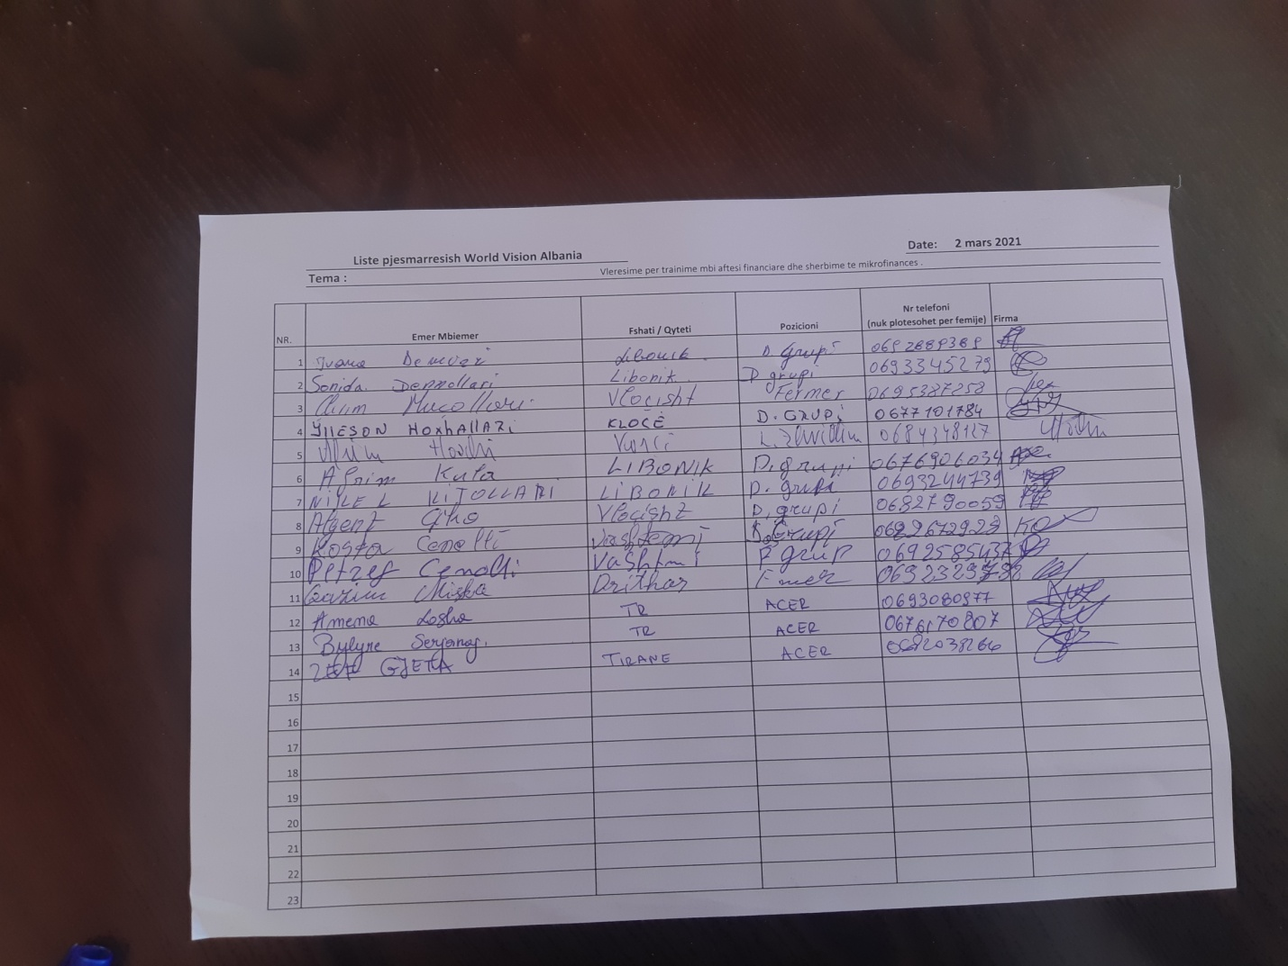

1. Kaplinsky, R., & Morris, M. (2000). Value Chain Research Manual (Vol. 113). Brighton: University of Sussex, Institute for Development Studies.

   Gereffi, G., & Fernandez-Stark, K. (2011). Global value chain analysis: a primer. Center for Globalization, Governance and Competitiveness (CGGC), Duke University, North Carolina, USA.

   DFID (2008) Making Value Chains Work Better for the Poor: A Handbook for Value Chain Analysis Practitioners. Manual. International Agriculture Development.

   Guidelines for a Methodology to Support Value Chains for BioTrade Products from Product Selection to the Development of Sectoral Strategies UNITED NATIONS New York and Geneva, 2009.
2. Four reports for Dibër, Librazhd, Korçë and Maliq area: WVAK & ISETNJ: “Landscape and natural resources assessment and curriculum development to address farmers' needs for capacity building”
3. ACER has prepared deepened interviews based on two main documents:

   World Vision (2018). “*Value Chain Assessment at national level”*: <https://www.wvi.org/sites/default/files/2020-05/National%20Value%20Chain%20Report_final%20%282%29.pdf>

   The food and Agriculture Organization of the United Nations (2018). “*Market and Value chain analysi of selected sectors for diversification of the rural economy and women’s economic empowerment*”: <http://www.fao.org/policy-support/tools-and-publications/resources-details/en/c/1114588/>
4. Referring to WVA reports in the four areas and similar reports for training needs assessment:  
   <https://snv.org/cms/sites/default/files/explore/download/training_needs_assessment_padee_2013.pdf>
5. DFID (2008) Making Value Chains Work Better for the Poor: A Handbook for Value Chain Analysis Practitioners. Manual. International Agriculture Development.

   Guidelines for a Methodology to Support Value Chains for BioTrade Products from Product Selection to the Development of Sector Strategies UNITED NATIONS New York and Geneva, 2009.
6. WVAK & ISETNJ: “Assessment of landscape and natural resources and development of the curricula to address the needs of farmers for capacity building ”, Maliq.
7. WVAK & ISETNJ: "Assessment of landscape and natural resources and development of curricula to address the needs of farmers for capacity building", Maliq.
8. WVAK & ISETNJ: "Assessment of landscape and natural resources and development of curricula to address the needs of farmers for capacity building", Maliq.
9. Municipality of Maliq: https://www.bashkiamaliq.gov.al/organigrama