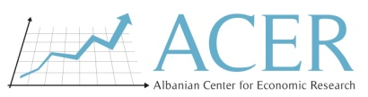

**FINAL REPORT**

**Assessment of the Value Chain for the selected product in Kurbin and building of the training module as per needs of farmers**

**Submitted by: Albanian Center for Economic Research (ACER)**

March, 2021

Table of Contents

ACKNOWLEDGEMENT 4

ABBREVIATIONS 5

EXECUTIVE SUMMARY 6

CHAPTER 1: METHODOLOGY OF THE ASSESSMENT 8

1.1 Selection of value chains for analysis 8

1.1.2 Defining criteria and building understanding on these criteria 9

1.1.3 Weighting of criteria 9

1.1.4 Identification of a potential list and the product ranking 10

1.2 Evaluation of the selected value chains 10

1.2.1 Collection of existing information and preparation of evaluation 10

1.3 Households’ Capacity Assessment 12

1.3.1 Development of the focus group discussion instrument 12

1.3.2 Field data collection 12

1.3.3 Data analysis 13

1.4 Limitations of the study 13

CHAPTER 2: IDENTIFICATION OF THE POTENTIAL PRODUCT 14

2.1 Workshop organized in Kurbin 14

2.2 Defining / approving of criteria and sub-criteria with participants 14

2.3 Ranking of the identified products 15

2.4 Identification of the potential product for Kurbin area 15

CHAPTER 3: VALUE CHAIN ANALYSIS - OLIVE 16

3.1 The selected product for VCH Analysis 16

3.2 Potential of Growth 17

3.3 Poverty alleviation potential 18

3.4 Market Assessment 19

3.4.1 Data on costs and benefits 20

3.5 Distribution channels and supply chain 23

3.6 Capacity Utilization and Technology 24

3.7 Promotion 24

3.8 Financial support and service providers 25

CHAPTER 4: TRAINING CAPACITY ASSESSMENT 26

4.1 The organization of the focus group discussion 26

4.2 Market access and financial opportunities 26

4.3 Management and collaborative relations 26

4.4 Technology and infrastructure 27

4.5 Knowledge and training 28

4.6 Assessing of expertise, service providers (NGOs / Local public institutions) 28

CHAPTER 5: CONCLUSIONS AND RECOMMENDATIONS 30

5.1 Conclusions of the study 30

5.2 Intervention matrix 32

5.3 Recommendations and next steps 40

Appendix 1: Product Identification (Kurbin) 41

Appendix 2: The guide for Focus Group Discussions 42

Appendix 3: In depth Interviews 45

Appendix 4: Participants’ lists and photos of activities in Kurbin 50

# List of Tables and Figures

Table 1: Sample of qualitative research 11

Table 2: Criteria averages for each product in the Kurbin area 15

Table 3: Average area of the cultivated land with olive groves, and the farmers who produce this product by administrative units and in total - Kurbin 16

Table 4: Production of olive- Kurbin 16

Table 5: Profile of the actors involved in the survey through in depth interviews 17

Table 6: Data on product price in Kurbin Area 20

Table 7: Revenues and Expenditures of an Olive producer in the Kurbin Area 21

Table 8: Financial data for the production of olives / in costs per unit 22

Table 9: SWOT analysis for the olive product in the area of Kurbin 31

Table 10: Intervention matrix 33

Figure 1: Value chain for Olive in Kurbin 23

# ACKNOWLEDGEMENT

The methodology for the implementation of the study: **“Assessment of the Value Chain for the selected product in Kurbin and building of the training module as per needs of farmers”** and field work package for the identification of 4 potential products (in Diber, Librazhd, Korca and Kurbin), opportunities for their development, the identification of the value chain status of each product was prepared by: Dr. Zef Preci, Dr. Brunilda Kosta, Bylyre Serjanaj MSc, Amena Losha MSc (ACER).

This final report would not have been possible without the reflective aid, support and contribution of Ms. Flovia Selmani, Monitoring and Evaluation Specialist of World Vision Albania staff, and Ms. Majlinda Hoxha, Project Manager, in charge of monitoring and implementation of the program "Building Secure Livelihoods", for the assistance provided during the implementation of this assessment. Special thanks also to the project coordination teams of World Vision Albania (WVA) in the field, Mr. Altin Vathaj (Municipality of Kurbin), Mr. Afrim Haxhi (Municipality of Maliq), Mr. Shpetim Cura (Municipality of Librazhd) and Mr. Erblin Burnazi (Municipality of Diber).

Finally, we are grateful to all the farmers who participated in the training needs assessment survey as well as key stakeholders in the VCH of potential products, including representatives of governmental and non-governmental organizations who participated in the workshop and interviews conducted in each region, during the period February 24th - March 18th, 2021. We thank the experts and households for their necessary contribution to this assessment and especially to our findings reflected in this report.

Clarification on Conflict of Interest: The authors declare no conflict of interest. Besides, the funders had no role in the design of the study; in the collection, analyses, or interpretation of data; in the writing of the manuscript, and in the decision to publish the results.

# ABBREVIATIONS

ACER Albanian Centre for Economic Research

COVID-19 Corona Virus 2019

ISETNJ Institute of Economic Studies and Knowledge Transfer

NGO Non-governemntal organizations

KII Key Informants Interviews

FGD Focus Group Discussion

ToR Terms of Reference

VCH Value Chain

WVA World Vision Albania

# EXECUTIVE SUMMARY

This research was conducted by the Albanian Center for Economic Research (ACER). The study team used a qualitative methodology, starting with a review of documentation in the field of study, followed by a collection of data through field interviews with key informants, business association leaders and farmers, and ending up with an analysis of value chain for the selected product (olive). The methodology chosen by ACER in collaboration with WVA, aims to strengthen the linkage **between value chain analysis and development interventions to improve the opportunities available to the poor.**

In the organized workshop in the municipality of Kurbin, on February 24th, 2021, the potential product was selected with the participation of nine experts in the field of agriculture and livestock. The selected product is olive, an evaluation based on criteria such as: a) The potential of the value chain to improve the livelihood of the local (poor) families; b) Market potential and c) Other criteria related to social inclusion and gender, existing strategies and infrastructure.

After the product selection, nine in-depth interviews were conducted with key stakeholders, in the municipality of Kurbin (2 interviews with NGO’s and public institution’s participants; 7 other interviews with producers, collectors, sellers), and a focus group discussion with households.

The actors in the VCH of Olive said that there is a workforce ready to be employed in the cultivation of the olive product, and since that this value chain does not have a **special collection point** or a **specific olive processing factory**, therefore it has a high potential in generating employment and consequently in poverty alleviation. Regarding the qualification and the skills of the workers in this product VCH, they are missing because the skillful workers in agriculture tend to go abroad, or they move to urban areas, as seasonal workers for a higher payment than in the region of Kurbin.

From the data of the semi-structured interviews, it results that the main obstacles that affect the growth of the Olivet product for the future are: 1) Lack of knowledge about the product (the difference in quality on the part of buyers between a high quality product and a low quality one), which directs the buyer to focus on the lowest price; 2) Lack of assistance data provided by local government or showed interest toward the farmers; 3) Expensive petrol for agricultural vehicles and transport; 4) High costs for chemical and organic fertilizers; 5) Lack of knowledge in processing and packaging issues; lack of knowledge regarding product marketing and approximation of standards; 6) Access to the market, very difficult (lack of a market to distribute the product).

Regarding the assistance received from government agencies, NGOs or local trade groups, they again stated that **they have not received any financial assistance.** The only exception is the case of World Vision Albania (WVA), which has helped them through the donation of the necessary agricultural tools and equipments for product development, such as for the milling machine or assistance with agricultural inputs, as well as consultancy provided by the field coordinator in the region of Kurbin.

One of the encountered challenges is the uncertified land, the fleeing of young people of working age and the lack of market development that makes communication channels difficult from producers / farmers to traders. **The most important policies for the future** that would help farmers to produce more are related to increasing economic interest in them, by providing subsidies from the state and non-governmental organizations.

In the interview with a representative from a public institution in the Kurbin region (extension service), it was stated that the support provided to farmers was mainly **technical assistance and during the last three years of the establishment of the institution there was no subsidy for the Olive product.** There is also a lack of specific plans or policies in this regard as well as a lack of specific programs for women or the youth, which requires assistance from the central government.

The approach to future interventions aims to build on the **use and benefit of current local resources and services** as well as focus on bringing key stakeholders to work together to improve product quality and open up new markets, and at the same time to achieve the improvement of the general framework on this sector.

# CHAPTER 1: METHODOLOGY OF THE ASSESSMENT

There is a burgeoning of literature that lay out various ways and tools of value chain analysis. Besides the universal use and technicalities that accompany value chain analysis, the designed methodology applied to **identify and select the product** so then appropriately analyse their respective value chains, **strongly depends on the final purpose of the analysis**. To serve these various purposes, different authors and organizations have developed different toolbooks. Besides the existence of a wide number of toolbooks on value chain analysis (see Kaplinsky and Morris, 2000; Gereffi and Fernandez-Stark, 2011; UNCTAD, 2009; DFID, 2008; FAO, 2006)[1], **ACER selected the toolbook designed by the UNCTAD (2009) which aims at strengthening the link between the value chain analysis and development interventions to improve the opportunities available to the poor.** In line with the context of the country, some adjustments have been made which are argued throughout the document.Consequently, the designed methodology further elaborated in the upcoming sections, is based on this guidebook and its focus perfectly fits with the World Vision Albania economic development program goal which is **to achieve its goal of sustainable economic empowerment of families and communities of WVA program area in Dibër, Korçë, Kurbin and Librazhd, to raise their capacities to build resilience and improve child well-being.**

ACER has pursued the following steps in preparing the value chain analysis in four selected areas.

## 1.1 Selection of value chains for analysis

Before developing the complete value chain Report in the Kurbin area (deliverable 2 according to ToRs), it was necessary to select the most suitable products in the region. As a note, WVA has already developed four contextual reports[2] and have served as basis of defining a clear contextual landscape. So, the prioritising process for selecting the potential product has followed the defined stages as below:

### **1.1.2** Defining criteria and building understanding on these criteria

Value chain analysis begins with the selection of a product. The entry point of the value chain analysis proposed in the manual we are referring to is poverty alleviation and achieving pro-poor outcomes. As a result, the set of criteria used by ACER reflected this entry point. In addition to guidelines for setting criteria, as suggested by various studies (DFID, 2008; UNCTAD, 2009), the local context is taken into account in enriching, approving and revising these theoretical criteria.

ACER sets out these criteria to prioritize local products, as suggested by the manual:

**(i) Potential of the value chains to improve livelihood of the local families (poor)**

* Present integration of the poor in the market (what are they producing, selling, employment);
* Potential of the product / activity for poverty reduction and economic empowerment;
* Low barriers to entry for the poor (capital, knowledge);

**(ii) Market potential**

* Strong domestic and / or regional/national demand for the product;
* Growth potential of certain product;
* Possibility for scaling up;
* Involves a large number of people.

**(iii) Other criteria**

* Social inclusion and gender;
* Within framework of national and regional strategies;
* Existing infrastructure, including equipments and tools.

As an important note and as suggested by the manual, the decision as to which specific criteria were used for value chain selection was reached in collaboration with WVA and several experts in the field.

### **1.1.3 Weighting of criteria**

After defining the set of criteria, weighting process took place. As a remark, the toolbook suggests various weighting systems. In our case, the weighting system is based on the general rule that *“the more pro-poor you wish the selection of value chain to be, the higher the weighting that should be given to the criteria that emphasise pro-poor characteristics”.*

This is why ACER gives more weight to the first category of criteria and less to the others. As a summary, this weighing system is shown in Appendix 1.

### **1.1.4 Identification of a potential list and the product ranking**

Once the criteria for selecting the value chains, for analysis and after defining the weighing system was done, the next step was to develop a list of all possible local products in Kurbin. A participatory approach was used to complete the list identification. ACER conducted a workshop in Kurbin to successfully finalize the product identification process. As a rule, the value chains identified during this phase were based on current products currently produced in the Kurbin area and having a pro-poor focus, or that the products are considered to have a good market potential (local, regional and national).Each of the products was evaluated against sub-criteria from 1 to 5, and the product with the highest average was the product selected for value chain analysis.

## 1.2 Evaluation of the selected value chains

Following the finalization of the value chain selection, ACER conducted the value chain evaluation for each selected product. This went through the following two stages.

### **1.2.1 Collection of existing information and preparation of evaluation**

During this phase, ACER carried out the following activities:

* **Mapping value chain actors.**

The mapping process aimed to identify all the actors involved along the chain and their respective roles they play in the production cycle, from production to product marketing and marketing in the target market. The following points were elaborated in this value chain mapping process: (i) the actors involved and the interrelationships between them; (ii) Identification of problems along the chain (Barriers in the chain, from the point of production to the final consumer, are described based on the flow of processes identified); (iii) Description of time and variable costs.

* **GAP Analysis**

With GAP analysis, actors in the chain assess their capacity to enter the market, identify weaknesses, and identify the causes of gaps between their current capacity and that required for the target market. This GAP analysis is based on the information available on demand in existing markets (regional and national), given the target market.

**ACER used qualitative data to collect information on each of the selected value chains**. Key informants Interviews (KII), value chain analysis questionnaires were designed and finalized after the agreement with WVA. A total of nine in-depth interviews were conducted (out of 12 initial targets), as defined in Table 1.

The qualitative study helped the evaluators to obtain more deepened information on the current situation, challenges and possible solutions for each of the value chain processes.

Table 1: Sample of qualitative research

|  |  |
| --- | --- |
| **Sample type** | **Sample number** |
| 1. Extensive services (government officials) | 1 |
| 1. Local NGOs communities | 1 |
| 1. Producers / Farmers 2. Collectors 3. Processors / Distributors 4. Wholesalers / retailers, etc. | 7 |
| **Total number of participants** | **9** |

*Source: ACER, Assessment of the Value Chain and building of the training module as per needs of farmers, 2021*

The instruments for each of the participants aim to analyze the gaps in a value chain product, based on several issues: a) Product growth potential; b) Potential for poverty alleviation; c) Market; d) The channels and the distribution processes; e) Technology, Promotion and financial support.[3] The in-depth interview questions can be found in Appendix 3.

## 1.3 Households’ Capacity Assessment

As defined in the Terms of Reference of the study, the economic development program of World Vision Albania aims to achieve its goal of sustainable economic empowerment of families and communities in the WVA program area, so one of the goals of this service is to evaluate Farming House capacities in the four project areas and preparation of a training module / guide to facilitate capacity building for Farming Families. Based on the work of World Vision Albania in this program "Building Secure Livelihoods", ACER developed the following steps to assess the capacity needs of Farming Families in Kurbin. During this phase, ACER conducted the following activities.

## 1.3.1 Development of the focus group discussion instrument

ACER in collaboration with WVA conducted a qualitative survey to assess the capacity of Farming Families in Kurbin, based on the program's goal of increasing their capacity to build sustainability and economic empowerment of WVA program[4] area to the families and communities. The households’ capacity assessment was focused on the following areas:

* Market access
* Financial Possibilities
* Organizational Capacities / Networks
* Knowledge
* Technology / Infrastructure
* Training needs

ACER and the expert group have conducted Focus Group Discussions (FGD) to assess the Farming Families' capacity for training, to identify current gaps / needs and building the training module (see Appendix 2).

## 1.3.2 Field data collection

The activities under this task were implemented on February 24th – 25th, 2021. The participants in the focus group discussions were households (8 farmers in the Kurbin area, respecting the anti-COVID-19 measures). The selected families were separated from the list of project beneficiaries (500 families per area have benefited from the project). Simple random sampling was used to design the sampling frame. ACER full-time in-house staff provided organization and logistics for the data collection process.

## 1.3.3 Data analysis

All qualitative data collected throughout this project were recorded and a transcript of each in depth interview with key informants in the first phase and FGD in Kurbin was developed. The transcript of each focus group interview and discussion was read and re-read by the ACER expert group for detailed analysis. The results of this analysis were later used for reporting formats.

Interpretation of results, drawing key conclusions and relevant recommendations were used by experts to develop training materials for the specific product selected in the region where the project is being implemented.

## 1.4 Limitations of the study

ACER’s experts, during the development of the study encountered several limits. First, the fieldwork was delayed due to atmospheric conditions in the country and secondly the pandemic situation with COVID- 19. The pandemic situation in the country also limited the participation of a number of experts and households in the workshop or focus group discussion. However, these limits did not affect the validity of the study.

# CHAPTER 2: IDENTIFICATION OF THE POTENTIAL PRODUCT

## 2.1 Workshop organized in Kurbin

ACER in cooperation with WVA, on February 24th, 2021, held a workshop in the municipality of Kurbin, in order to identify a potential product for this region. The workshop lasted about 90 minutes (start time 08:30 and end time 10:00). This workshop involved 11 experts in the field of agriculture and livestock (Representatives from NGOs; Extensionists; Farmers; Producers; Collectors; Processors; Wholesalers, in the municipality of Kurbin (See Appendix 4).

At the beginning of the workshop, the introduction of the participants took place, and the purpose of the meeting. Participants were previously familiar with the WVA project and its purpose for the sustainable economic empowerment of families and communities in the WVA program area in Diber, Korce, Kurbin and Librazhd, to increase their capacity to build sustainability and improve the well-being of children.

## 2.2 Defining / approving of criteria and sub-criteria with participants

Participants were introduced to the methodology of the potential product identification by the ACER’s expert. Potential product identification began with the enrichment, approval and revision of theoretical criteria. The entry point of the potential product identification was fully in line with the purpose of the WVA program and value chain assessment, i.e. poverty alleviation and achieving pro-poor outcomes.

As presented in the methodology chapter on potential product identification, based on various studies (DFID, 2008; UNCTAD, 2009)[5] the basic criteria are: a) The potential of the value chain to improve the livelihoods of local (poor) families; b) Market potential and c) Other criteria related to social inclusion and gender, existing strategies and infrastructure.

The weighting system was based on "**the more pro-poor we want the value chain choice to be, the higher the weight that should be given to the criteria that emphasize the pro-poor characteristics**". As a result, participants gave a higher weight of 60% to the first criterion "The potential of the value chain to improve the livelihoods of local (poor) families". The second criterion “Market potential” was evaluated with 30% of the weight and with a specific weight of 10% the other criteria were evaluated.

## 2.3 Ranking of the identified products

A review of the literature developed by WVA[6] for each project implementation area helped identify the top five products. Participants were introduced to the top five products derived from WVA reports and that have the potential to develop in their area by adapting to the core purpose of the program (pro-poor and with a good market potential). The five products listed were: **Milk; Pig; Bee (Honey); Olive and Vineyards.**

Participants agreed with the listed products and decided to rate the products from 1 to 5 (where 1 indicates the minimum product compliance with the criteria, and 5 the maximum product compliance with the criteria) for the municipality they represented.

## 2.4 Identification of the potential product for Kurbin area

In the evaluation of products based on specific criteria, 9 participants were included in the workshop organized by ACER and WVA. In the Kurbin area, the olive tree has been rated with the highest potential to improve the livelihoods of poor families, followed by vineyards and dairy. Meanwhile, even for the market and other criteria, olive accompanied by dairy vineyards are seen as the products with the highest potential in the market, allowing a greater inclusion of women and youth in the value chain. **With a mean of 3.74, participants identified as a potential product for the Kurbin area, the Olive product**. Table 2 presents the means of the products evaluated by the participants based on the specific criterias.

Table 2: Criteria averages for each product in the Kurbin area

|  |  |  |  |  |  |
| --- | --- | --- | --- | --- | --- |
| Criterion | Cattle (Milk)  Points | Pig  Points | Bee  Points | Olive  Points | Vineyards  Points |
| The potential of value chains to improve the livelihoods of the local households (poor)  Weight: 60 % | 2.96 | 2 | 2.04 | 3.7 | 3.19 |
| Market potential  Weight: 30% | 3.31 | 2.5 | 1.8 | 3.8 | 3.38 |
| Others  Weight: 10 % | 2.96 | 2.4 | 1.8 | 3.8 | 3.22 |
| The Mean in total = 0.6*M1 + 0.3*M2 + 0.1*M3 | 3.06 | 2.19 | 1.94 | **3.74** | 3.25 |

*Source: ACER, Assessment of the Value Chain and building of the training module as per needs of farmers, 2021*

# CHAPTER 3: VALUE CHAIN ANALYSIS - OLIVE

## 3.1 The selected product for VCH Analysis

As presented in the above-mentioned sections, the selected product by the actors involved in the workshop, for the Kurbin area is Olive. Data from “The territory Development Plan of the municipality of Kurbin" for the year 2017 show that in the municipality of Kurbin is produced 2,842 tons of olives (especially in Mamurras and Milot). In the Kurbin area, the average size for olive groves is 3.2 dynym.[7]

Table 3: Average area of the cultivated land with olive groves, and the farmers who produce this product by administrative units and in total - Kurbin

|  |  |  |
| --- | --- | --- |
| Administrative Unit | Dynym/ farmers | % |
| Mamurras | 3.6 | 76% |
| Milot | 1.5 | 24% |
| Total | 3.2 | 57% |

*Source: Authors - WVAK & ISETNJ (2019)*

Olive is a plant of the Mediterranean climate that is characterized by a mild and quite wet winter and a dry and hot summer. Meanwhile, in the territory of Kurbin district, the Mediterranean climate prevails, as a result, the Kurbin area has a good orientation towards olives and the only project area that produces olives..

In Kurbin there are about 12,000 olive roots from centuries’ old which are not well-maintained and it is the only project area that produces olives. The oil processing industry in Kurbin is represented by 2-3 olive oil factories (small) with insufficient technology. Table 4 shows the average of olive production per farmer.

Table 4: Production of olive- Kurbin

|  |  |  |
| --- | --- | --- |
| Administrative Unit | Production (quintal / farmer) | Kg/ person |
| Mamurras | 11.1 | 222.8 |
| Milot | 3.4 | 61.4 |
| Total | 9.3 | 190.5 |

*Source: Authors - WVAK & ISETNJ (2019)*

The following data refer to the findings from the in depth interviews conducted with the VCH actors of the selected product in the Kurbin area.

Table 5: Profile of the actors involved in the survey through in depth interviews

|  |  |  |  |  |  |  |  |
| --- | --- | --- | --- | --- | --- | --- | --- |
| Category of the Actor | A | B | C | D | E | F | G |
| **Producer, processer, seller** | **Producer, processer** | **Producer** | **Producer** | **Collector**  **(not adequate)** | **Producer** | **Wholesalers** |
| Years in Business | 11 | 14 | 30 | 30 | 3 | 10 | 22 |
| Number of the Employees  - of Family  - Seasonal | 6  2 | 3  0 | Family  0 | 10  0 | 2 | 3  4 | 2 |
| Land area | 1 hectare | 3 hectare | - | - | - | 4 hectare | - |
| Roots of olive | 300 roots | - | 100 roots | 100 roots | - | 1000 roots | - |
| Olive production (annual) | 0.5 – 0.7 ton | 6 – 14 ton | 1 – 2 ton | 0.5 – 1 ton | - | 2.5 – 3.5 ton | - |
| Revenues from the sale of: | Olive Oil | Olives + Olive Oil | Olives + Olive Oil | Olives + Olive Oil | Processing of raw material coming to the manufactory by the local farmers | Olives + Olive Oil | Olives |

*Source: ACER, Assessment of the Value Chain and building of the training module as per needs of farmers, 2021*

## 3.2 Potential of Growth

There are **different obstacles** that affect the growth of Olive product for the future, according to the interviewed actors involved in the VCH. The obstacles they face are listed as follows:

1. Lack of knowledge about the product (makingthe difference on quality from buyers part, between a high quality product and a low quality one), which leads the buyer to be oriented on the lowest price.
2. Lack of assistance provided by the local government or showed interest toward the farmers.
3. Expensive diesel for agricultural vehicles and transport (the effects of excise removal on agricultural equipments have not yet started[8])
4. High costs for chemical and organic fertilizers (pesticides, herbicides, DAP) and their low quality
5. Lack of knowledge in processing and packaging issues (generally, post-harvest processes).
6. Lack of knowledge regarding product marketing and approximation with standards.
7. Access to the market very difficult. Lack of a market to distribute the product.
8. Lack of laboratory analysis of olive processing, which leads to lack of information about the quality of the final product.
9. Road infrastructure in very poor condition.

If the above barriers are managed to be reduced or completely removed, the Olive product possesses a high development potential in the Kurbin Area. Producers are willing to improve their production process in order to increase productivity and quality, but for this the above obstacles must be mitigated in order to earn higher returns to invest in the production process. The current income provided by farmers is insufficient to reach their potential in Olive production and processing. The lack of controlled markets, quality assessment and the establishment of collection points are obstacles that are also acknowledged by in-depth interviews with NGOs.

**The main buyers** of the product are the local citizens, while the sale from the Producer to the wholesaler is still a new distribution channel in olive VCH, which has started, but at a slow pace. Current consumers of the product are found privately/ personal connection of knowing each-other due to the lack of a real market. While traders are interested in lower purchase prices, which penalizes Producers who have to choose between - lowering the price or not selling their product - where both result in lower revenue for them.

Finding the raw material for production and its availability is another factor that affects the growth potential of the product. According to the interviews with the VCH actors, it turns out that **there are enough raw materials** for the production of olives, which they order according to the amount of production that they have.

Also, **the way of packaging** is another opportunity to the product increase in this VCH. In most cases, disposable plastic packaging of olive oil is used. Meanwhile, buyers prefer packaging in glass, but on the other hand, do not want to pay extra on the cost of the product. The producers claim that they are ready at any moment to use the packaging in glass if the market demand would match the price they offer. So, Producers choose plastic packaging to reduce their costs and not change the market price. As for the primary product - olives, there is no special packaging for their sale. As a result it can be seen as potential in the future, the trade of olives in glass jars of different sizes.

## 3.3 Poverty alleviation potential

Given that the cultivation of olives in the Kurbin Area is carried out mainly **by poor farming families**, **their main obstacle to enter the market** starts from their financial inability to perform the full service needed by the product. This financial impossibility leads to further and other obstacles such as the difficulty in purchasing organic and chemical fertilizers, in product certification, labeling, etc.

The workforce during the year is another hurdle for households, because they work with unpaid family members and the cost of getting an extra worker (e.g. during a season with increased production) is high for them. A major obstacle for farming families is the lack of **a proper collection point in the area**, in order to collect olives from all farming families to increase the efficiency of product distribution through value chain actors.

The actors in this VCH were asked about the **generation of additional employment** if this product will be developed in the future. They answered unanimously 'yes' in their interviews. Respondents said that there is a workforce ready to be employed in the cultivation of olive product and since this value chain does not have a special collection point or specific olive processing plant then it would have high potential in generating employment and poverty alleviation as a result.

An important aspect of the potential for poverty alleviation is the **inclusion of women in this value chain** to minimize discrimination and to be heard. As a result, the interviewed actors responded that women have a high potential for inclusion because olive production is part of the household (family) economy, which includes women, who offer their contribution throughout the production cycle of the product from planting to final sale.

Regarding the **qualification and skills of workers** in this product VCH, there is a large deficiency because skillful workers in agriculture tend to emigrate outside Albania or in urban areas, as seasonal workers for a higher wage than in the district of Kurbin. Their qualification comes only from previous work experience. In conclusion, training is needed for them for the olive product.

## 3.4 Market Assessment

**The most important markets** in the Kurbin Area are: Milot Bazaar, Laç Market and Mamurras Market. Manufacturers say that only about 40% of the product currently produced can easily find a market. But other actors say that there is a mismatch of supply and demand in different areas (in some areas there is more supply than demand and in other areas there is more demand than supply). **Demand for olive / olive oil is seasonal** and the greatest demand for the product is in October according to the findings from interviews with value chain actors.

The actors interviewed in the Olive VCH also answered about the way of setting the price of their product. The basic basis for pricing is cost according to them, further including selling expenses and a necessary profit margin. However, the calculation of the profit margin depends a lot on the market price of the product in order not to fall prey to competition. As a result, the price of the product is set according to the market.

All farming families interviewed stated that they do not have a certificate of quality on the product but that they would like to have it, if they had cost coverage for the application procedure, approval, etc. In conclusion, they see the necessary documentation on the quality standard as a very important tool to compete in the market, but for this tool to be applied to all, so that the clientele is oriented towards quality and not price.

Table 6: Data on product price in Kurbin Area

|  |  |  |  |  |
| --- | --- | --- | --- | --- |
|  |  | Selling price for the producer  (Variants) | | |
| No. | **Product** | A | B | C |
| 1 | Olive | 80 lek/kg | 100 lek/kg | 120 lek/kg |
| 2 | Olive Oil | 700 lek/liter | 800 lek/liter | - |

*Source: ACER, Assessment of the Value Chain and building of the training module as per needs of farmers, 2021*

## 3.4.1 Data on costs and benefits

During the interviews conducted with the actors of the Olive VCH in the Kurbin Area, some financial data were obtained about their annual income as well as the items of expenses they incur for the cultivation of olives until the final sale of the product. As the supply chain of the Olive product in the Kurbin Area lacks specific links for processors or collectors (farmers are their own processors or spend extra on another entity for processing and then sell the final product themselves), we encountered some limitations for finding profit margins from one link to another. For this reason, in the continuation of this sub-section, an overview of revenues and expenditures is presented in the span of three years, for a producer that produces and sells Olive Oil to the final consumer in the area.

The economic data for the following producer are for the ownership of 1 hectare of land (owned by the owner who does not pay rent for the land), equal to 300 olive roots.

Table 7: Revenues and Expenditures of an Olive producer in the Kurbin Area

|  |  |  |  |  |
| --- | --- | --- | --- | --- |
| PRODUCER 🡪 FINAL CUSTOMER  (The Producer processes and sells to the final customer) | | Year | | |
|
| **2017** | **2018** | **2019** |
| Annual Olive Production (ton) | | 0.5 | 0.6 | 0.7 |
| Olive oil sales per year (liters) | | 400 | 500 | 600 |
| Selling Price (lek/liter) | | 800 | 800 | 800 |
| Annual Revenues (lek) | | **320,000** | **400,000** | **480,000** |
| PRODUCTION COST | |  |  |  |
|  | Organic fertilizer | 12,000 | 14,000 | 20,000 |
|  | Olives DAP | 49,000 | 63,000 | 70,000 |
|  | Pesticides | 22,000 | 24,000 | 30,000 |
|  | Transport (petrol milling machine) | 15,000 | 15,000 | 17,000 |
|  | Personnel costs (harvest, etc.) | 30,000 | 40,000 | 45,000 |
|  | Factory costs (processing manufactory) | 48,000 | 56,000 | 65,000 |
| Total Production Cost (I) | | **176,000** | **212,000** | **247,000** |
| Farmer's gross profit | | 144,000 | 188,000 | 233,000 |
| OTHER COSTS | |  |  |  |
|  | Rent | - | - | - |
|  | Personnel costs (fertilizer, fuel) | 15,000 | 15,000 | 15,000 |
|  | Personnel costs (pruning, spraying) | 70,000 | 70,000 | 70,000 |
|  | Technical assistance | - | - | - |
|  | Packaging | 6,000 | 6,000 | 6,000 |
|  | Distribution Cost | 6,000 | 6,000 | 6,000 |
|  | Tax | - | - | - |
|  | Storage | - | - | - |
| Other Costs in Total (II) | | **97,000** | **97,000** | **97,000** |
| Total Cost (I+II) | | **273,000** | **309,000** | **344,000** |
|  | **Cost per unit** | **682.5** | **618** | **573.3** |
| NET PROFIT | | **47,000** | **91,000** | **136,000** |

*Source: ACER, Assessment of the Value Chain and building of the training module as per needs of farmers, 2021*

The data shows that a farmer owning 300 olive roots has an annual production of 0.5 to 0.7 tons of olives per year, of which he processes up to 400-600 liters of olive oil ready for sale. The selling price of olive oil in the market in the area of ​​Kurbin is 800 ALL per liter, relatively low compared to large markets in populated areas of Albania. Among the main costs for the production of olives are mentioned: organic fertilizer or chemicals, spraying olives with pesticides, expenses for fuel of agricultural tools (milling) and fuel for transporting the product to a small workshop in the area, which performs the processing. From the interviews it turned out that the farmer sends his product (Olive) to the manufactory of the area and pays about 100 ALL for each liter of olive oil[9] - obtained by crushing olives. The total cost of production for this farmer (Table 6) varies from 176,000 ALL in 2017 to 247,000 ALL in 2019. This cost has increased as a result of the increase in annual production, ie corresponds to the increase in revenue from year to year. In addition to the cost of production, the farmer has other costs he needs for packaging, distribution, etc. of the product and this cost is equal to 97,000 ALL for the amount of production as above.

Also, the cost per unit of olive oil produced and sold is calculated (in our case, the farmer sold the entire amount of annual stock he produced). The average unit cost for the three years under consideration is approximately 625 ALL / liter. For a sale price of 800 ALL / liter, the farmer has a profit margin of 175 ALL for every 1 (one) liter of olive oil sold.

The following table explains in more detail the unit costs for each of the items of expenditure incurred by the olive producer. The following calculations are based on data collected from all interviewees and are averaged on a case-by-case basis.

Table 8: Financial data for the production of olives / in costs per unit

|  |  |  |  |  |
| --- | --- | --- | --- | --- |
| Cost Item | Primary data* | | Calculation of Annual Cost - per 100 olive roots (0.5 to 1 ton of olives) | |
| * Organic Fertilizer | **500 lek/root/ year** | | 50,000 lek/year | |
| * DAP (Chemical fertilizer) | **500 lek/root/ year** | | 50,000 lek/ year | |
| * Pesticides | **100 lek/root/ year** | | 10,000 lek/ year | |
| * Sprayings | **50 lek/root/ year** | | 5,000 lek/ year | |
| * Petrol (for transp. and milling-agricultural tool) | **20,000 lek/year**  for 1 ton olives produced (around 100 roots olive) | | 20,000 lek/ year | |
| * Staff cost per 1 employee | **1200 lekë/dita punës**  (vary from 1000 lek to 1500 lek per work day) | | 48,000 lek/ year** | |
| * The cost of packaging in plastic bottles | **15 lek/liter** | | 7000 lek/ year | |
| * Processing costs (from olives to olive oil) | **100 lek/liter** | | 65,000 lek/ year | |
| ANNUAL TOTAL COST*** | | | **255,000 lek/ year** | |
|  | | | | |
| Land renting | | **2500 - 3000 lek/dynym/month** | | Additional costs for new investments and land leases/renting |
| Purchase of new olive roots (new / initial investment) | | **500 lek/** **young plant** | |
|  | | | | |

*Source: ACER, Assessment of the Value Chain and building of the training module as per needs of farmers, 2021*

* Primary data from in-depth interviews with VCH actors

**Assuming that 1 worker has to work 40 working days a year. The total amount is variable depending on the working days.

***The total annual cost was calculated based on the production of 0.5 to 1 ton of olives for a farmer who owns 100 olive roots. For farmers who own more than 100 roots, the cost for raw material, fertilizers, spraying, etc. are larger than indicated on the board.

In conclusion, we say that a minimum of 255,000 ALL / year is needed for the development of up to 1 ton of Olive product in the Kurbin Area. For larger producers, this amount increases exponentially. It is also worth noting two other additional costs to be considered for olive growers, which are the cost of renting the land in cases where it is not owned by the farmer (varies from 2500 to 3000 ALL per dynym per month) and the cost of buying new olive roots for planting (a small sapling costs 500 lek, but this figure increases depending on the size of the sapling). In the case of paying rent for the land, the cost of farmers increases to a great extent. However, for the Kurbin area it was noted that the vast majority of farmers (all those interviewed) do not rent land because they owned it. Respondents claim that their biggest problem lies in the market, so it is finding customers to buy the product at the price they offer because a lower price penalizes them by not being able to cover even production costs and not thinking about their profit

## 3.5 Distribution channels and supply chain

Distribution channels for olive product in the area are not very well developed. Olive product and its by-product - olive oil, do not pass through multiple distribution channels or different routes before reaching the final consumer. In the value chain for olives in Kurbin, are not found all the categories of actors that are part of a complete full VCH. Data collected through in-depth interviews show that producers / farmers transport their own product to the market and sell it at the end client. The producer also processes the product himself to extract the olive oil and prepare it for sale to the final consumer. The findings also show that the whole Kurbin Area does not have a proper collection point for the olive product.

Figure 1: Value chain for Olive in Kurbin

**Producer**

**Consumer**

**Producer**

**Local Vendor\***

**Consumer**

**Producer**

**Processor\*\***

**Consumer**

*Source: ACER, Assessment of the Value Chain and building of the training module as per needs of farmers, 2021*

*It is a very rare case for this actor to be included in VCH of olive. According to in depth interviews, only 1 (one) was interviewed in the whole area.

**According to the interviews with the Producer / farmers, it turns out that they process the product themselves and are the ones who sell it in the market. In case the farmer sends the olives to a small workshop in the processing area, it is again the farmer who takes the processed product (olive oil) and sells it on the market - so the supply chain is interrupted at the processor, returned to the Producer / farmer and then passes to the final customer.

According to interviews with VCH actors it is reported that it is very difficult to find buyers. The way of communication is mainly followed through personal acquaintances and trusted persons for both parties. As for the suppliers of raw materials, the Producer reports that they buy from the same, which is reliable, so there are no suppliers competing for the supply of raw materials (including organic fertilizers, chemicals, pesticides, etc.).

## 3.6 Capacity Utilization and Technology

Since that olive **production capacity** depends directly on climatic conditions, households find it difficult to make accurate forecasts for the current year or the following year. If it is calculated how much a farmer has invested in the development of the olive product from planting to sale, the total amount reaches the amount of 8,000,000 ALL (including land + irrigation system + services rendered until production) or at least up to 1,500,000 ALL without including the area of land. Some of the farmers have invested in new Olive roots up to 4 hectares and are considering expanding again.

Farmers are ready to **increase their production technology** whenever they can afford to do so. Also, the improvement of the infrastructure that connects the roads with the main markets of the area is seen as very necessary by the manufacturers as they are depreciated.

## 3.7 Promotion

The vast majority of Olive farmers / producers in the Kurbin Area are small family enterprises and therefore do not specialize in **product marketing**, moreover the cost does not justify the price in this case. The marketing done in this case is only kind of "mouth-to-mouth" marketing or word of mouth advertising among acquaintances in the area. In one of the interviews conducted with the actors of the Olive VCH, it turned out that farmers provide free samples to buyers before buying the product to approach the clientele. The non-profit organization interviewed suggests that more time should be devoted to product promotion through writing, fairs, presentations and product certification.

Currently, none of the Olive Producers in the Kurbin Area own a **brand name** for their product, but according to data collected from in-depth interviews, everyone claims to see it as very likely in the future to have their own “brand”.

## 3.8 Financial support and service providers

In the in depth interviews with value chain actors for the Olive product, they were asked if they are members of any farmers association or trade group. All actors unanimously answered "no" and were unaware of such associations in the Kurbin area. Regarding the assistance received from government agencies, NGOs or local trade groups, they again stated that they did not receive financial assistance. The only exception is the case of World Vision Albania (WVA), which has helped them through the donation of agricultural tools necessary for product development such as for milling or assistance with agricultural inputs, as well as consultancy provided by the field coordinator in the Kurbin Area.

Recently, the VCH actors have been asked about applying for grants or state support schemes for agriculture. According to the interviews, it turned out that most of them have never applied because they do not meet the criteria set by the government and the rest did not apply because they do not think they can win (lack of confidence in the selection).

The same findings as above are confirmed by the in-depth interview with NGOs in the Kurbin Area. WVA has provided services to farming families in the Kurbin Area through training and the provision of agricultural inputs. One of the challenges faced by NGOs is uncertified land, the departure of young people of working age and the lack of market development that complicates communication channels from producers / farmers to traders. The most important policies for the future that would help farmers to produce more are related to increasing economic interest in them, by providing subsidies from the state and non-governmental organizations.

In the interview conducted with a representative of the public institution in the Kurbin Area (extension service), it was stated that the support provided to farmers was mainly technical assistance and during the last three years of the establishment of the institution there was no subsidy for Olive product . There is also a lack of specific plans or policies in this regard as well as a lack of specific programs for women or youth, which requires assistance from the central government.

# CHAPTER 4: TRAINING CAPACITY ASSESSMENT

## 4.1 The organization of the focus group discussion

ACER in collaboration with WVA, on February 24th, 2021 held a focus group discussion with Farmer Families in Kurbin. The focus group discussion lasted about 1 hour and 40 minutes (starting time 10:30 and ending time 12:10). World Economic Development Program Vision Albania aims to achieve its goal of sustainable economic empowerment of families and communities in the WVA program area, so one of the goals of this service is to assess the capacity of Farming Families and prepare a training module / guide to facilitate capacity building for Farming Families.

In the discussion held in Kurbin, a total of 9 participants from farmers' families were included. The capacity assessment of Farming Families focused on the following areas: Market access and financial opportunities; Management and collaborative relationships; Technology and infrastructure; Knowledge and training needs.

## 4.2 Market access and financial opportunities

Farming families in Kurbin assess the a**ccess to market the olive product in the national market as very difficult**. The sale of the olive product takes place through personal acquaintances and there is no specific market or point of sale for the olive product and oil.

Focus group participants reported that there is **no specific promotion** on the product and thus there is a **low buyer/ consumer trust** in the seller on the olive and oil product. The opportunities and knowledge of farming families on product promotion are estimated to be very limited and this affects the marketing of the product.

*"Kurbin is very little known for the cultivation of olives and oil, so there is a need for a higher promotion on this product." - Farmer family, Kurbin*

Focus group participants assessed their financial capabilities to produce, process, transport and sell the olive / oil product. **Financial opportunities have been assessed as very limited**, mainly to process and transport the product. Financial assistance was provided by the WVA but not by associations or other public bodies.

## 4.3 Management and collaborative relations

Focus group participants reported that they see it very positively the fact of being trained in managerial and organizational skills for setting up, developing and promoting the olive product / olive oil.

The private consultant and the Directorate of Agriculture are leading counseling service providers. Meanwhile, the **most important development partners in Kurbin are the Directorate of Agriculture and the Municipal Unit.**[10]

The families of the farmers, participants in the focus group, report that the most fruitful collaborations have been and are **the cooperative relations with other farmers / families** on the product in question, with the extensive service and WVA as a non-profit organization. Collaborative relationships have consisted of information on product production and processing, as well as marketing through personal acquaintances.

*"The quality of counseling is not good; we want to get information from real experts in this field and not to be involved in useless training." - Farming family, Kurbin*

Data on collaborative relations and partner capacity, reported by focus group participants, are also supported by the study conducted by WVA and ISETNJ. From these data, there is a need **to strengthen in the future the cooperative relations between farmers and public institutions on the produced product and to improve the capacity of the partners in the olive value chain**

## 4.4 Technology and infrastructure

Technological opportunities in the production and provision of services on the olive product are considered very scarce by farming families. Participants in the focus group discussion confirm that in the development of the olive product it **is necessary to improve the condition of the current infrastructure in Kurbin, such as road conditions, 24 h electricity and water supply, storage and internet service.**

The pandemic has hampered face-to-face communication and in addition to telephone communication, internet service has been seen as a necessity by farmers more than ever before. Farmers report that internet service is seen as a disadvantage, the more so not everyone is financially able to have internet service. Meanwhile, the lack of stock for the olive product (lack of a collection point) has been reported as a problem by all focus group participants.

*"In Kurbin there is no collection point on the olive product, meanwhile our knowledge of the use of technology is very poor" - Farmer family, Kurbin.*

*.*

## 4.5 Knowledge and training

Farmers report to possess sufficient information on the olive product market. They get this information from the cooperative relationship they have with each other and with the consumer. Knowledge about the initiatives or policies pursued by the Albanian government in the agricultural sector is very limited for farmers in the municipality of Kurbin. At the same time, they report that they are almost unaware of international / national standards and regulations in the field of olive products.

*"Information can be heard in the news but it never comes and is not conveyed properly" - Farmer family, Kurbin*

Farmers reported receiving training from WVA, but not from public institutions or other non-public associations. Trainings are preferred to be taken in practice / field or in specific classes. Focus group participants confirm that they have a primary need for capacity building and advice on product production, processing and promotion.

*"We want a lot of training, knowledge has no end. We want training on olive production and its preparation. "The most important thing is that we have very little knowledge about the promotion of olives and olive oil produced in Kurbin." - Farmer family, Kurbin.*

## 4.6 Assessing of expertise, service providers (NGOs / Local public institutions)

The Municipality of Kurbin in its structure has two specific sectors in the field of agriculture and livestock: (i) Agriculture Sector and (ii) Veterinary, Environment and Tourism Sector. The Agriculture Sector consists of four employees, two of whom are agronomists (Head of Sector and Agriculture Specialist. The Head of the Veterinary, Environment and Tourism Sector is a veterinarian and the other employee in this sector is an environmental engineer. [11] This shows that the municipality of Kurbin is structurally well organized in the field of agriculture and livestock but the services provided remain to be improved reported by farming families in both WVA & amp; ISETNJ (2019); WVA & amp; ACER (2021).

As mentioned in the above issues, the main provider of advice and information for farming families is the Private Consultant, followed by the Directorate of Agriculture and the local government. In the WVA and ISETNJ (2019) reports, more than 60% of farming households report having a “very difficult / difficult” approach to obtaining information and counseling. Also, the quality of counseling service was assessed as “very good / good” by 18% of farming families and the highest percentage of respondents answered negatively about the quality of counseling service.

Farming families in Kurbin have a negative assessment of the capacity of service providers and information. Leading partners in providing advice and information are the Directorate of Agriculture and the Municipal Unit, but more than 6 in 10 interviewed farmers (65% of them) estimate that the capacities of the partners are “low and very low”. This is an indicator of the low trust of farming families in the service provided by regional public institutions.

The above mentioned data on partners and service providers are supported by the study conducted by ACER (2021) the actors involved in the value chain for the olive product in the municipality of Kurbin. In the interview conducted with a representative of the public institution in the Kurbin Area (extension service), it was stated that the support provided to farmers was mainly technical assistance and during the last three years of the establishment of the institution there was no subsidy for Olive product and there is a lack of specific plans or policies in this direction. In terms of assistance received from government agencies, NGOs or Local trade groups, the actors involved in the olive grove, have stated that they have not received financial assistance. The farming families in Kurbin report that the most fruitful cooperative relations are only World Vision Albania (WVA), which in addition to the consultancy provided, has helped them by donating the agricultural tools needed for product development.

# CHAPTER 5: CONCLUSIONS AND RECOMMENDATIONS

## 5.1 Conclusions of the study

* In the municipality of Kurbin, **the olive is a potential product** for improving the economic situation of poor families and this product increases the possibility of involving women, who offer their contribution throughout the production cycle of the product from planting to final sale.
* According to the interviews with the actors of VCH, it turns out that there **are enough raw materials** for the production of olives, which they order according to the amount of production that they own.
* The main obstacles in this VCH are:
* Lack of assistance provided by local government or interest shown for farmers.
* Expensive fuel for agricultural vehicles and transpor
* High costs for chemical and organic fertilizers (pesticides, herbicides, DAP) and their low quality.
* Market access is very difficult.
* Lack of a market to distribute the product.
* Lack of laboratory analysis of olive processing, which leads to lack of information about the quality of the final product.
* Road infrastructure in very poor condition.
* The cultivation of olives in the Kurbin Area is carried out mainly by **poor farming families, their main obstacle to entering the market** starts from their financial inability to perform the full service that the product needs.
* Producers report **a financial shortcoming regarding packaging**. They choose plastic packaging to reduce their costs and not change the market price even though the demand is with glass packaging.
* All farming families interviewed stated that they **do not have a certificate of quality on the product** but that they would like to have it, if they had cost coverage for the application procedure, approval, etc. Currently, **none of the Olive Producers in the Kurbin Area owns a brand name for their product.**
* The findings also show that the entire Kurbin Area **does not have a proper collection point for the olive product.**
* The vast majority of Olive farmers / producers in the Kurbin Area are small family enterprises and therefore **are not specialize in product marketing;** moreover the cost does not justify the price in this case.
* Farming families in Kurbin assess **the access to market the olive product in the national market as very difficult.** Financial opportunities have been assessed as very limited, mainly to process and transport the product. **Financial assistance was provided by the WVA but not by associations or other public institutions.**
* Knowledge about the initiatives or policies pursued by the Albanian government in the sector of agriculture is very scarce for farmers in the municipality of Kurbin. At the same time, they report that they are almost **unaware of international / national standards and regulations in the field of olive products.**
* **Technological opportunities** in the production and provision of services on the olive product are considered **very scarce** by farming families.
* Participants in the focus group discussion, confirm that in the development of the olive product it **is necessary to improve the condition of the current infrastructure in Kurbin, such as road conditions, 24 hour electricity and water supply, storage and internet service.**

**Table 9: SWOT analysis for the olive product in the area of Kurbin**

|  |  |
| --- | --- |
| Strengths | Weaknesses |
| * High potential of production in the Kurbin area. * Increasing investments in the olive sector * Increased willingness to improve the processes of olive substitution (production, collection, processing, sale). * Positive demand for domestic olives and olive oil. * Increasing consumer demand for bio / natural products, with high quality. | * Lack of a proper collection point for the the olive product in the Kurbin area. * Existence of a processing point with low technological capacities. * Poor knowledge of national / international standards of olive product. * Low financial opportunities for capacity building. * Insufficient promotion of the olive product and olive oil in the Kurbin area. |
| Opportunities | **Threats** |
| * Positive trend in raising nationwide the standards of the olive product and olive oil. * Demand at the regional level is also growing. * The olive and olive oil sector is considered a priority in the country's agricultural policy. * Export of olive oil product if international requirements / standards are met. | * Import of foreign products * Buyers are driven by price, not quality (lack of knowledge). * Exposure to harmful climatic conditions for the olive product. * Business formalization (equipping with NUIS) will increase production and processing costs. |

*Source: ACER, Assessment of the Value Chain and building of the training module as per needs of farmers, 2021*

## 5.2 Intervention matrix

The approach to future interventions aims to build on the use and benefit of current local resources and services as well as focus on bringing together key stakeholders to work together to improve product quality and open up new markets, and at the same time to improve the overall framework of the sector. This includes addressing the key challenges facing the olive sector in Kurbin, particularly with regard to costs at all stages of production and the lack of cooperation between farmers and government institutions.

Based on the findings, areas of intervention were identified. Together with sector stakeholders, the study team has formulated intervention proposals and activities which it believes will improve conditions in the olive value chain, generate more income and pro-growth for the poor, and hopefully make the sector more competitive. These proposals are presented in the intervention matrix in the table below.

Table 10: Intervention matrix

|  |  |  |  |
| --- | --- | --- | --- |
| **LIMITATIONS AND OPPORTUNITIES** | **INTERVENTIONS** | **ACTIVITIES** | **EXPECTED RESULT** |
| **Intervention of area 1: Improving quality and increasing production by updating technology** | | | |
| **Production can be increased**  **Low quality** | Through the use of good agricultural practices as well as the planting of new fields.  Productivity increase and quality improvement through the transfer of knowledge and technology, including:   1. Use the right growers that are suitable for the area and are marketable at home and abroad. 2. Methods of using internationally permitted pesticides and fertilizers. 3. Use of modern agricultural technologies required by Global GAP and accepted by importing countries. 4. Training of the workforce for the application of modern agricultural techniques ranging from planting, proper pruning, to day-to-day operations, harvesting and / or processing, in order to ensure a high quality product that meets the level of national and international specifications. | Conducting awareness campaigns  Conducting trainings for farmers and producers  Training of trainers - both agricultural extension workers and private sector trainers | Production increased and quality improved |
| Transfer of the most advanced knowledge and technology in the fields of collection, grading, printing, refrigeration, storage, packaging, processing and transportation.  This can be done through the following measures:  1. Ongoing consultation and coordination with buyers, importers and stakeholders in order to stay informed about pre-defined conditions, specifications and standards that precede local market and export preparation processes.  2. Encourage investment in the collection, grading, printing, packaging, cold storage and equipment necessary to ensure proper handling of the product and maintain its quality during its stay in the warehouse.  3. Training of technical staff that is able to prepare the product within the required specifications, efficiency and minimal cost.  4. Providing Crushing/manufacory processing Centers with high quality raw materials, in order to be able to keep high quality products at all stages until reaching the customer.  5 Maintaining complete sanitary conditions inside and outside the Centers through the installation of appropriate systems and training of specialized personnel.  6. Installing appropriate systems and follow appropriate measures and practices to ensure that all production and value added requirements are met.  7. Equipping with certificates and licenses that certify the conformity of products and production practices to meet the requirements. | Conducting awareness campaigns  Conducting training of Farmers and Producers  Training of trainers – both, as agricultural extensionists as well as private sector trainers |  |
| **The quality of olive oil is low and no distinction is made between high and low quality oil** | Adoption of best standards in agricultural practices leading to engagement in new markets  Introduction of standards, such as Risk Analysis system and Critical Control Points (HACCP system) Training in better pruning methods | Training in better pruning methods  Training in post-harvest treatment  Training for value chain stakeholders to understand international standards for olive oil production  Training in quality management systems  Capacity building of the government function for quality control and possibly training of private sector service providers in the field of quality management systems |  |
| **No services to assist farmers and manufacturing processing centers** | Establishment of a service center, providing assistance in storage, packaging, marketing, etc. | Preparation of proposal (or concept note) for the service center, based on a sustainable business model  Funding request |  |
| **Poor access to finance to grow olive groves** | Facilitate farmers and producers to have better access to finance | Assess current lending financial institutions and assess why they are not being used  Capacity building of financial insurers to provide loans to farmers and producers  Capacity building of farmers and producers to access loans, such as preparing business plans |  |
| **Intervention Area 2: Market Development** | | | |
| **Few opportunities to improve the livelihoods of small producers** | Increase the number of people, especially women in the olive sector through technical training and entrepreneurship | Training in the artisanal production of olive-based products, such as pickled olives, soap production and products other cosmetics as well as olive oil production. | More product differentiation.  A more competitive sector in terms of international parameters  More revenues from more sales |
| **Create a structure for joint marketing, perhaps in the form of a marketing cooperative** | Create a structure for joint marketing, perhaps in the form of a marketing cooperative | Appreciate the interest and create incentives among Olive Oil Producers  If there is sufficient interest, continue with assistance in training and practice in setting up a common structure for cooperation in the field of product marketing |  |
| **Limited knowledge about new market opportunities** | Prepare a market study to explore local, national and international markets and prepare a marketing plan to address these opportunities and overcome challenges related to entering new and / or existing markets. | Develop ToR and recruit experts to conduct the study  Prepare a marketing plan |  |
| **Very little services and technical assistance to support the sector** | Mbështetje nga ofruesit e kualifikuar të shërbimeve të biznesit për të ndihmuar sektorin në përmirësimin e qasjes së tij ndaj tregjeve të eksportit dhe konsumatorëve më të sofistikuar | The training of the service providers of business development, in technical competences also in the managerial ones for the sector |  |
| **There are no available services in packaging** | Find and enable the service provider to provide services or to set up a common equipment center that can provide packaging services | Training and capacity building |  |
| **NO quality and certification control** | Find and enable service providers to provide quality control and certification services  Establish laboratories and testing equipment in the area of Kurbin | Investment in laboratory facilities and technical training |  |
| **Intervention Area 3: Improvement of the supporting functions and coordination** | | | |
| **Bad situation of road infrastructure** | Improvement of the agricultural connecting road | Raise issues with the Transport department    Seek resources for road repairs | The interested actors are empowered to addressthe challenges |
| **Poor external cooperation and coordination and no mechanism for promoting the interests of the sector** | Establish an olive sector forum or Board for stakeholders in the sector, both the private sector and the government.  Develop a long-term strategy for the forum / board | Arrange regular meetings  Support chambers of commerce and industry to include agriculture and strengthen their capacity to assist small agribusinesses  Recruit strategy design experts | Better support which leads to better methods and knowledge, imporving the products and the business |
| **Lack of human resources and budget for research work** | Strengthening the capacity of local institutions to conduct research and disseminate knowledge to farmers and producers | Technical assistance from central level institutions |  |
| **Low availability of extensive services** | Development of relevant and more targeted field-based training and extensive services | Assess the current availability of field training and expansion service as needed  Develop reliable capacity and resources for training and services |  |
| **Poor access to advisory and financial services** | Better access to advisory services to assist businesses in using financial and non-financial services | Build the capacity of local service providers to provide training and business development advice |  |
| **Intervention Area 4: Improving the enabling environment** | | | |
| **Government policies are considered weak as they fail to support the sector** | Creating a platform to address the sector's challenges  Increase the capacity of dialogue and advocacy of stakeholders in the value chain to address issues facing the government and other relevant actors | Holding a dialogue forum, perhaps at the initiative of the olive oil board, forum or business association  Prepare evidence-based arguments for ways to address challenges and create opportunities   Involve agricultural unions (if any) in government-related decision-making processes | Dialogue which leads toward the addressing of the problems, better business and better welfare |
| **Competition from imported olive oil** | Identify ways to protect the olive oil sector from imported olive oil (legal and illegal) | Assess whether the olive sector can be protected from competition by imported oil, at least temporarily  Strengthen measures to stem the flow of counterfeit olive oil smuggled from neighboring countries |  |

*Source: ACER, Assessment of the Value Chain and building of the training module as per needs of farmers, 2021*

## 5.3 Recommendations and next steps

Other follow-up actions and recommendations include the following:

* The analysis of findings and proposed solutions should be further reviewed in a verification seminar with project beneficiaries, i.e. farmers, both large and small, and other businesses operating in the olive sector.
* Responsible partners need to be better defined and allow a wider group of local organizations to implement the interventions, in cooperation with the Department of Agriculture, which remains the main partner. Local Community Meetings and verification workshop can be used to gather input and secure engagement.
* The intervention matrix should be seen as a living document that can be reviewed when needed.
* Appropriate monitoring and documentation system for value chain development activities for the project should be established.
* A gender specialist should be invited to assess potential gender dimensions in the value chain and adjust interventions to take into account the different needs and roles of women and men while promoting equal opportunities for both genders.
* Implementation should be pro-poor and provide support for vulnerable groups, such as women, as well as promoting a culture of dialogue. Promoting decent work is essential to the project and should be integrated into the planning, contracting and implementation process.
* Consideration should be given to how a coordination mechanism can be organized with other initiatives in the sector, including with other development partners, such as UNDP, FAO, UNIDO, UNFPA, EU and USAID.

To summarize, there are great opportunities for expanding the olive sector and using it as a means of generating income, business and livelihood opportunities. However, a number of issues will need to be addressed and will require effort, initiative and cooperation from all stakeholders in and around the value chain to succeed in addressing the constraints and taking advantage of the opportunities offered.

# Appendix 1: Product Identification (Kurbin)

|  |  |  |  |  |  |  |
| --- | --- | --- | --- | --- | --- | --- |
| **Criterion** | **Sub-criterion** | **Cattle (Milk)**  **Points** | **Pig**  **Points** | **Bee**  **Points** | **Olive**  **Points** | **Vineyards**  **Points** |
| **The potential of value chains to improve the livelihoods of local (poor) households**  **Weight: 60 %** | a. Current integration of the poor in the market (what they are producing, selling, employing). |  |  |  |  |  |
| b. Product / activity potential for poverty reduction and economic empowerment. |  |  |  |  |  |
| c. Low entry barriers for the poor (capital, knowledge). |  |  |  |  |  |
| **Market potential**  **Weight: 30%** | d. Strong domestic and / or regional / national demand for the product |  |  |  |  |  |
| e. Growth potential of certain products / activities; |  |  |  |  |  |
| f. Possibility for scaling |  |  |  |  |  |
| g. Involving a large number of people. |  |  |  |  |  |
| **Others**  **Weight: 10 %** | h. Social inclusion and gender; |  |  |  |  |  |
| i. Within the framework of national and regional strategies; |  |  |  |  |  |
| j. Existing infrastructure, including equipment and tools. |  |  |  |  |  |

# Appendix 2: The guide for Focus Group Discussions

**Region:**

a) Dibër b) Korçë c) Kurbin d) Librazhd

**ACCSESS IN THE MARKET**

1. How do you assess the access to market the product in the local / national market? Do you have difficulty selling your product to buyers? (comment)

_____________________________________________________________________________________

_____________________________________________________________________________________

1. What do you think are the strengths and weaknesses in selling your products? What about the strengths and weaknesses of your buyers?

_____________________________________________________________________________________

_____________________________________________________________________________________

1. What do you think are the strengths and weaknesses in selling your products? What about the strengths and weaknesses of your buyers?

__________________________________________________________________________________________________________________________________________________________________________

1. What are your opportunities to promote / market the product?

_____________________________________________________________________________________

_____________________________________________________________________________________

**FINANCIAL POSSIBILITIES**

1. How do you assess your financial capabilities to:
   1. Produce a product __________________________________________
   2. Process a product __________________________________________
   3. Transport the product __________________________________________
   4. Sell the product (to the final customer ______________________________

*(Get feedback from participants about their ability to afford the above activities if they would offer it themselves)*

1. Have you received financial aid / grants to help produce a product other than WVA? If yes, specify from whom you received these grants?

Were they enough?

_____________________________________________________________________________________

_____________________________________________________________________________________

1. What are your primary needs that would help you directly in the production of the product?

_____________________________________________________________________________________

_____________________________________________________________________________________

**MANAGMENT/ COOPERATING RELATIONS**

1. Do you find it positive to be trained in managerial and organizational knowledge and skills for setting up, developing, marketing and marketing a product? Do you think such training is needed for farming families in general?

_____________________________________________________________________________________

_____________________________________________________________________________________

1. What have been or are the most fruitful collaborations, from the following alternatives if you have had any?
2. Collaborative relations with farmers / other families on a product produced _______
3. Relations with local government officials _________________________
4. Relations with business associations _________________________
5. Relations with non-profit organizations _________________________

*9.1 Where did these cooperative relations consist / in what aspects? (Comment extensively)*

_____________________________________________________________________________________

**KNOWLEDGE**

1. Do you have enough information on the market of your product? If yes, where do you get this information (eg from the buyer, collection / processing companies, extensive services, etc.)?

____________________________________________________________________________________

____________________________________________________________________________________

1. Do you have knowledge about the initiatives or policies pursued by the Albanian government in the agricultural sector (eg strategies, action plans undertaken by the Ministry of Agriculture and Rural Development) ?

____________________________________________________________________________________

____________________________________________________________________________________

1. Are you aware of international / national standards and regulations for your business / product area (eg ISO, GAP, GMP standards, quality standards and laws, etc.)
2. Yes. What are these standards? Describe below.
3. No.

_____________________________________________________________________________________

_____________________________________________________________________________________

**TECHNOLOGY AND INFRASTRUCTURE**

1. How do you assess your technological capabilities in producing or providing a service on the product?

_____________________________________________________________________________________

_____________________________________________________________________________________

1. Do you think it is necessary to increase your technological knowledge in producing or providing a service on the product?

_____________________________________________________________________________________

_____________________________________________________________________________________

1. Give your opinions on the state of the current infrastructure in product development:
   1. Road conditions/Transport _______________________________________
   2. Telephone Service _______________________________________
   3. Internet Service _______________________________________
   4. Electricity supply _______________________________________
   5. Storage _______________________________________

_____________________________________________________________________________________

_____________________________________________________________________________________

**TRAINING**

1. Have you previously received training on the production or provision of a service on agricultural / livestock product? If yes, please specify by whom you were trained and what were the topics?

_____________________________________________________________________________________

_____________________________________________________________________________________

1. Do you need training on production and service delivery on agricultural / livestock product? Specify which areas you want to train the most.

_____________________________________________________________________________________

_____________________________________________________________________________________

# Appendix 3: In depth Interviews

**The guide of the questions for the value chain actors**

*(Producer/farmers, collector, transporter, processer, wholesaler/reatailer)*

**I. BASIC DATA**

Region: ___________________________________________

Product: ____________________________________________

Name: ____________________________________________

Actor (or the name of the company): _______________________________

Geographical coverage: _______________________________

For how long you’ve been working for this business (for a specific product)? ___________ years

Number of the employees (officials, seasonal, genitive): ___________________

The volume of the Annual production: ___________________

Annual turnover: ___________________

**II. SELECTED VALUE CHAIN/ product**

**II.1 Growth Potential**

1. What are the main obstacles to the production / collection / processing / marketing / sale .. of this product?

2. Who is buying this product? Are traders willing to buy more of the product in the future?

3. At what price is the product supplied to the consumer? Is he competitive?

4. Do you use packaging for the product? What packaging do you use? What packaging do buyers and consumers want? Can you do them?

5. What are the prospects for future demand growth?

6. What do you think is the main demand trend (higher quality products, cheaper products, typical products)?

7. Where do you get the raw materials? Can you get enough raw material to fulfill all the orders from the buyers?

8. What are the competitive advantages of manufacturers (cost, product features)?

9. Is there potential for product improvement and innovation?

**II.2 Poverty Alleviation Potential**

10. What are the barriers to market entry for producers / farmers (from poor households)?

11. Will the increase in this specific VC generate additional employment?

12. Is there increasing competition in this sector? Does the VO offer the opportunity to improve (or at least maintain) the actual distribution of benefits across the value chain?

13. Is there a risk of replacement / change of unskilled workers or women?

14. Does the value chain offer any potential to increase income-generating activities for women?

15. Is the inclusion of women in this value chain potential to increase local governance on priority issues (for example, less discrimination, listening to women's voices)?

16. Does the value chain offer the possibility of diversification from agriculture / ordinary agricultural production?

17. Are there any productive / entrepreneurial women groups that have been successful in this particular V / product?

18. What types of interventions can be successful in improving the economic activities performed by women? What would be the impact of such interventions? Can you give some estimates for the costs?

19. Are local groups willing to cooperate in implementing these interventions?

20. Are the workers qualified? Do they lack skills? Get feedback on the circulation, presence and role of women, youth, urban versus rural, circulation, informality, etc. (Approximate if no specific data is provided)

*Get feedback on the circulation, presence and role of women, youth, urban versus rural, circulation, informality, etc. (Approximate if no specific data is provided)III. THE MARKET*

1. How much product is currently sold in the area? Please specify the most important markets (geographically).
2. Is the existing supply suitable to meet the demand, or is there a shortage?
3. Is it seasonal demand? Please explain. Are there any implications for your activity / company? Please specify.
4. How do you set your prices (market based prices, competitive prices, entry prices, prices for different sizes, geographic price, price plus cost)? Why? (Show prices along the value chain.)
5. Do you have a clear idea of ​​your exact production / collection / processing / marketing costs? (utilities, labor, high raw material costs, transportation)?
6. Do you have a good profit margin idea for this product?
7. Do you have any certificates, quality standards, etc.? Please elaborate. Do you consider these standards as important "tools" to compete?

**IV. DISTRIBUTING CHANNELS AND SUPPLYING CHAIN**

1. How is your product distributed (directly to consumers, distributors, wholesalers, supermarkets, grocery, etc.)? How do you deliver the products, when and in what quantity? How many buyers do you have? Do you use your own transportation?
2. Do you sell to the same reliable buyers? Is it hard for you to find buyers? Do you collaborate with others to sell your products (especially to farmers)?
3. How many suppliers do you have? Do you buy from the same reliable suppliers? Is it difficult for you to find suppliers? Why?

**V. CAPACITY AND ITS USE**

1. Please specify projected capacity and current output. If capacity utilization is low, explain WHY (poor planning, low demand due to internal or market factors, technology deficiencies, etc.).

**VI. PROCCESSES AND TECHNOLOGIES**

1. What are the most important processes? What technology do you use? Is the technology expensive? Please elaborate.
2. How much have you invested in the development of this product? Do you intend to increase your production / diversification / capacity improvement technology?
3. To improve your business, which infrastructure improvements (markets, roads) would be most important?

**VII. PROMOTION**

1. What types of promotion do you use (advertising, point of sale shows, free samples, word of mouth, coupons, special prices, free advertising)? Please comment (cost effectiveness if data is available). Do you have a promotion strategy?
2. Do you have a "brand name"? if not, will you give your product a "brand name"?

**VIII. FINANCIAL SUPPORT AND SERVICE PROVIDERS**

1. Are you a member of an association or trade group?
2. Do you have, or do you currently receive, any assistance from government agencies, CSOs, NGOs, social enterprises or local trade groups (formal or informal - for your business and family)?
3. Are you supported by donors or other government agencies? What kind of support is provided by donors, consulting companies or other marketing service providers?
4. Is it difficult to apply for grants? What are the main obstacles? What can be done to facilitate the process? Has the availability of state / IPARD support schemes changed business in recent years? In what way?
5. Are there any additional barriers for women?

**Interview for Public Institutions/ NGO/ Associations**

GENERALINFORMATION

|  |  |
| --- | --- |
| Date: |  |
| Name and Surname of the interviewee |  |
| Institution: |  |
| Function/Institution type: |  |
| Contact Phone Number: |  |
| Geographical Inclusion: |  |

***Inform the interviewee about the profile of the beneficiaries of the project that WVA is implementing.***

**What services do you offer: ____________________________________________**

1. For GOV: The commitment of the central or local government towards the improvement of agriculture / livestock and the quality of the product in question? And in the face of poor farmers?
2. For NGOs: What is your organization's experience in providing services to farmers or consumers on the product? Have you faced any challenges in providing the service?

-Ask first if they have served any such beneficiaries (farmers / collectors / sellers). If they say **YES**, then ask:

* 1. **Do you offer any kind of support to poor farmers?**
  2. **Which services did the farmers benefit from and what were the characteristics of these services.**
  3. **Are the services provided to farmers increasing or decreasing and what are the reasons for the increase / decrease?**
  4. Ask the provider what was the experience of the institute in providing the required services, **i.e. if they have faced any challenges in serving the farming families, if the farmers understood all the rules and requirements of the provider and the procedure they had to follow to benefit from these services**
  5. **How do you think the access of farming families can be improved to benefit from the services you provide?**

-If not, then ask the institution:

1. **Why did not they serve such a beneficiary (farmers in our case)?**
2. **What prevented you from serving farmers in the respective regions?**

Ask the interviewees:

1. Do you have plans in the future to provide new or existing services to farmers in these regions? What are they?
2. What capacity support will be needed to provide such services?
3. What is your assessment as an additional service provider for farming families regarding the inclusion of women, children and youth in the relevant value chain?
4. Do you have any specific programs or services for women, children and young people? (Yes No)
5. If "Yes", please specify about the program or services and service feature. (Program / service duration, recipient selection criteria, training / service fee, etc.)
6. Are Farmers Associations registered or accredited?
7. How important do you see the role of Farmers Associations in supporting agriculture / livestock?
8. Have you developed any support strategies to facilitate the market chain of the product in question (production / collection / processing / sales)? At what stage of the chain does it intervene concretely?
9. What policies do you think would help poor farmers produce more, with better quality / hygiene / packaging and labeling and lower costs?
10. In your opinion, what are some of the main obstacles / gaps for empowering farmers / community regarding this product?
11. How do you assess the interventions of local and central government on the improvement and empowerment of farmers or the value chain?
12. What is your opinion as an NGO on the promotion of the relevant product?
13. What is your opinion on the technology used for the production / collection / processing and sale of the product in question?

Evaluation of previous experiences:

1. What has been the most successful approach among those applied by various donors / programs / projects? Why (discussion)?
2. What were the most successful support schemes applied in the past (subsidies for inputs / fiscal reductions, investment portion, matching grants, soft loans, etc.) Why (discussion)?
3. Were there or are there examples of successful collaboration activities (eg cooperatives or producer groups)? Who are they and why did they succeed? What are the reasons for failure?
4. What kind of approach would you recommend to develop more cost-effective interventions (eg capacity building and investment)?

# Appendix 4: Participants’ lists and photos of activities in Kurbin

* **Workshop, dated 24.02.2021**

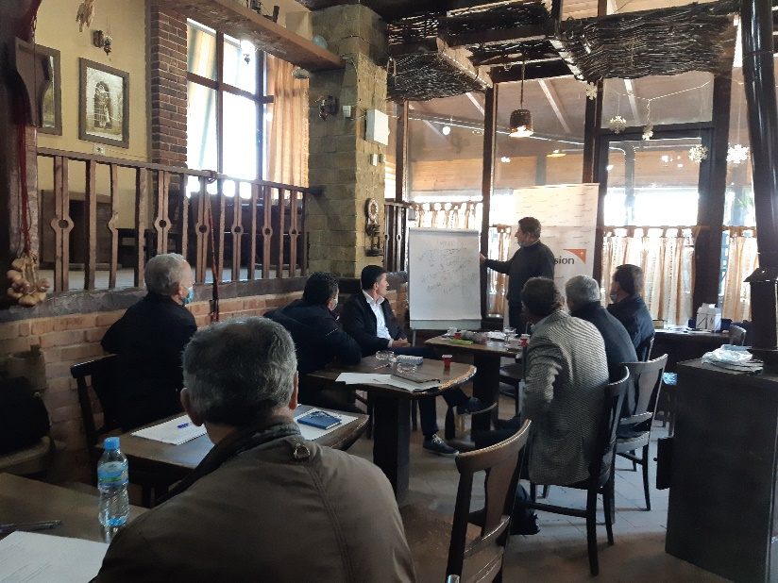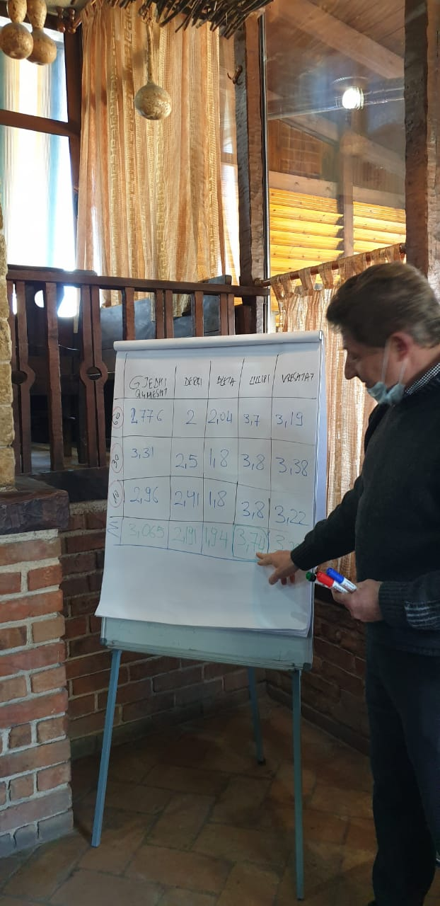

**Photo of the participants’ list**

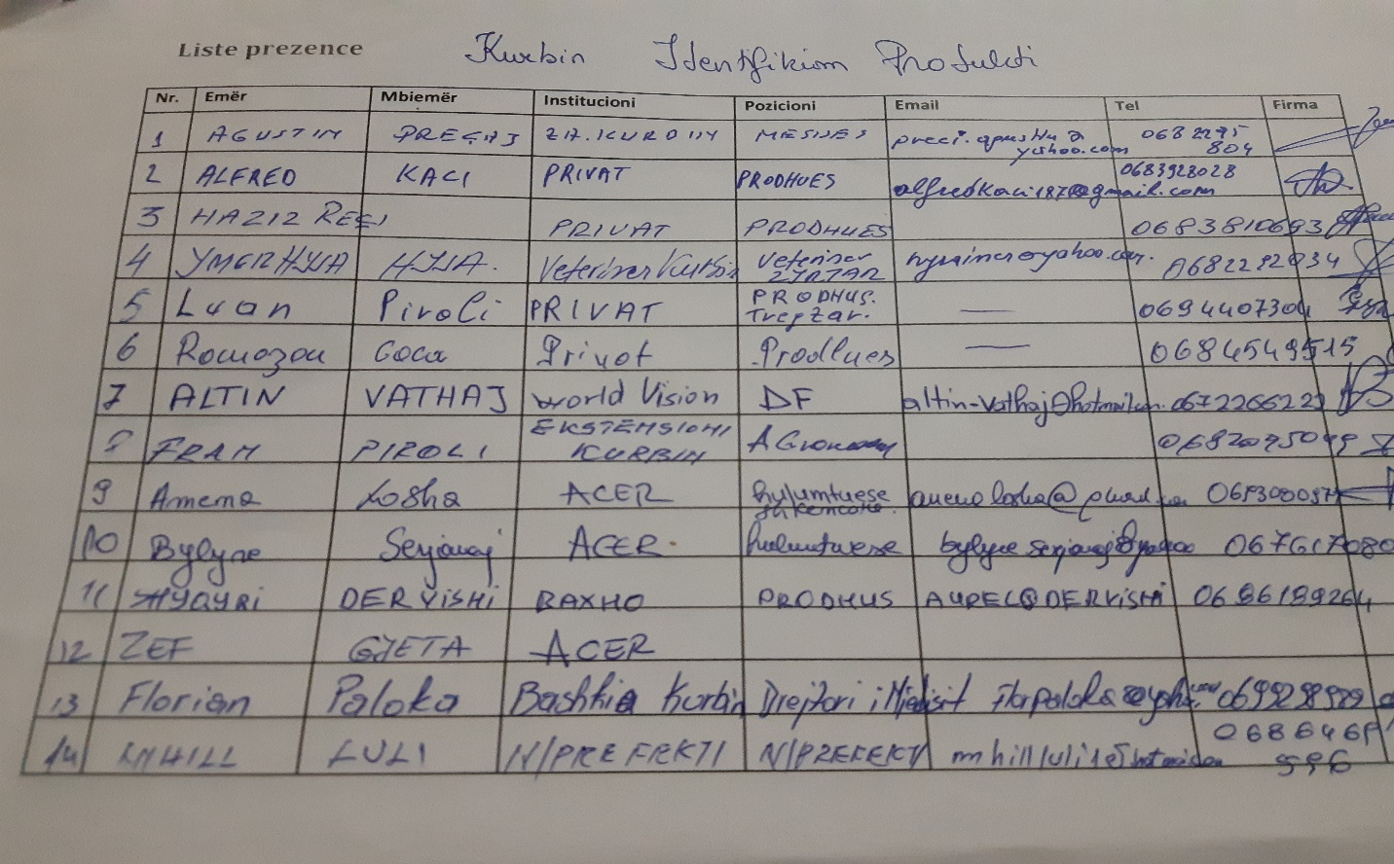

* **Focus Group Discussions, dated 24.02.2021**

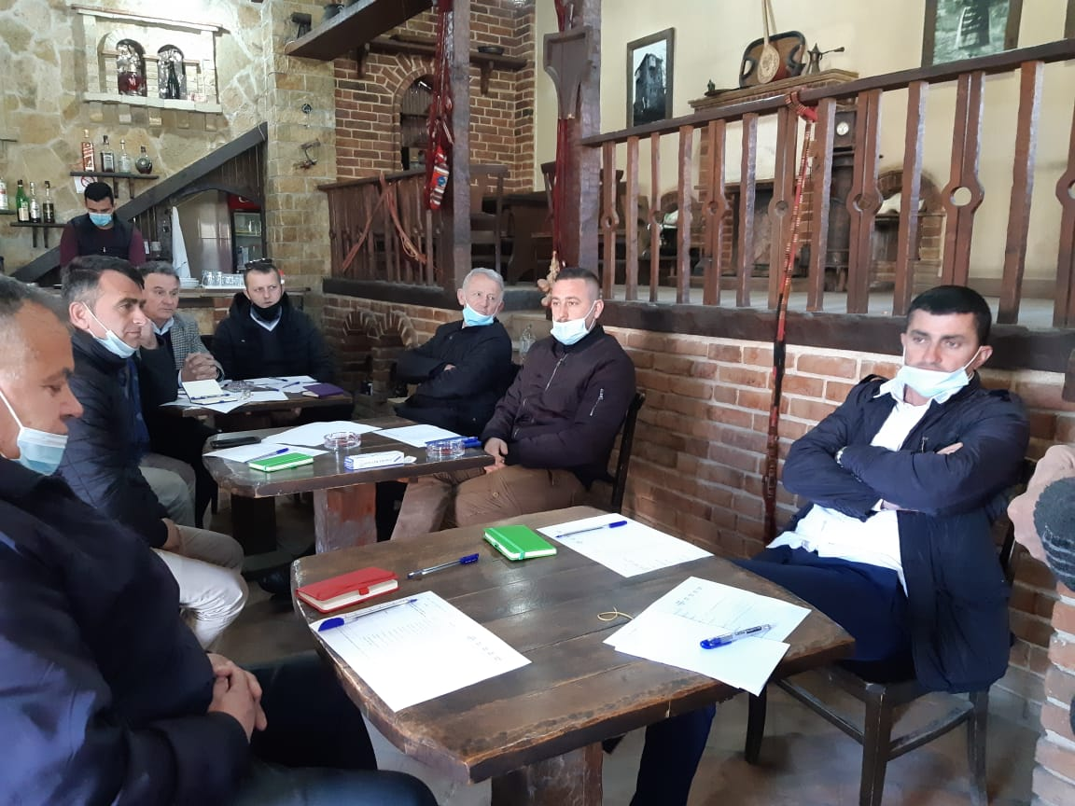

**Photo of the participants’ list**

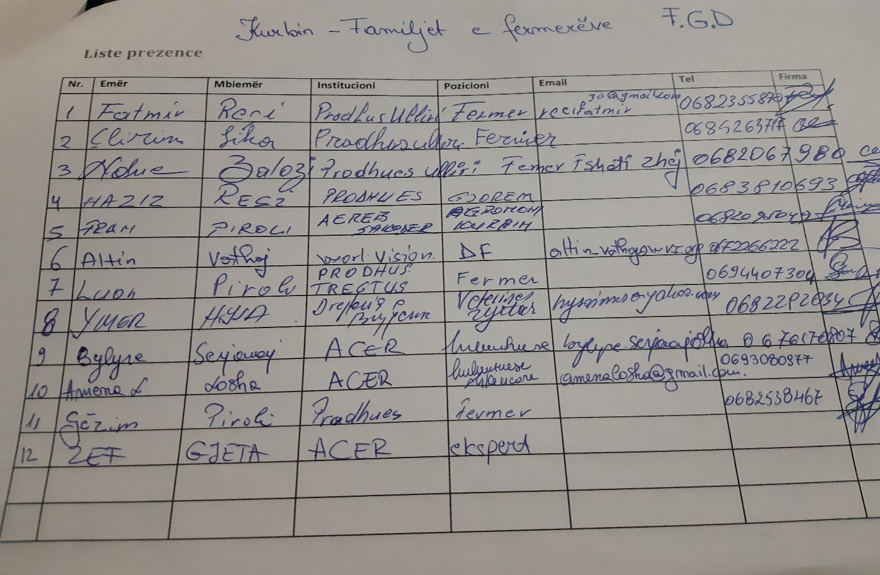

1. Kaplinsky, R., & Morris, M. (2000). *A handbook for value chain research* (Vol. 113). Brighton: University of Sussex, Institute of Development Studies.

   Gereffi, G., & Fernandez-Stark, K. (2011). Global value chain analysis: a primer. *Center on Globalization, Governance & Competitiveness (CGGC), Duke University, North Carolina, USA*.

   DFID (2008) Making Value Chains Work Better for the Poor: a Toolbook for Practitioners of Value Chain Analysis. Manual. Agricultural Development International.

   Guidelines for a Methodology to Support Value Chains for BioTrade Products from the Selection of Products to the Development of Sector Strategies UNITED NATIONS New York and Geneva, 2009.

   http://www.fao.org/fileadmin/templates/esa/LISFAME/Documents/Ecuador/value_chain_methodology_EN.pdf
2. Four reports for Diber, Librazhd, Korce and Kurbin area: WVAK & ISETNJ: “Assessment of landscape and natural resources and development of the curricula to address the needs of farmers for capacity building”.
3. ACER has prepared in depth intervews, referring to the two main documents:

   World Vision (2018). “*Value Chain Assessment at national level”*: <https://www.wvi.org/sites/default/files/2020-05/National%20Value%20Chain%20Report_final%20%282%29.pdf>

   The food and Agriculture Organization of the United Nations (2018). “*Market and Value chain analysi of selected sectors for diversification of the rural economy and women’s economic empowerment*”: <http://www.fao.org/policy-support/tools-and-publications/resources-details/en/c/1114588/>
4. Refering to WVA reports in four areas and similar reports on the training needs assessment: <https://snv.org/cms/sites/default/files/explore/download/training_needs_assessment_padee_2013.pdf>
5. DFID (2008) Making value chains work better for the poor: a handbook for value chain practitioners. Manual. International Agriculture Development.

   Guidelines for a Methodology to Support Value Chains for BioTrade Products from Product Selection to the Development of Sector Strategies UNITED NATIONS New York and Geneva, 2009.
6. WVAK & ISETNJ: “Assessment of landscape and natural resources and development of the curricula to address the needs of farmers for capacity building”, Kurbin.
7. WVAK & ISETNJ: “Assessment of landscape and natural resources and development of the curricula to address the needs of farmers for capacity building ”, Kurbin.
8. From January 1st, 2021 the farmer will pay a liter of petrol only for 79.6 ALL, while the fiscal burden of 80.4 ALL per liter is removed: <http://ata.gov.al/2020/10/15/83-mije-fermere-perfitojne-nga-heqja-e-akcizes-se-naftes-formalizi>m-i-ekonomise-dhe-rritje-e-siperfaqes-se-punuar/
9. The cost per unit is an average calculated by the authors according to the data presented in the table of revenues and expenditure for olive production
10. WVAK & ISETNJ: “Assessment of landscape and natural resources and development of the curricula to address the needs of farmers for capacity building ”, Kurbin.
11. Municipality of Kurbin <http://bashkiakurbin.gov.al/struktura-organizative/>