

**FINAL REPORT**

**Assessment of the Value Chain for the selected product in Diber and building of the training module as per needs of farmers**

**Submitted by: Albanian Center for Economic Research (ACER)**

March, 2021

Tabel of Contents

ACKNOWLEDGEMENT 4

ABBREVIATIONS 5

EXECUTIVE SUMMARY 6

CHAPTER 1: METHODOLOGY OF THE ASSESSMENT 8

1.1 Selection of value chains for analysis 8

1.1.2 Defining criteria and building understanding on these criteria 9

1.1.3 Weighting of criteria 9

1.1.4 Identification of a potential list and the product ranking 10

1.2 Evaluation of the selected value chains 10

1.2.1 Collection of existing information and preparation of evaluation 10

1.3 Households’ Capacity Assessment 12

1.3.1 Development of the focus group discussion instrument 12

1.3.2 Field data collection 12

1.3.3 Data analysis 13

1.4 Limitations of the study 13

CHAPTER 2: IDENTIFICATION OF THE POTENTIAL PRODUCT 14

2.1 Workshop organized in Diber 14

2.2 Defining / approving of criteria and sub-criteria with participants 14

2.3 Ranking of the identified products 15

2.4 Identification of the potential product for Diber area 15

CHAPTER 3: VALUE CHAIN ANALYSIS - APPLE 16

3.1 The selected product for the VCH analysis 16

3.2 Potential of Growth 16

3.3 Poverty alleviation potential 17

3.4 Market Assessment 18

3.4.1 Data on costs and benefits 19

3.5 Distribution channels and supply chain 21

3.6 Capacity Utilization and Technology 23

3.7 Promotion 23

3.8 Financial support and service providers 23

CHAPTER 4: TRAINING CAPACITY ASSESSMENT 25

4.1 The organization of the focus group discussion 25

4.2 Market access and financial opportunities 25

4.3 Management and collaborative relations 26

4.4 Technology and infrastructure 26

4.5 Knowledge and training 26

4.6 Evaluation of expertise, service providers (NGOs / Local public institutions) 27

CHAPTER 5: CONCLUSIONS AND RECOMMENDATIONS 28

5.1 Study conclusions 28

5.2 Intervention Matrix 30

5.3 Recommendations 35

Appendix 1: Identification of the product (Diber) 36

Appendix 2: The guide for Focus Group Discussions 37

Appendix 3: In depth Interviews 40

Appendix 4: Participants’ lists and photos of activities in Diber 46

**List of Tables and Figures**

Table 1: Sample of qualitative research 11

Table 2: Criteria averages for each product in the Kurbin area 15

Table 3: Revenues and Expenditures of an Apple producer in Diber Area 21

Table 4: SWOT analysis on apple product in Diber area 30

Table 5: Intervention Matrix 32

Figure 1: Distribution by land area of the apple farms in Diber 17

Figure 2: Apple value chain in Diber 23

# ACKNOWLEDGEMENT

The methodology for the implementation of the study: **“Assessment of the Value Chain for the selected product in Diber and building of the training module as per needs of farmers”** and field work package for the identification of 4 potential products (in Diber, Librazhd, Korca and Kurbin), opportunities for their development, the identification of the value chain status of each product was prepared by: Dr. Zef Preci, Dr. Brunilda Kosta, Bylyre Serjanaj MSc, Amena Losha MSc (ACER).

This final report would not have been possible without the reflective aid, support and contribution of Ms. Flovia Selmani, Monitoring and Evaluation Specialist of World Vision Albania staff, and Ms. Majlinda Hoxha, Project Manager, in charge of monitoring and implementation of the program "Building Secure Livelihoods", for the assistance provided during the implementation of this assessment. Special thanks also to the project coordination teams of World Vision Albania (WVA) in the field, Mr. Altin Vathaj (Municipality of Kurbin), Mr. Afrim Haxhi (Municipality of Maliq), Mr. Shpetim Cura (Municipality of Librazhd) and Mr. Erblin Burnazi (Municipality of Diber).

Finally, we are grateful to all the farmers who participated in the training needs assessment survey as well as key stakeholders in the VCH of potential products, including representatives of governmental and non-governmental organizations who participated in the workshop and interviews conducted in each region, during the period February 24th - March 18th, 2021. We thank the experts and households for their necessary contribution to this assessment and especially to our findings reflected in this report.

Clarification on Conflict of Interest: The authors declare no conflict of interest. Besides, the funders had no role in the design of the study; in the collection, analyses, or interpretation of data; in the writing of the manuscript, and in the decision to publish the results.

# ABBREVIATIONS

ACER Albanian Centre for Economic Research

COVID-19 Corona Virus 2019

ISETNJ Institute of Economic Studies and Knowledge Transfer

NGO Non-governemntal organizations

KII Key Informants Interviews

FGD Focus Group Discussion

ToR Terms of Reference

VCH Value Chain

WVA World Vision Albania

# EXECUTIVE SUMMARY

This research was conducted by the Albanian Center for Economic Research (ACER). The study team used a qualitative methodology, starting with a review of documentation in the field of study, followed by a collection of data through field interviews with key informants, business association leaders and farmers, and ending up with an analysis of value chain for the selected product (apple). The methodology chosen by ACER in collaboration with WVA, aims to strengthen the linkage **between value chain analysis and development interventions to improve the opportunities available to the poor.**

In the organized workshop in the municipality of Diber, on March 16th, 2021, the potential product was selected with the participation of eight experts in the field of agriculture and livestock. The selected product is olive, an evaluation based on criteria such as: a) The potential of the value chain to improve the livelihood of the local (poor) families; b) Market potential and c) Other criteria related to social inclusion and gender, existing strategies and infrastructure.

After the selection of product, ten in-depth interviews were conducted with key stakeholders, in the municipality of Kurbin (2 interviews with NGO’s and public institution’s participants; 8 other interviews with producers, collectors, sellers), and a focus group discussion with households.

From the data of in-depth interviews, it results that the main obstacles in the apple's VCH are: Lack of market, collection points, standardization, refrigeration rooms; High cost for agricultural inputs (pesticides, chemical fertilizers, etc.); unfair competition in markets; Importing of apples. The presence of foreign production in local markets, while domestic production remains unsold (loss to domestic farmers from crop rot); the geographical location of the city, which makes it difficult to transport the product from households to the local market or even to the national market.

Households in Diber Area have great difficulty accessing the market and financial inability to process large quantities of apples in its by-products in order to diversify their economic activity and increase income. **Intervention to help these families in processing their product** is a good opportunity for poverty alleviation of farmers. A positive aspect resulting from the interviews is that **women have the potential to get involved** in this value chain and increase their influence in local government to raise women’s voices and be heard, but they lack initiatives.

**The product promotion** of apples by farmers is not developed in the area of Diber, but the opposite happens for its by-products, where processing firms develop this aspect of their business not only locally but also nationally. **Processors have developed marketing strategies** for their product which include, among other things, advertising on national television - apple juice and apple cider vinegar promoting the origin of the product from Diber area.

**The role of farmers' associations** is viewed positively by VCH actors and local government / NGOs interviewed. Farmers' associations are necessary to apply and benefit from support schemes and to reduce competition in the markets. According to the interviews, it turned out that none of the producers / farmers benefited from them.

The most important policies for the future that would help farmers in the production and marketing of the product are reliance on technological processes, investment in refrigeration equipment for long-term storage of the product, increasing the capacity of farmers in the field of product promotion and information and awareness.

# CHAPTER 1: METHODOLOGY OF THE ASSESSMENT

There is a burgeoning of literature that lay out various ways and tools of value chain analysis. Besides the universal use and technicalities that accompany value chain analysis, the designed methodology applied to **identify and select the product** so then appropriately analyse their respective value chains, **strongly depends on the final purpose of the analysis**. To serve these various purposes, different authors and organizations have developed different toolbooks. Besides the existence of a wide number of toolbooks on value chain analysis (see Kaplinsky and Morris, 2000; Gereffi and Fernandez-Stark, 2011; UNCTAD, 2009; DFID, 2008; FAO, 2006)[1], **ACER selected the toolbook designed by the UNCTAD (2009) which aims at strengthening the link between the value chain analysis and development interventions to improve the opportunities available to the poor.** In line with the context of the country, some adjustments have been made which are argued throughout the document.Consequently, the designed methodology further elaborated in the upcoming sections, is based on this guidebook and its focus perfectly fits with the World Vision Albania economic development program goal which is **to achieve its goal of sustainable economic empowerment of families and communities of WVA program area in Dibër, Korçë, Kurbin and Librazhd, to raise their capacities to build resilience and improve child well-being.**

ACER has pursued the following steps in preparing the value chain analysis in four selected areas.

## **1.1 Selection of value chains for analysis**

Before developing the complete value chain Report in the Kurbin area (deliverable 2 according to ToRs), it was necessary to select the most suitable products in the region. As a note, WVA has already developed four contextual reports[2] and have served as basis of defining a clear contextual landscape. So, the prioritising process for selecting the potential product has followed the defined stages as below:

### **1.1.2 Defining criteria and building understanding on these criteria**

Value chain analysis begins with the selection of a product. The entry point of the value chain analysis proposed in the manual we are referring to is poverty alleviation and achieving pro-poor outcomes. As a result, the set of criteria used by ACER reflected this entry point. In addition to guidelines for setting criteria, as suggested by various studies (DFID, 2008; UNCTAD, 2009), the local context is taken into account in enriching, approving and revising these theoretical criteria.

ACER sets out these criteria to prioritize local products, as suggested by the manual:

**(i) Potential of the value chains to improve livelihood of the local families (poor)**

* Present integration of the poor in the market (what are they producing, selling, employment);
* Potential of the product / activity for poverty reduction and economic empowerment;
* Low barriers to entry for the poor (capital, knowledge);

**(ii) Market potential**

* Strong domestic and / or regional/national demand for the product;
* Growth potential of certain product;
* Possibility for scaling up;
* Involves a large number of people.

**(iii) Other criteria**

* Social inclusion and gender;
* Within framework of national and regional strategies;
* Existing infrastructure, including equipments and tools.

As an important note and as suggested by the manual, the decision as to which specific criteria were used for value chain selection was reached in collaboration with WVA and several experts in the field.

### **1.1.3 Weighting of criteria**

After defining the set of criteria, weighting process took place. As a remark, the toolbook suggests various weighting systems. In our case, the weighting system is based on the general rule that *“the more pro-poor you wish the selection of value chain to be, the higher the weighting that should be given to the criteria that emphasise pro-poor characteristics”.*

This is why ACER gives more weight to the first category of criteria and less to the others. As a summary, this weighing system is shown in Appendix 1.

### **1.1.4 Identification of a potential list and the product ranking**

Once the criteria for selecting the value chains, for analysis and after defining the weighing system was done, the next step was to develop a list of all possible local products in Diber. A participatory approach was used to complete the list identification. ACER conducted a workshop in Diber to successfully finalize the product identification process. As a rule, the value chains identified during this phase were based on current products currently produced in the Diber area and having a pro-poor focus, or that the products are considered to have a good market potential (local, regional and national).Each of the products was evaluated against sub-criteria from 1 to 5, and the product with the highest average was the product selected for value chain analysis.

## **1.2 Evaluation of the selected value chains**

Following the finalization of the value chain selection, ACER conducted the value chain evaluation for each selected product. This went through the following two stages.

### **1.2.1 Collection of existing information and preparation of evaluation**

During this phase, ACER carried out the following activities:

* **Mapping value chain actors.**

The mapping process aimed to identify all the actors involved along the chain and their respective roles they play in the production cycle, from production to product marketing and marketing in the target market. The following points were elaborated in this value chain mapping process: (i) the actors involved and the interrelationships between them; (ii) Identification of problems along the chain (Barriers in the chain, from the point of production to the final consumer, are described based on the flow of processes identified); (iii) Description of time and variable costs.

* **GAP Analysis**

With GAP analysis, actors in the chain assess their capacity to enter the market, identify weaknesses, and identify the causes of gaps between their current capacity and that required for the target market. This GAP analysis is based on the information available on demand in existing markets (regional and national), given the target market.

**ACER used qualitative data to collect information on each of the selected value chains**. Key informants Interviews (KII), value chain analysis questionnaires were designed and finalized after the agreement with WVA. A total of ten in-depth interviews were conducted (out of 12 initial targets), as defined in Table 1.

The qualitative study helped the evaluators to obtain more deepened information on the current situation, challenges and possible solutions for each of the value chain processes.

Table 1: Sample of qualitative research

|  |  |
| --- | --- |
| **Sample type** | **Sample number** |
| 1. Extensive services (government officials) | 1 |
| 1. Local NGOs communities | 1 |
| 1. Producers / Farmers 2. Collectors 3. Processors / Distributors 4. Wholesalers / retailers, etc. | 8 |
| **Total number of participants** | **10** |

*Source: ACER, Assessment of the Value Chain and building of the training module as per needs of farmers, 2021*

The instruments for each of the participants aim to analyze the gaps in a value chain product, based on several issues: a) Product growth potential; b) Potential for poverty alleviation; c) Market; d) The channels and the distribution processes; e) Technology, Promotion and financial support.[3] The in-depth interview questions can be found in Appendix 3.

## **1.3 Households’ Capacity Assessment**

As defined in the Terms of Reference of the study, the economic development program of World Vision Albania aims to achieve its goal of sustainable economic empowerment of families and communities in the WVA program area, so one of the goals of this service is to evaluate Farming House capacities in the four project areas and preparation of a training module / guide to facilitate capacity building for Farming Families. Based on the work of World Vision Albania in this program "Building Secure Livelihoods", ACER developed the following steps to assess the capacity needs of Farming Families/ Households in Diber. During this phase, ACER conducted the following activities.

## **1.3.1 Development of the focus group discussion instrument**

ACER in collaboration with WVA conducted a qualitative survey to assess the capacity of Farming Families in Diber, based on the program's goal of increasing their capacity to build sustainability and economic empowerment of WVA program[4] area to the families and communities. The households’ capacity assessment was focused on the following areas:

* Market access
* Financial Possibilities
* Organizational Capacities / Networks
* Knowledge
* Technology / Infrastructure
* Training needs

ACER and the expert group have conducted Focus Group Discussions (FGD) to assess the Farming Families' capacity for training, to identify current gaps / needs and building the training module (see Appendix 2).

## **1.3.2 Field data collection**

The activities under this task were implemented on March 16th – 17th, 2021. The participants in the focus group discussions were households (7 farmers in the Diber area, respecting the anti-COVID-19 measures). The selected families were separated from the list of project beneficiaries (500 families per area have benefited from the project). Simple random sampling was used to design the sampling frame. ACER full-time in-house staff provided organization and logistics for the data collection process.

## **1.3.3 Data analysis**

All qualitative data collected throughout this project were recorded and a transcript of each in depth interview with key informants in the first phase and FGD in Diber was developed. The transcript of each focus group interview and discussion was read and re-read by the ACER expert group for detailed analysis. The results of this analysis were later used for reporting formats.

Interpretation of results, drawing key conclusions and relevant recommendations were used by experts to develop training materials for the specific product selected in the region where the project is being implemented.

## **1.4 Limitations of the study**

ACER’s experts, during the development of the study encountered several limits. First, the fieldwork was delayed due to atmospheric conditions in the country and secondly the pandemic situation with COVID- 19. The pandemic situation in the country also limited the participation of a number of experts and households in the workshop or focus group discussion. However, these limits did not affect the validity of the study.

# CHAPTER 2: IDENTIFICATION OF THE POTENTIAL PRODUCT

## **2.1 Workshop organized in Diber**

ACER in cooperation with WVA, on March 16th, 2021, held a workshop in the municipality of Diber, in order to identify a potential product for this region. The workshop lasted about 70 minutes (start time 11:00 and end time 12:05). This workshop involved 8 experts in the field of agriculture and livestock (Representatives from NGOs; Extensionists; Farmers; Producers; Collectors; Processors; Wholesalers, in the municipality of Kurbin (See Appendix 4).

At the beginning of the workshop, the introduction of the participants took place, and the purpose of the meeting. Participants were previously familiar with the WVA project and its purpose for the sustainable economic empowerment of families and communities in the WVA program area in Diber, Korce, Kurbin and Librazhd, to increase their capacity to build sustainability and improve the well-being of children.

## **2.2 Defining / approving of criteria and sub-criteria with participants**

Participants were introduced to the methodology of the potential product identification by the ACER’s expert. Potential product identification began with the enrichment, approval and revision of theoretical criteria. The entry point of the potential product identification was fully in line with the purpose of the WVA program and value chain assessment, i.e. poverty alleviation and achieving pro-poor outcomes.

As presented in the methodology chapter on potential product identification, based on various studies (DFID, 2008; UNCTAD, 2009)[5] the basic criteria are: a) The potential of the value chain to improve the livelihoods of local (poor) families; b) Market potential and c) Other criteria related to social inclusion and gender, existing strategies and infrastructure.

The weighting system was based on "**the more pro-poor we want the value chain choice to be, the higher the weight that should be given to the criteria that emphasize the pro-poor characteristics**". As a result, participants gave a higher weight of 60% to the first criterion "The potential of the value chain to improve the livelihoods of local (poor) families". The second criterion “Market potential” was evaluated with 30% of the weight and with a specific weight of 10% the other criteria were evaluated.

## **2.3 Ranking of the identified products**

A review of the literature developed by WVA[6] for each project implementation area helped identify the top five products. Participants were introduced to the top five products derived from WVA reports and that have the potential to develop in their area by adapting to the core purpose of the program (pro-poor and with a good market potential). The five products listed in Diber area were: **Cattle (cow); Livestock; Apples; Hazelnut and Honey.**

Participants agreed with the listed products and decided to rate the products from 1 to 5 (where 1 indicates the minimum product compliance with the criteria, and 5 the maximum product compliance with the criteria) for the municipality they represented.

## **2.4 Identification of the potential product for Diber area**

In the evaluation of products based on specific criteria, 14 participants were included in the workshop organized by ACER and WVA. In Diber area, apples are rated with the highest potential to improve the livelihoods of poor families (criterion I), followed by livestock and honey. Meanwhile, even for market and other criteria, apples accompanied by livestock and beekeeping are seen as products with the highest potential in the market, allowing a greater inclusion of women and youth in the value chain. **With a mean of 3.33, participants identified as a potential product for the Dibra area, the apple product.** Table 2 presents the means of the products evaluated by the participants based on the specific criteria.

Table 2: Criteria averages for each product in the Diber area

|  |  |  |  |  |  |
| --- | --- | --- | --- | --- | --- |
| Criterion | Cattle (Milk)  Points | Livestock Points | Apple  Points | Hazelnuts  Points | Bee  Points |
| The potential of value chains to improve the livelihoods of the local households (poor)  Weight: 60 % | 2.6 | 3.1 | 3.2 | 2.95 | 3.12 |
| Market potential  Weight: 30% | 2.6 | 3.4 | 3.5 | 3.03 | 3.03 |
| Others  Weight: 10 % | 3.04 | 3.7 | 3.67 | 2.6 | 2.7 |
| The Mean in total = 0.6*M1 + 0.3*M2 + 0.1*M3 | 2.66 | 3.25 | **3.33** | 2.93 | 3.05 |

*Source: ACER, Assessment of the Value Chain and building of the training module as per needs of farmers, 2021*

# CHAPTER 3: VALUE CHAIN ANALYSIS - APPLE

### **3.1 The selected product for the VCH analysis**

The selected product by the actors involved in the workshop, for the area of Diber is the Apple. There are a total of 586,414 fruit trees in the area of Diber, of which 254,593 belong to the apple fruit trees,[7] so **43.4% of the fruit trees in Diber are Apples**. The distribution of these farms according to their size is illustrated in the figure below.

Figure 1: Distribution by land area of the apple farms in Diber

*Source: Ministry of Agriculture and Rural Development*

As can be seen from the figure, the largest numbers of farms where apples are grown in the Area of Diber, have a surface from 3 to 5 dynym (about 64% of them in total). Only a small number of apple farms have sizes over 11 dynym to 50 dynym (6.7% of the total). The average apple production in the Area of Diber is approximately 28.4 kV / farm or 508 kg / capita, according to the latest WVA reports for the Municipality of Diber.[8]

## 

## **3.2 Potential of Growth**

Apple producers, processors, collectors and sellers in Diber area have been asked about **the main obstacles** they face regarding this product. According to the data collected by these value chain actors, have resulted obstacles as following:

* Lack of market;
* Lack of collection points, standardization, refrigeration rooms;
* High cost for agricultural inputs (pesticides, fertilizers, etc.);
* Unfair competition in markets;
* Import of apples. Presence of foreign production in local markets, while domestic production remains unsold (loss to local farmers from product rot);
* Geographical location of the city, which makes it difficult for the poor farming families to transport the product from the local market to the national market;
* The low price that the producer receives compared to the final price of the customer.

The actors of the Apple VCH in Area of Diber have stated different opinions about the future demand for this product and the customer type. **Producers** report that they do not have enough demand to sell the Apple and that their customers are mainly local and a few collectors who collect the product on farms. One of the interviewed producers said that he sells his product in the markets of cities such as: Burrel, Kukes and Tirana. However, the producers have stated that they have not entered into any regular sales contract with any trader and do not always sell the entire quantity sent to the markets. **Collector**s say they sell the collected product in local markets and in Tirana. They report that wholesalers / retailers are willing and interested in different and new apple varieties. Apple **processors** are estimated to have the largest market and highest market access for the sale of apple by-products. The processors interviewed state that they sell products such as: apple juices, apple jam, apple cider vinegar and / or hashfe in supermarkets throughout Albania or in stores with orientation of natural products. **Wholesale / retail traders** in the Dibra area are more pessimistic about the growing demand in the future. Traders sell directly to local consumers and say there is a drop in demand from locals. One reason for the latter is that most local consumers (ie Dibra Area) can have their own fruit trees at home or process products at home, so there is no high demand for this product as it is already enriched as an area with apple production. **The perspective in this aspect is always seen towards the national market and there is the potential for future growth.**

The **packaging** that farmers use for the apple product is done in the form of plastic or wooden crates with a capacity of 15-20 kilograms, but even in this aspect they lack a sufficient amount of crates for the transport of goods. Due to the high load of a cash register, farmers also encounter difficulties in sending them for sale to the market. Meanwhile, genuine apple processors have specific packaging of by-products such as glass bottles of 0.25 L and 1 L, glass jars of different sizes and those, plastic packaging bags sealed with compression, depending on the product that hold.

## **3.3 Poverty alleviation potential**

According to the conducted interviews, it turns out that farming families in the Area of Diber have great difficulties to access the market and financial inability to process large quantities of apples in its by-products in order to diversify their economic activity and increase their income. **Intervention to help these families in processing their product** is a good opportunity to alleviate the poverty of farmers. Achieving this intervention also requires strong cooperation between farming groups as a single one finds it impossible to extract large quantities of processing, but some groups of them can process by-products such as: apple juice, jam, vinegar or dried apples (hoshafe). For the sale it can be seen some of long-term agreements with sales distributors or hotels in the area of ​​Diber, but also in the surrounding cities, which order large quantities of product. **An additional obstacle** to the market entry of poor farming families is the import of apples from abroad (North Macedonia), which increases competition in the markets further complicating the situation of farmers. Although, according to data collected by the actors of the Apple Office, it turns out that there is no increasing competition in this sector. Such a statement by the actors implies that there is an opportunity to sell the product, but the difficulty lies in building a bridge of communication between the farm and the market.

The actors have been asked if there will be **generation of additional employment** in this sector and most of them say that they definitely do, if the actors will cooperate together. Meanwhile, there are cases of negative responses, from actors belonging to the last link in the chain - final sellers (local traders). According to the sellers, there will be no generation of employment in this sector due to the ever-decreasing value of the price of apples and the lack of a market for sale in the Dibra Area. Respondents also spoke about the qualifications and skills of the employees who are part of this VCH. According to them, the workers are unskilled and lack modern knowledge on the product, production processes, storage and maintenance.

A positive aspect resulting from the interviews is that **women have the potential to get involved** in this value chain and increase their influence in local government to raise women’s voices and be heard, but there is no initiative on the part of theirs. The Dibra area is known for entrepreneurial - productive women who have succeeded in the Apple VCH. **One of the successful cases** is part of one of the in-depth interviews conducted with local processors. In its venture, it processes and sells apple cider vinegar product, apple jam and hoshafe using specific packaging in glass bottles and jars and with its own brand label. This successful example is proof of the potential that the woman farmer has in the Diber Area to develop and set up her own enterprise.

## **3.4 Market Assessment**

In the area of Diber, 30% of apple production is currently sold, while the rest is destined to reach the capital city of Albania, Tirana. The most important local markets for the sale of apples from Dibra producers are: Market of Peshkopi, Market of Bulqiza, Market of Burrel, Market of Klos and Market of Kukes. The sales ratio for processed apples (juice, jam, etc.) is 10% in the area of Diber, and 90% in Tirana, according to the results from the in-depth interviews with VCH actors.

According to reports from the in-depth interviews, it turns out that the **existing supply** of apples is lacking in some cases and surplus in other cases, which leads to a reduction in the price of apples by farmers. If the cooperation and coordination between the different links of the chain as well as the cooperation with the extensive service would be increased, a better market regulation and better-matching between the supply and demand for apples in the market could be achieved.

In the way of setting the price of apples, farmers are based on market demand and supply, processors set prices based on product cost and profit margin supplements, while sellers set them based on variety, apple size and in line with market purchasing power. The type of demand for apples in the markets is uniform throughout the year (non-seasonal).

## **3.4.1 Data on costs and benefits**

Through in-depth interviews with the actors of the Apple’ VCH in Diber Area, data were collected on annual production, annual revenues and expenditure, product prices, etc. in order to understand an overview of the financial situation of farming families in the area as well as the change of profit margin for this product from one link in the chain to another. The following table provides an overview of the figures obtained from in-depth interviews with local producers.

Table 3: Revenues and Expenditures of an Apple producer in Diber Area

|  |  |  |  |  |
| --- | --- | --- | --- | --- |
|  | | Year | | |
|
| **2017** | **2018** | **2019** |
| Annual production of Apple (ton) | | 22 | 27 | 30 |
| Annual production of Apple (kg) | | 22000 | 27000 | 30000 |
| Selling price (lek/kg) | | 36 | 33 | 37 |
| ANNUAL REVENUES (Lek) | | **800,000** | **900,000** | **1,100,000** |
| PRODUCTION COSTS | |  |  |  |
|  | Organic / chemical fertilizer | 26,000 | 40,000 | 50,000 |
|  | Pesticides | 70,000 | 80,000 | 100,000 |
|  | Transport (fuel) | 15,000 | 20,000 | 20,000 |
|  | Personel costs | 100,000 | 100,000 | 100,000 |
| Total Cost of Production (I) | | **211,000** | **240,000** | **270,000** |
| OTHER COSTS | |  |  |  |
|  | Rent | - | - | - |
|  | Technical assisstance | - | - | - |
|  | Packing | - | - | - |
|  | Cost of delivery | - | - | - |
|  | taxes | - | - | - |
|  | Refrigerated storage | - | - | - |
| Total other costs (II) | | **0** | **0** | **0** |
| TOTAL COSTS (I+II) | | **211,000** | **240,000** | **270,000** |
|  | **Total Cost per unit (lek/kg)** | **10** | **10** | **10** |
| Net Profit |  | **589,000** | **660,000** | **830,000** |
|  | **Profit Margin (lek/liter)** | 27 | 24 | 28 |
|  | % | 74% | 73% | 75% |

*Source: ACER, Assessment of the Value Chain and building of the training module as per needs of farmers, 2021*

The selling price of 1 (one) kilogram of apples in the market of Dibra reaches up to 60 ALL / kg, while **the price that the producer gets when he sells it to the collector / processor or traders is approximately 30 to 35 ALL per kilogram**. The main costs for a farmer who produces apples in the Dibra area include: costs for fertilizer and pesticide spraying, transportation costs and labor costs. In terms of other costs such as land rent, packaging, storage, etc. none of the farmers reported in interviews about additional expenses related to them. As a result, it turns out that the total production and operating costs for a farmer, who produces from 20 to 30 tons of apples per year, reach an average of 693,000 ALL per year.

If we make a cost calculation per unit of apple sales by farmers in the Dibra area, it is equal to 10 ALL / kg according to the table above. For a sale price of 35 lek / kg, the farmer **has a profit margin of 25 lek for every 1 (one) kilogram of apples sold**. According to in-depth interviews, it turns out that in general, farmers spend 10 to 20 lek / kg to produce 1 kg of apples. To gain a higher profit margin, farmers generally choose to sell their product directly to the consumer.

The following reflects the change in the selling price of apples and the calculation of the profit margin from the first link of the chain to the final customer, assuming a complete line of VCH in Diber area. This area consists of all the links of the value chain, but with a reservation to the collector actor since there are no real apple collection points, but more as a distribution / transport actor from the producer to the market or from the producer to the firm of processing. However, this actor is involved in the results of this value chain analysis.

**Producer 🡪** **Collector 🡪 Processor 🡪 Seller/Vendor**

**SellingPrice = 30-35 lek/kg 45 lek/kg 150 lek/liter 55 lek/kg**

Costper unit= 10-20 lek/kg 35 lek/kg 100 lek/liter 45 lek/kg

Profit margin **= 15-20 lek/kg 10 lek/kg** 50 lek/liter **10 lek/kg**

Profit margin(%) **= 54%* 22.2% 33.3% 18.2%**

*\** *This result is calculated by averaging the selling price = 32.5 and the cost per unit = 15, which brings the profit margin = 17.5 or 53.8%.*

The figure above shows the prices that have the highest frequency to occur along the apple value chain in Diber. The total cost of the collector, processor and seller includes the cost of purchasing apples from the farmer and the cost of operating the warehouse / shop in one year or the cost of processing to produce apple by-products. The calculated profit margins (sale price minus unit cost) for the producer, collector and seller belong to the sale of apples, while the profit margin for the above processor belongs to the sale of apples after processing (value added). Referring to these data, it turns out that the producer receives 54% profit from the sale of apples, the collector 22.2% profit, the processor 33.3% profit and the seller 18.2% profit. The processor link is the only one that exploits the increase of the value of the apple product by contributing to the technological processes for the processing of the fruit and its marketing. The sales market for the processor is not only local, but also distributes in the national market.

## **3.5 Distribution channels and supply chain**

The organization of the value chain for Apple in Diber area is still in the initial stage. Farmers sell the product to their regular buyers rather than looking for new buyers, cooperation between farmers or organization in farmer groups is very weak. There are no written contracts between the parties and the informality is high. The actors of the value chain for Apples in Diber Area are: small producers or farmers, collectors (not genuine points), processors and wholesalers or wholesalers who sell to the final consumer. Data collected through in-depth interviews show that a part of the farmers perform the role of seller of their product directly to the final consumer in order to get a higher price to increase their income and the rest sells it to collectors, processors or traders, who then send it to the final consumer or process it to add value to the product,. A simple illustration of the Apple’s VCH in Diber area is shown in the following figure.

Figure 2: Apple value chain in Diber

Apple Vinegar

**Producer**

**Consumer**

**Local Trader**

**Apple**

**Processor**

Apple Jam

**Consumer**

**Homemade processor**

Apple Juice

Dried

**Apple**

**Producer**

**Collector**

**Apple**

**Producer**

**Apple**

**Producer**

**Local Trader**

**Local Trader**

**Consumer**

**Consumer**

*Source: ACER, Value chain assessment and construction of training module according to farmers' needs, 2021*

**Producers** claim to sell to the same buyers, who are familiar with the type and quality of the product and have difficulty finding new buyers. **Collectors** say they collect from many different suppliers and the problem for them is the poor quality of the product.

**Processors** differ from other links in the apple VCH by stating that they have no difficulty in finding buyers and have numerous collaborations with farmers in the area of Diber, where they receive the raw material for processing. The difficulty that the latter face is the fluctuation of the price for the raw material, which may come as a result of the lack of a written contract with the supplier. In terms of data collected from the in-depth interviews with **vendors / traders**, they resemble producers' data. So, sellers generally sell to the same reliable buyers and have difficulty finding new buyers.

## **3.6 Capacity Utilization and Technology**

The data resulting from in-depth interviews conducted in the Diber area with the actors of this VCH, show that the **possibility of increasing the capacity** of farmers is difficult as long as there is no storage under the appropriate refrigeration conditions needed for the product of Apples (long-term storage). Investing in refrigeration equipment is costly and unaffordable for farming families. The same goes for collector actors. The situation changes when it comes to processors, who have the most modern technologies for product storage and warehousing as they are developed businesses, with higher market access and consequently with higher financial opportunities than small farmers.

Among the **main improvements** of their business, the actors of this VCH have expressed as the most important: the finalization of the Arbri road to increase access to markets outside the Diber area at a lower cost; market development; various trainings to increase their knowledge about product and marketing and automation of apple processing processes.

## **3.7 Promotion**

**Product promotion for apples** by farmers is not developed in the Diber Area, but the opposite happens for its by-products, where processing firms develop this aspect of their business not only locally but also nationally. Processors have developed marketing strategies for their product which include, among other things, advertising on national television - apple juice and apple cider vinegar promoting the origin of the product from the Dibra area.

Farmers in Diber area do not see interest in equipping a product with a **brand name**, given their annual income, but also do not consider it as a prospect in the future. Meanwhile, the processors in the area have already passed this stage and have performed the relevant laboratory analyzes for the equipment with the quality certificate and brand name to identify their product throughout Albania.

## **3.8 Financial support and service providers**

In the service of this analysis of the Apple value chain, in Diber area were interviewed a representative of the local government and a representative of NGOs in the area, in addition to interviews conducted with the VCH actors. **Services provided** to farmers by the above two representatives, include: free advice to farmers on benefiting from support schemes (subsidies), technical assistance and training. Among the **challenges** faced by the local government and / or NGOs to serve farming families are mentioned: difficulties in clarifying the subsidy schemes in agriculture, in clarifying the procedures to be followed to benefit the services. **Barriers** that affect the lack of service to farmers in this area include: low number of counselors per capita and open and difficult terrain to access the farmer in a coherent manner. **In order to improve the access of farming families** to the services provided by the local government, it is necessary to create a complete infrastructure, vehicles that connect the villages with the city, increase the access of farmers to have more efficient information on policies undertaken in the field of activity. of them.

**The role of farmers' associations** is viewed positively by the VCH actors and the local government / NGO interviewed. Farmers associations are necessary to apply and benefit from support schemes and reduce competition in the markets. Some of the VCH actors have stated that they belong to groups / farmers associations, but some of them are registered and the rest are informal groups.

VCH actors have been asked about **applying for grants** or state support schemes. According to the interviews, it turned out that none of the producers / farmers have benefited from them 30 years operating in this business. Respondents claim that the ways of applying have been improved by eliminating bureaucracies, but higher support is needed in order to really make a difference. However, there are cases of interviewed actors who have applied to these schemes and have never benefited. Among the reasons which lead to failure are mentioned as following:

* Insufficient awareness of the Product Value Chain
* Loss of trust among members of the farmer group
* Lack of supportive strategies / policies for farmers or
* Lack of capacity of farmers to benefit from support schemes.

**The most important policies** for the future that would help farmers in the production and marketing of the product are reliance on technological processes, investment in refrigeration equipment for long-term storage of the product, increasing the capacity of farmers in the field of product promotion and continuous informing and awareness.

# CHAPTER 4: TRAINING CAPACITY ASSESSMENT

## **4.1 The organization of the focus group discussion**

ACER in cooperation with WVA, on March 16, 2021 held a focus group discussion with Farmer Families in Diber. The focus group discussion lasted about 90 minutes (start time 12:30 and end time 14:00). World Vision Albania economic development program aims to achieve its goal of sustainable economic empowerment of families and communities in the WVA program area, so one of the goals of this service is to assess the capacity of Farming Families and prepare the module of training / guidance to facilitate capacity building for Farming Families.

In the discussion held in Diber, a total of 8 participants from farmers' families were included. The capacity assessment of Farming Families focused on the following areas: Market access and financial opportunities; Management and collaborative relationships; Technology and infrastructure; Knowledge and training needs.

## **4.2 Market access and financial opportunities**

**Access to market the apple product** is considered **difficult** by farming families in the local and national market. Focused group participants report that there is not enough market and the price of 30 lek apples does not benefit them to trade this product, as they have no profit. **Promotional knowledge** about apple product **is scarce**, reported by farming families in Dibra municipality. Farming families say that the opportunities and knowledge to market / promote the apple product are very limited.

“*We do not know what promotion is, we only associate it with TV commercials. Also, no one buys our apples here, especially since the very low price does not bring us profit. ”-* Farming family, Diber.

Farming families in Diber also value their financial opportunities. **Production, collection, processing and transportation until the sale of the product are seen as impossible to develop by farming families.** They have not received financial assistance / grants to assist in the production of a product from any public or private institution.

*"We have no financial means/opportunities at all. I live on assistance and it does not benefit me to deal with apple production, when I have nowhere to sell it. - Farming family, Diber.*

Focus group participants were asked about **their primary** **needs** for production. The primary need in the production of apple product was the increase of knowledge starting from the production to the sale of the product. Financial assistance and appropriate technological tools on apple production are the other two needs listed by farming families in the municipality of Dibra.

## **4.3 Management and collaborative relations**

Management and cooperative relationships have been evaluated by farming families in the focus group developed in the municipality of Diber. **Their knowledge and management skills have been assessed as very insufficien**t. Consequently, participants find it very positive to be **trained in the knowledge, management and organizational skills** for setting up, developing, marketing and marketing the apple product.

The families of the farmers, participants in the focus group, report that the **most fruitful collaborations have been and are with WVA as a non-profit organization**. Participants report very poor cooperative relationships with regional public institutions. Another problem was that farming families in the municipality of Dibra did not cooperate with each other to improve the value chain of the apple product. Lack of this cooperation, or cooperations with public institutions, leads to insufficient knowledge and low profit from the apple product.

“*It's good that the government is not helping us, but our problem is that we are not able to work and help each other.” - Farming family, Diber.*

## **4.4 Technology and infrastructure**

**Technological opportunities** in the production and delivery of apple products are considered very scarce by farming families. Focus group participants confirm that their technological knowledge in producing / providing a service on apple product is very insufficient.

**Road infrastructure is also considered problematic** in Diber area, hindering the transport and sale of this product. Road infrastructure is one of the main obstacles to product sales at the national level. Participants in the focus group see positively the construction and future operation of the road "Arbri", which will enable the connection of the inhabitants of Dibra with the capital, for a shorter time, affecting the trade of apple products.

## **4.5 Knowledge and training**

Farmers report that they have insufficient **information on the market of apple product**, whether local or national. The participants in the focus group assess as very weak the collaborations with the apple collectors or processors in the area of Dibra and as a result it is difficult to get information about the market of the apple product.

**Knowledge** about the initiatives or policies pursued by the Albanian government in the agricultural sector is unknown to farmers in the municipality of Dibra. At the same time they report that they are almost **unaware of international / national standards and regulations** in the field of apple product.

*“We are ordinary farmers and have no knowledge of the market or the standards or regulations of the Albanian government on agriculture. ”- Farming family, Diber.*

Farmers reported receiving training from the WVA, but not from public institutions or other non-public associations. Participants in the focus group in Diber express as an immediate necessity for training in increasing knowledge on all links of the apple product VO.

*"We want to be trained from the production to the sale of the apple product." - Farming family, Diber.*

## **4.6 Evaluation of expertise, service providers (NGOs / Local public institutions)**

In relation to the expertise of service providers, farming families are rated as the main providers of advice and information, the Directorate of Agriculture, the Product Buyer and the Input Trader. Almost ½ of farmers in the municipality of Dibra (41% of them) report the quality of counseling as “very bad / bad”. Meanwhile, only 18% of farming families rate the quality of counseling as “good / very good”. WVA and ISETNJ (2019) assessed access to advice and information to farmers in the municipality of Dibra and the results show that more than half of farmers (56%) report having a “very difficult / difficult” approach to advice.

Product buyers and the Directorate of Agriculture (extensive service) are the most important development partners in Diber. Almost two out of three farmers in the municipality of Diber (60.7%) rate their partners' capacity to provide advice and information as “very low”. This is an important indicator for increasing the capacity of service providers in the future, towards farming families in the municipality of Diber.

The above mentioned data on partners and service providers are supported by the actors involved in the value chain for the apple product in the municipality of Diber (WVA & ACER, 2021). In the interview conducted with representatives of local government (extensive service) it resulted that the Municipality provides free advice to farmers to benefit from support schemes (subsidies), technical assistance and training.

Among the **challenges** faced by the local government and / or NGOs to serve farming families are mentioned: difficulties in clarifying the subsidy schemes in agriculture, in clarifying the procedures to be followed to benefit the services. Farming families in Diber report that they are not part of any farmers' association and are not aware of them, **while the most fruitful cooperative relations are only with World Vision Albania** (WVA).

# CHAPTER 5: CONCLUSIONS AND RECOMMENDATIONS

## **5.1 Study conclusions**

* In the municipality of Dibra, **Apple is the potential product** selected by key actors to improve the economic situation of poor families. **Generating additional employment** (mainly of women) is the primary aspect that would develop if this value chain increases in the Dibra area.
* The actors involved in the Mollws Substation in the Dibra Area have listed these **main obstacles:**
* Lack of market;
* Lack of collection points, standardization, refrigeration rooms;
* High cost for agricultural inputs (pesticides, fertilizers, etc.);
* Unfair competition in markets;
* Import of apples. Presence of foreign production in local markets, while domestic production remains unsold (loss to domestic farmers from crop rot);
* Geographical location of the city, which makes it difficult to transport the product to poor farming families from the local market to the national market;
* The low price that the producer receives compared to the final price of the consumer.
* **Producers** report that they do not have enough demand to sell the Apple product and that their customers are mainly local consumers and a few collectors who collect the product on farms.
* **Wholesale / retail traders** in Diber area are more pessimistic about the growing demand in the future. Traders sell directly to local consumers and say there is a drop in demand from locals.
* Farming families in Diber Area **have great difficulty accessing the market** and financial inability to process large quantities of apples in its by-products in order to diversify their economic activity and increase income.
* **An additional obstacle** to the market entry of poor farming families is the import of apples from abroad (Macedonia), which increases competition in markets by further complicating the situation of farmers.
* **The possibility of increasing the capacity** of farmers is difficult as long as there is no storage under proper refrigeration conditions needed for the Apple product (long-term storage).
* **Promotion of the product** for apples by farmers is not developed in the Diber Area. Farmers are not interested in equipping a product with a **brand name**, given their financial capabilities. **Processors have devised marketing strategies** for their product that include, among other things, national television advertising - apple juice and apple cider vinegar.
* Apple VCH actors find it very difficult to **apply for grants** or state support schemes.
* Among the **challenges** faced by the local government and / or NGOs to serve farming families are mentioned: difficulties in clarifying the subsidy schemes in agriculture, in clarifying the procedures to be followed to benefit the services.
* **Obstacles**, which affect the lack of service to farmers in this area include: low number of counselors per capita and open and difficult terrain to coherently access the farmer.
* **Financial opportunities** are assessed as very limited, mainly to process, transport and sell the product with proper quality and packaging. Financial assistance was provided by the WVA but not by associations or other public bodies.
* Farmers report that they have insufficient information on the market of apple product.

Table 4: SWOT analysis on apple product in Diber area

|  |  |
| --- | --- |
| Strengths | Weaknesses |
| * High production potential in the Dibra area. * Increasing investments in the apple sector (mainly by processors) * Increased willingness to improve apple VCH processes (production, collection, processing, sales). * Significant number of key actors in apple VCH, market-oriented visionaries. | * Poor knowledge of women on national / international standards * Low financial opportunities for capacity building. * Insufficient technical instructions on the production and promotion of the apple product. * Lack of infrastructure and incomplete technology for apple VCH processes. |
| Opportunities | **Threats** |
| * Demand at the regional level is increasing. * Favorable policy for support from the government or various donors for these sectors * Export of apple product and its by-products if international requirements / standards are met. | * Import of foreign products. * Exposure to harmful climatic conditions for the apple product. * Inadequate investments towards specific problems in this sector. |

*Source: ACER, Value chain assessment and construction of training module according to farmers' needs, 2021*

## **5.2 Intervention Matrix**

The approach to future interventions aims to build on the use and benefit of current local resources and services as well as focus on bringing together key stakeholders to work together to improve product quality and open up new markets and at the same time to achieve the improvement of the general framework of the sector. This includes addressing the main challenges facing the apple sector in Diber, especially with regard to costs at all stages of production and the lack of cooperation between farmers and government institutions.

Based on the findings, areas of intervention were identified. Together with sector stakeholders, the study team has formulated intervention proposals and activities which it believes will improve conditions in the apple value chain, generate more income and pro-growth for the poor, and hopefully do so, the most competitive sector. These proposals are presented in the intervention matrix in the table below.

Table 5: Intervention Matrix

|  |  |  |  |
| --- | --- | --- | --- |
| **LIMITATIONS AND OPPORTUNITIES** | **INTERVENTIONS** | **ACTIVITIES** | **EXPECTED RESULT** |
| **Intervention of area 1: Improving quality and increasing production by updating technology** | | | |
| **Low-tech production and lack of product storage** | Technical knowledge of harvesting and post-harvest practices and the availability of logistical tools greatly affect performance. Increase productivity by improving the technological processes that must follow the various links of VCH.  1. Use the right growers that are suitable for the area and are marketable both locally, nationally and internationally.  2. Methods of using internationally permitted pesticides and fertilizers.  3. Training of the workforce for the application of modern agricultural techniques that include from planting, proper pruning, to daily operations, harvesting and / or processing, in order to ensure a high quality product that meets the level of specifications national and international. | Conducting awareness campaigns  Conduct training for farmers and other VCH actors  Training of trainers - both agricultural extensionists and private sector trainers | Production increased and storage capacity increased |
| Improving the storage capacity of the product, which can be achieved through:  1. Transfer of product storage knowledge over a long period of time (because Apple is an expiration product / rots after a certain period)  2. Transfer of knowledge on product storage through various processes: storage, packaging, processing and transportation.  3. Encourage investment in equipment needed to ensure proper product handling and quality maintenance while in stock. More specifically - investments in refrigerators refrigerators to protect apples from rot.  4. Training of technical staff that is able to prepare the product within the required specifications, efficiency and minimal cost.  5. Provision of Collection / Processing Centers with high quality raw materials, in order to be able to keep high quality products at all stages until reaching the customer.  6. Maintaining complete sanitary conditions inside and outside the Centers through the installation of appropriate systems and training of specialized personnel. | Conducting awareness campaigns  Conduct training for farmers and other VCH actors  Training of trainers - both agricultural extensionists and private sector trainers |
| **Poor quality of inputs (including seedlings) adversely affects apple fruit production** | Practice the selection of seedling varieties, as well as other inputs by first verifying their adaptation to the requirements of culture, soil and climatic conditions of the area.  To offer the most appropriate agronomic practices to reduce the costs of fruit production and to increase the quality of the product as natural as possible. | Training in the best methods of planting, fertilizing, spraying, apple picking.  Value chain stakeholder training to understand quality standards for apple production  Building the capacity to operate an extensive service as close as possible to the farmer by offering practical advice, etc. |  |
| **Poor access to finance for the production, collection, collection and transportation of the product with advanced technological tools** | Facilitate farmers and producers to have better access to finance.  Establishment of a service center, offering assistance in storage, packaging, marketing, etc.  Establishment of specific apple product collection centers in the municipality of Dibra. | Evaluate current financial institutions that offer loans and evaluate why they are not used  Capacity building of farmers for drafting business plans.  Request for funds / Request for project proposal from donors |  |
| **Intervention Area 2: Market Development** | | | |
| **Few opportunities to improve the livelihoods of small producers** | Increasing the number of people, especially women in the apple sector through technical training and entrepreneurship development.  (Women have the opportunity to grow in this sector as they deal extensively with fruit growing in the Area. In the Focus Group Discussion conducted in the Municipality of Dibër, the level of participation was 100% women.) | Training in the artisanal processing of apple-based products (apple cider vinegar, jam and hoshafe - which have a longer expiration date). | More product differentiation.  A more competitive sector in terms of international parameters.  Recognition of the origin of the product at the national level.  More INCOME from more sales |
| **Lack of joint/common marketing efforts** | Prepare a market study to explore local, national and international markets and prepare a marketing plan to address these opportunities and overcome challenges related to entering new and / or existing markets. | Prepare a marketing plan.  Marketing experts can be recruited to achieve this intervention (call for proposals) |
| **Few services and technical assistance available to the sector** | Support from qualified business service providers to assist the sector in improving its access to export markets and more sophisticated customers. | Training of business development service providers in both technical and managerial competencies for the sector |
| **Intervention area 3: Improving coordination, support functions and enabling environment** | | | |
| **Poor internal cooperation and coordination (between producers)** | Build communication structures or bridges to increase cooperation between farmers with each other.  Combining production into groups of farmers to facilitate finding markets and increase their ability to process apples by adding value to the product and selling at a higher price. | Arrange regular meetings with farmers.  Assess the current availability of field training and expansion service as needed  Trainings with farmers on the importance of uniting production to compete in markets. | Better support leading to better methods and knowledge, which in turn improves products and business |
| **Low support for the possibility of exporting apples from small farmers** | Offering the most appropriate agronomic practices to increase the quality of the product, to be healthy and as organic as possible to be preferred by foreign markets and to stimulate exports. |  |  |
| **Poor access to advisory and financial services** | Better access to advisory services (extensive service) to assist business activity in using financial and non-financial services | Build the capacity of local service providers to provide training and business development advice |  |
| **Government policies are considered weak as they fail to support the sector** | Increasing farmers' access to addressing problems to local government  Creating a platform to address the challenges of the sector  Increase the capacity of dialogue and advocacy of stakeholders in the value chain to address issues facing the central government and other relevant actors | Prepare evidence-based arguments for ways to address challenges and create opportunities  Involve farmers 'associations, farmers' groups or others in government-related decision-making processes | Dialogue leading to addressing problems, better business and improved living/welfare. |

*Source: ACER, Assessment of the Value Chain and building of the training module as per needs of farmers, 2021*

## **5.3 Recommendations**

Some of the recommendations derived from the workshop data, in-depth interviews with key actors on apple production in the municipality of Dibra and the focus group with farmers' families are listed below.

* To assess the situation, trends, perspectives and opinions of operators in certain value chains (apples) in the municipality of Dibra.
* Identify limitations / issues from time to time for the development of apple VCH and evaluate ongoing Livestock / Agriculture Technical Assistance initiatives and address constraints by local government, actors involved in this VCH or NGO / donor different.
* Establishing and maintaining production, collection, processing and sales standards for apple products in the Dibra area.
* Support for state-of-the-art refrigerated storage technology and processes throughout the apple VCH.
* Investments in processing capacities (apple juice, vinegar, jam, etc.) by analyzing the business model.
* Providing training of the workforce for their inclusion in this chain (mainly women).
* Providing trainings for Farming Families in Diber, to increase knowledge on national / international standards and establish cooperative relationships with other actors involved in the apple VCH.
* Increase the knowledge of farmers and actors involved in the VCH of milk on the national and international market. Practical information on apple product promotional methods and its by-products is suggested.
* Trainings are recommended for farmers in Diber and various actors in the Dairy VCH on policy recognition, advocacy with local and central government on respecting the fundamental rights of farmers in strengthening the apple VCH and obtaining special subsidies.

# Appendix 1: Identification of the product (Diber)

|  |  |  |  |  |  |  |
| --- | --- | --- | --- | --- | --- | --- |
| **Criterion** | **Sub-criterion** | **Cattle**  **Points** | **Livestock Points** | **Apple**  **Points** | **Hazelnuts**  **Points** | **Bee**  **Points** |
| **The potential of value chains to improve the livelihoods of local (poor) households**  **Weight: 60 %** | a. Current integration of the poor in the market (what they are producing, selling, employing). |  |  |  |  |  |
| b. Product / activity potential for poverty reduction and economic empowerment. |  |  |  |  |  |
| c. Low entry barriers for the poor (capital, knowledge). |  |  |  |  |  |
| **Market potential**  **Weight: 30%** | d. Strong domestic and / or regional / national demand for the product |  |  |  |  |  |
| e. Growth potential of certain products / activities; |  |  |  |  |  |
| f. Possibility for scaling |  |  |  |  |  |
| g. Involving a large number of people. |  |  |  |  |  |
| **Others**  **Weight: 10 %** | h. Social inclusion and gender; |  |  |  |  |  |
| i. Within the framework of national and regional strategies; |  |  |  |  |  |
| j. Existing infrastructure, including equipment and tools. |  |  |  |  |  |

# Appendix 2: The guide for Focus Group Discussions

**Region:**

a) Dibër b) Korçë c) Kurbin d) Librazhd

**ACCSESS IN THE MARKET**

1. How do you assess the access to market the product in the local / national market? Do you have difficulty selling your product to buyers? (comment)

_____________________________________________________________________________________

_____________________________________________________________________________________

1. What do you think are the strengths and weaknesses in selling your products? What about the strengths and weaknesses of your buyers?

_____________________________________________________________________________________

_____________________________________________________________________________________

1. What do you think are the strengths and weaknesses in selling your products? What about the strengths and weaknesses of your buyers?

__________________________________________________________________________________________________________________________________________________________________________

1. What are your opportunities to promote / market the product?

_____________________________________________________________________________________

_____________________________________________________________________________________

**FINANCIAL POSSIBILITIES**

1. How do you assess your financial capabilities to:
   1. Produce a product __________________________________________
   2. Process a product __________________________________________
   3. Transport the product __________________________________________
   4. Sell the product (to the final customer ______________________________

*(Get feedback from participants about their ability to afford the above activities if they would offer it themselves)*

1. Have you received financial aid / grants to help produce a product other than WVA? If yes, specify from whom you received these grants?

Were they enough?

_____________________________________________________________________________________

_____________________________________________________________________________________

1. What are your primary needs that would help you directly in the production of the product?

_____________________________________________________________________________________

_____________________________________________________________________________________

**MANAGMENT/ COOPERATING RELATIONS**

1. Do you find it positive to be trained in managerial and organizational knowledge and skills for setting up, developing, marketing and marketing a product? Do you think such training is needed for farming families in general?

_____________________________________________________________________________________

_____________________________________________________________________________________

1. What have been or are the most fruitful collaborations, from the following alternatives if you have had any?
2. Collaborative relations with farmers / other families on a product produced _______
3. Relations with local government officials _________________________
4. Relations with business associations _________________________
5. Relations with non-profit organizations _________________________

*9.1 Where did these cooperative relations consist / in what aspects? (Comment extensively)*

_____________________________________________________________________________________

**KNOWLEDGE**

1. Do you have enough information on the market of your product? If yes, where do you get this information (eg from the buyer, collection / processing companies, extensive services, etc.)?

____________________________________________________________________________________

____________________________________________________________________________________

1. Do you have knowledge about the initiatives or policies pursued by the Albanian government in the agricultural sector (eg strategies, action plans undertaken by the Ministry of Agriculture and Rural Development)?

____________________________________________________________________________________

____________________________________________________________________________________

1. Are you aware of international / national standards and regulations for your business / product area (eg ISO, GAP, GMP standards, quality standards and laws, etc?)
2. Yes. What are these standards? Describe below.
3. No.

_____________________________________________________________________________________

_____________________________________________________________________________________

**TECHNOLOGY AND INFRASTRUCTURE**

1. How do you assess your technological capabilities in producing or providing a service on the product?

_____________________________________________________________________________________

_____________________________________________________________________________________

1. Do you think it is necessary to increase your technological knowledge in producing or providing a service on the product?

_____________________________________________________________________________________

_____________________________________________________________________________________

1. Give your opinions on the state of the current infrastructure in product development:
   1. Road conditions/Transport _______________________________________
   2. Telephone Service _______________________________________
   3. Internet Service _______________________________________
   4. Electricity supply _______________________________________
   5. Storage _______________________________________

_____________________________________________________________________________________

_____________________________________________________________________________________

**TRAINING**

1. Have you previously received training on the production or provision of a service on agricultural / livestock product? If yes, please specify by whom you were trained and what were the topics?

_____________________________________________________________________________________

_____________________________________________________________________________________

1. Do you need training on production and service delivery on agricultural / livestock product? Specify which areas you want to train the most.

_____________________________________________________________________________________

_____________________________________________________________________________________

# Appendix 3: In depth Interviews

**The guide of the questions for the value chain actors**

*(Producer/farmers, collector, transporter, processer, wholesaler/reatailer)*

**I. BASIC DATA**

Region: ___________________________________________

Product: ____________________________________________

Name: ____________________________________________

Actor (or the name of the company): _______________________________

Geographical coverage: _______________________________

For how long you’ve been working for this business (for a specific product)? ___________ Years

Number of the employees (officials, seasonal, genitive): ___________________

The volume of the Annual production: ___________________

Annual turnover: ___________________

**II. SELECTED VALUE CHAIN/ product**

**II.1 Growth Potential**

1. What are the main obstacles to the production / collection / processing / marketing / sale... of this product?

2. Who is buying this product? Are traders willing to buy more of the product in the future?

3. At what price is the product supplied to the consumer? Is he competitive?

4. Do you use packaging for the product? What packaging do you use? What packaging do buyers and consumers want? Can you do them?

5. What are the prospects for future demand growth?

6. What do you think is the main demand trend (higher quality products, cheaper products, typical products)?

7. Where do you get the raw materials? Can you get enough raw material to fulfill all the orders from the buyers?

8. What are the competitive advantages of manufacturers (cost, product features)?

9. Is there potential for product improvement and innovation?

**II.2 Poverty Alleviation Potential**

10. What are the barriers to market entry for producers / farmers (from poor households)?

11. Will the increase in this specific VC generate additional employment?

12. Is there increasing competition in this sector? Does the VO offer the opportunity to improve (or at least maintain) the actual distribution of benefits across the value chain?

13. Is there a risk of replacement / change of unskilled workers or women?

14. Does the value chain offer any potential to increase income-generating activities for women?

15. Is the inclusion of women in this value chain potential to increase local governance on priority issues (for example, less discrimination, listening to women's voices)?

16. Does the value chain offer the possibility of diversification from agriculture / ordinary agricultural production?

17. Are there any productive / entrepreneurial women groups that have been successful in this particular V / product?

18. What types of interventions can be successful in improving the economic activities performed by women? What would be the impact of such interventions? Can you give some estimates for the costs?

19. Are local groups willing to cooperate in implementing these interventions?

20. Are the workers qualified? Do they lack skills? Get feedback on the circulation, presence and role of women, youth, urban versus rural, circulation, informality, etc. (Approximate if no specific data is provided)

*Get feedback on the circulation, presence and role of women, youth, urban versus rural, circulation, informality, etc. (Approximate if no specific data is provided) III. THE MARKET*

1. How much product is currently sold in the area? Please specify the most important markets (geographically).
2. Is the existing supply suitable to meet the demand, or is there a shortage?
3. Is it seasonal demand? Please explain. Are there any implications for your activity / company? Please specify.
4. How do you set your prices (market based prices, competitive prices, entry prices, prices for different sizes, geographic price, price plus cost)? Why? (Show prices along the value chain.)
5. Do you have a clear idea of ​​your exact production / collection / processing / marketing costs? (Utilities, labor, high raw material costs, transportation)?
6. Do you have a good profit margin idea for this product?
7. Do you have any certificates, quality standards, etc.? Please elaborate. Do you consider these standards as important "tools" to compete?

**IV. DISTRIBUTING CHANNELS AND SUPPLYING CHAIN**

1. How is your product distributed (directly to consumers, distributors, wholesalers, supermarkets, grocery, etc.)? How do you deliver the products, when and in what quantity? How many buyers do you have? Do you use your own transportation?
2. Do you sell to the same reliable buyers? Is it hard for you to find buyers? Do you collaborate with others to sell your products (especially to farmers)?
3. How many suppliers do you have? Do you buy from the same reliable suppliers? Is it difficult for you to find suppliers? Why?

**V. CAPACITY AND ITS USE**

1. Please specify projected capacity and current output. If capacity utilization is low, explain WHY (poor planning, low demand due to internal or market factors, technology deficiencies, etc.).

**VI. PROCCESSES AND TECHNOLOGIES**

1. What are the most important processes? What technology do you use? Is the technology expensive? Please elaborate.
2. How much have you invested in the development of this product? Do you intend to increase your production / diversification / capacity improvement technology?
3. To improve your business, which infrastructure improvements (markets, roads) would be most important?

**VII. PROMOTION**

1. What types of promotion do you use (advertising, point of sale shows, free samples, word of mouth, coupons, special prices, free advertising)? Please comment (cost effectiveness if data is available). Do you have a promotion strategy?
2. Do you have a "brand name"? If not, will you give your product a "brand name"?

**VIII. FINANCIAL SUPPORT AND SERVICE PROVIDERS**

1. Are you a member of an association or trade group?
2. Do you have, or do you currently receive, any assistance from government agencies, CSOs, NGOs, social enterprises or local trade groups (formal or informal - for your business and family)?
3. Are you supported by donors or other government agencies? What kind of support is provided by donors, consulting companies or other marketing service providers?
4. Is it difficult to apply for grants? What are the main obstacles? What can be done to facilitate the process? Has the availability of state / IPARD support schemes changed business in recent years? In what way?
5. Are there any additional barriers for women?

**Interview for Public Institutions/ NGO/ Associations**

GENERALINFORMATION

|  |  |
| --- | --- |
| Date: |  |
| Name and Surname of the interviewee |  |
| Institution: |  |
| Function/Institution type: |  |
| Contact Phone Number: |  |
| Geographical Inclusion: |  |

***Inform the interviewee about the profile of the beneficiaries of the project that WVA is implementing.***

**What services do you offer: ____________________________________________**

1. For GOV: The commitment of the central or local government towards the improvement of agriculture / livestock and the quality of the product in question? And in the face of poor farmers?
2. For NGOs: What is your organization's experience in providing services to farmers or consumers on the product? Have you faced any challenges in providing the service?

-Ask first if they have served any such beneficiaries (farmers / collectors / sellers). If they say **YES**, then ask:

* 1. **Do you offer any kind of support to poor farmers?**
  2. **Which services did the farmers benefit from and what were the characteristics of these services?**
  3. **Are the services provided to farmers increasing or decreasing and what are the reasons for the increase / decrease?**
  4. Ask the provider what was the experience of the institute in providing the required services, **i.e. if they have faced any challenges in serving the farming families, if the farmers understood all the rules and requirements of the provider and the procedure they had to follow to benefit from these services**
  5. **How do you think the access of farming families can be improved to benefit from the services you provide?**

-If not, then ask the institution:

1. **Why did not they serve such a beneficiary (farmers in our case)?**
2. **What prevented you from serving farmers in the respective regions?**

Ask the interviewees:

1. Do you have plans in the future to provide new or existing services to farmers in these regions? What are they?
2. What capacity support will be needed to provide such services?
3. What is your assessment as an additional service provider for farming families regarding the inclusion of women, children and youth in the relevant value chain?
4. Do you have any specific programs or services for women, children and young people? (Yes No)
5. If "Yes", please specify about the program or services and service feature. (Program / service duration, recipient selection criteria, training / service fee, etc.)
6. Are Farmers Associations registered or accredited?
7. How important do you see the role of Farmers Associations in supporting agriculture / livestock?
8. Have you developed any support strategies to facilitate the market chain of the product in question (production / collection / processing / sales)? At what stage of the chain does it intervene concretely?
9. What policies do you think would help poor farmers produce more, with better quality / hygiene / packaging and labeling and lower costs?
10. In your opinion, what are some of the main obstacles / gaps for empowering farmers / community regarding this product?
11. How do you assess the interventions of local and central government on the improvement and empowerment of farmers or the value chain?
12. What is your opinion as an NGO on the promotion of the relevant product?
13. What is your opinion on the technology used for the production / collection / processing and sale of the product in question?

Evaluation of previous experiences:

1. What has been the most successful approach among those applied by various donors / programs / projects? Why (discussion)?
2. What were the most successful support schemes applied in the past (subsidies for inputs / fiscal reductions, investment portion, matching grants, soft loans, etc.) Why (discussion)?
3. Were there or are there examples of successful collaboration activities (eg cooperatives or producer groups)? Who are they and why did they succeed? What are the reasons for failure?
4. What kind of approach would you recommend to develop more cost-effective interventions (eg capacity building and investment)?

# Appendix 4: Participants’ lists and photos of activities in Diber

* **Workshop, dated 16.03.2021**

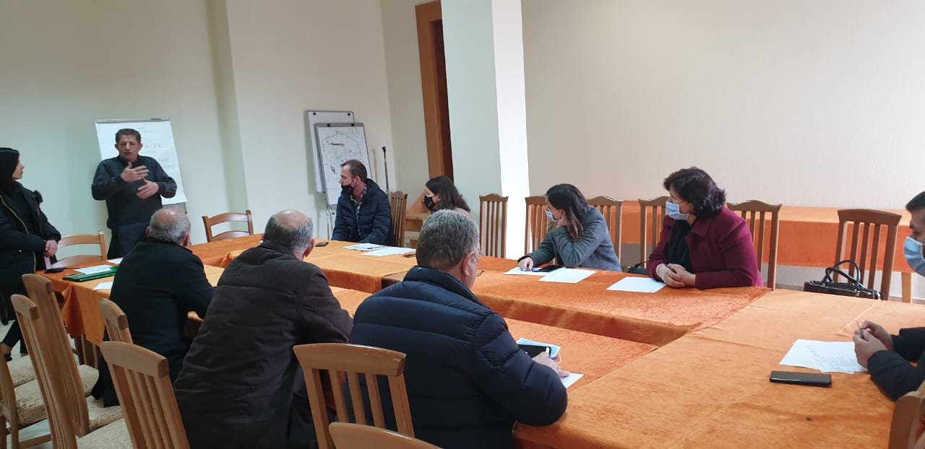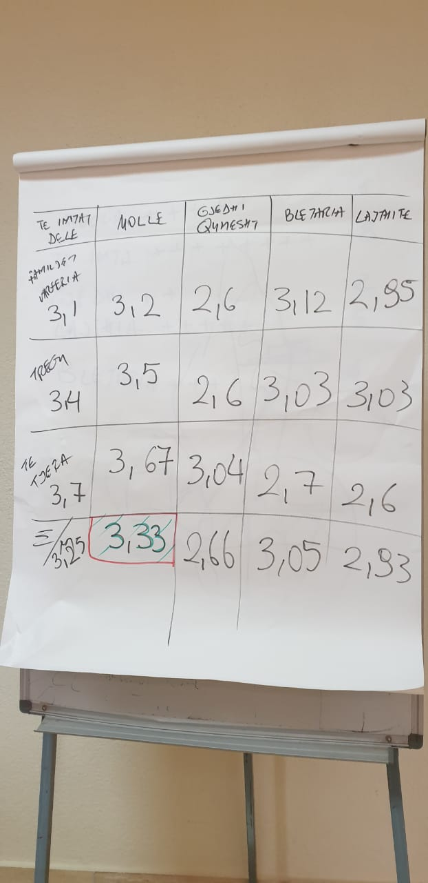

**Photo of the participants’ list**

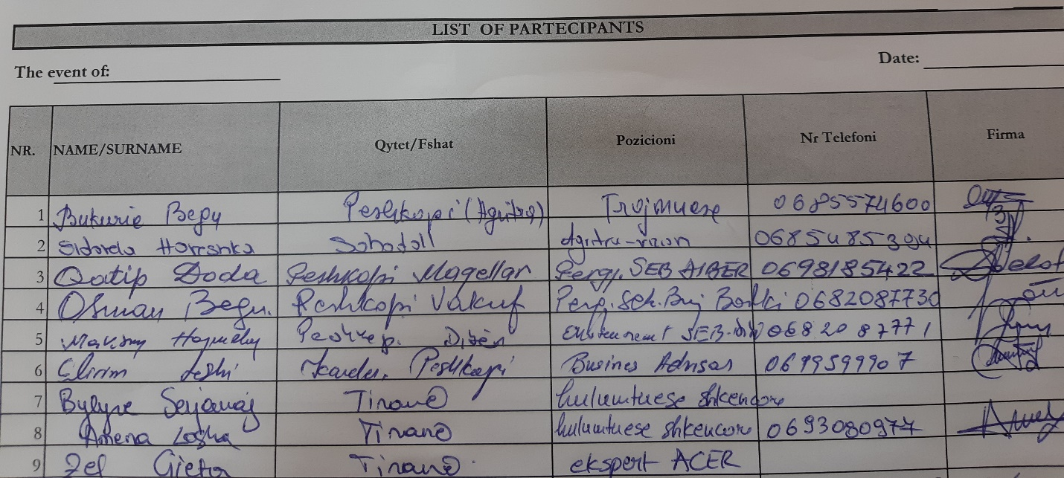

* **Focus Group Discussions, dated 16.03.2021**

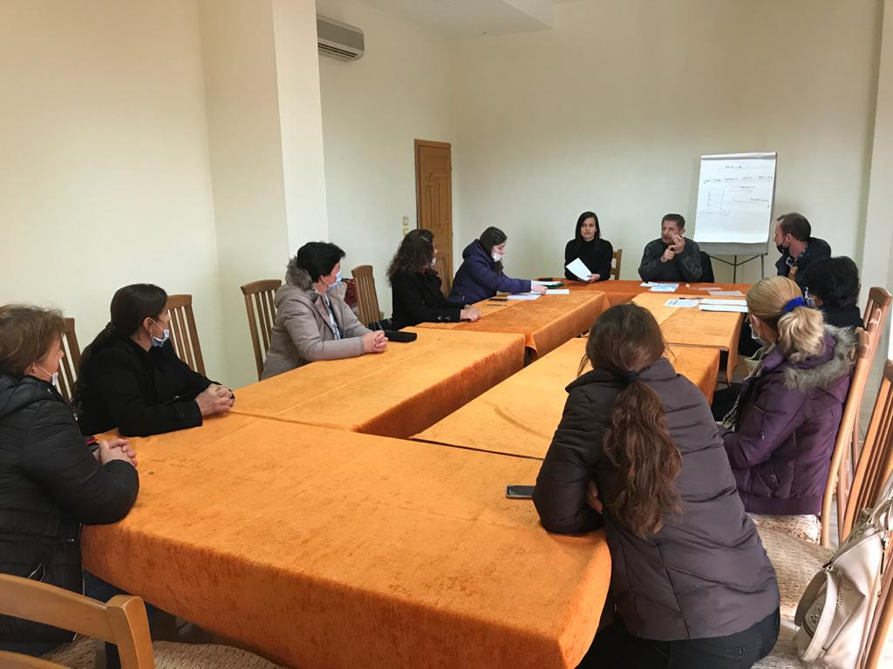

**Photo of the participants’ list**

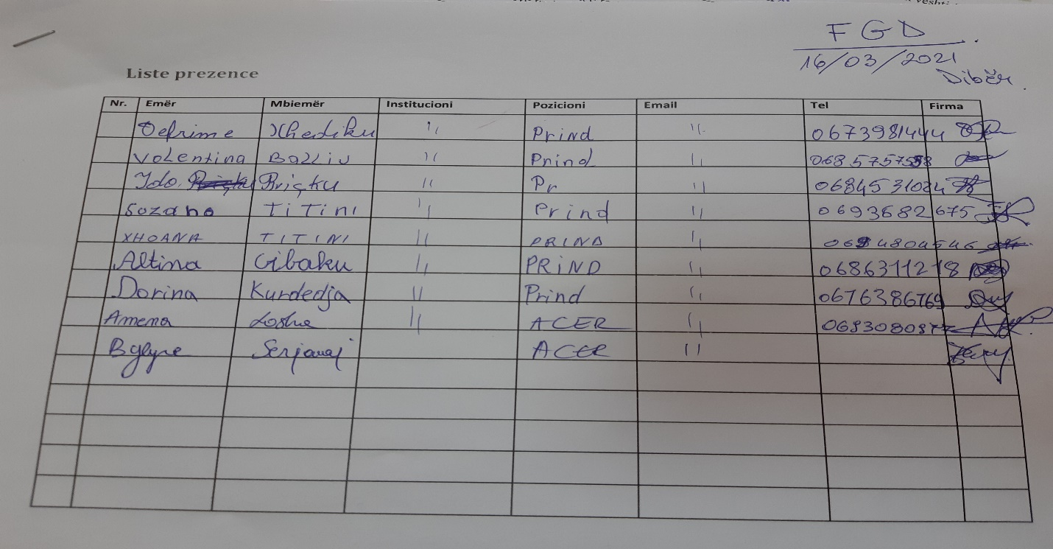

1. Kaplinsky, R., & Morris, M. (2000). *A handbook for value chain research* (Vol. 113). Brighton: University of Sussex, Institute of Development Studies.

   Gereffi, G., & Fernandez-Stark, K. (2011). Global value chain analysis: a primer. *Center on Globalization, Governance & Competitiveness (CGGC), Duke University, North Carolina, USA*.

   DFID (2008) Making Value Chains Work Better for the Poor: a Toolbook for Practitioners of Value Chain Analysis. Manual. Agricultural Development International.

   Guidelines for a Methodology to Support Value Chains for BioTrade Products from the Selection of Products to the Development of Sector Strategies UNITED NATIONS New York and Geneva, 2009.

   http://www.fao.org/fileadmin/templates/esa/LISFAME/Documents/Ecuador/value_chain_methodology_EN.pdf
2. Four reports for Diber, Librazhd, Korce and Kurbin area: WVAK & ISETNJ: “Assessment of landscape and natural resources and development of the curricula to address the needs of farmers for capacity building”.
3. ACER has prepared in depth intervews, referring to the two main documents:

   World Vision (2018). “*Value Chain Assessment at national level”*: <https://www.wvi.org/sites/default/files/2020-05/National%20Value%20Chain%20Report_final%20%282%29.pdf>

   The food and Agriculture Organization of the United Nations (2018). “*Market and Value chain analysi of selected sectors for diversification of the rural economy and women’s economic empowerment*”: <http://www.fao.org/policy-support/tools-and-publications/resources-details/en/c/1114588/>
4. Refering to WVA reports in four areas and similar reports on the training needs assessment: <https://snv.org/cms/sites/default/files/explore/download/training_needs_assessment_padee_2013.pdf>
5. DFID (2008) Making value chains work better for the poor: a handbook for value chain practitioners. Manual. International Agriculture Development.

   Guidelines for a Methodology to Support Value Chains for BioTrade Products from Product Selection to the Development of Sector Strategies UNITED NATIONS New York and Geneva, 2009.
6. WVAK & ISETNJ: “Assessment of landscape and natural resources and development of the curricula to address the needs of farmers for capacity building”, Diber.
7. INSTAT, 2017
8. WVAK & ISETNJ: “Assessment of landscape and natural resources and development of curricula to address the farmers` needs for capacity building, Municipality of Diber".